NETAJI SUBHASH UNIVERSITY OF TECHNOLOGY

DESIGN AND ANALYSIS OF ALGORITHMS

COURSE CODE: CACSC06

PROJECT

III SEMESTER

SNEHA GUPTA: 2021UCA1859

TABLE OF CONTENTS

1. Perform the following sorting algorithms-Merge sort, Quick sort, Bubble sort, insertion sort and selection sort.
2. Perform the following sorting algorithms-Radix sort, Count sort, Bucket sort, and Shell sort.
3. Perform searching algorithm-Linear and Binary search.
4. Perform tower of Hanoi.
5. Write a program for inserting elements in:
   1. AVL tree
   2. Red-Black Tree
   3. BST
6. Write a program for deleting elements in:
   1. AVL tree
   2. Red-Black Tree
   3. BST
7. Given the root of a binary tree, return the maximum height of the tree.
8. Find maximum and minimum of array using the dynamic programing.
9. Job sequencing problem
10. Fractional knapsack problem
11. Write a program for the fractional and dynamic knapsack problem
12. Implement Minimum Spanning trees: Prim’s algorithm and Kruskal’s algorithm
13. Matrix chain multiplication
14. Write a program to implement Strassen’s Matrix Multiplication.

Implement Matrix chain multiplication (MCM) using dynamic programming

1. Write a program to implement Longest Common Subsequence.
2. Implement Travelling Salesman Problem

EXPERIMENT NUMBER: 01

Dr. Johnson has collected the blood pressure rate of a tuberculosis infected patient. He has stored the collected data for observing the blood pressure behavior of a given patient. During the operation of the patient one of the doctors has asked Dr. Johnson to tell the maximum and minimum blood pressure of the patient. So, this is the routine work of Dr. Johnson. So, he wishes to have a divide conquer based approach which takes lesser comparison to achieve the desire results.

Perform the following sorting algorithms-Merge sort, Quick sort, Bubble sort, insertion sort and selection sort.

OBJECTIVE:

To work on different sorting algorithms to find the minimum and maximum blood pressure of the patient.

MERGE SORT

OVERVIEW:

The merge sort algorithm is a sorting algorithm that is based on the Divide and Conquer paradigm. In this algorithm, the array is initially divided into two equal halves and then they are combined in a sorted manner.

ALGORITHM

step 1: start

step 2: declare array and left, right, mid variable

step 3: perform merge function.  
    if left > right  
        return  
    mid= (left+right)/2  
    mergesort(array, left, mid)  
    mergesort(array, mid+1, right)  
    merge(array, left, mid, right)

step 4: Stop

COMPLEXITY

Time Complexity: O(N log(N))

Sorting arrays on different machines. Merge Sort is a recursive algorithm and time complexity can be expressed as following recurrence relation.

T(n) = 2T(n/2) + 0(n)

CODE:

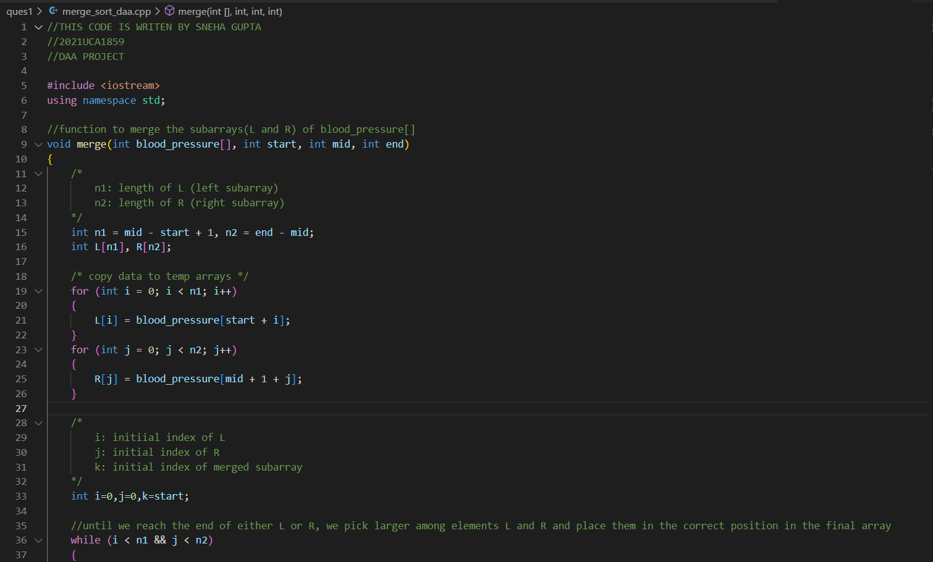

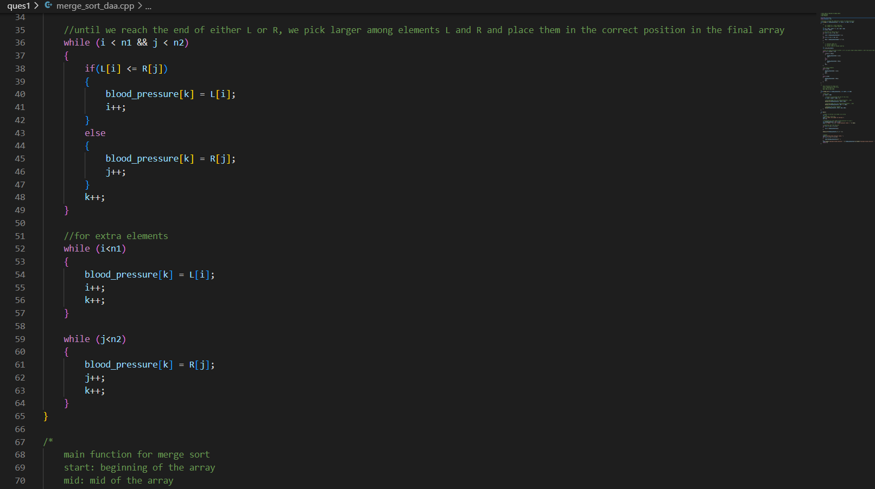

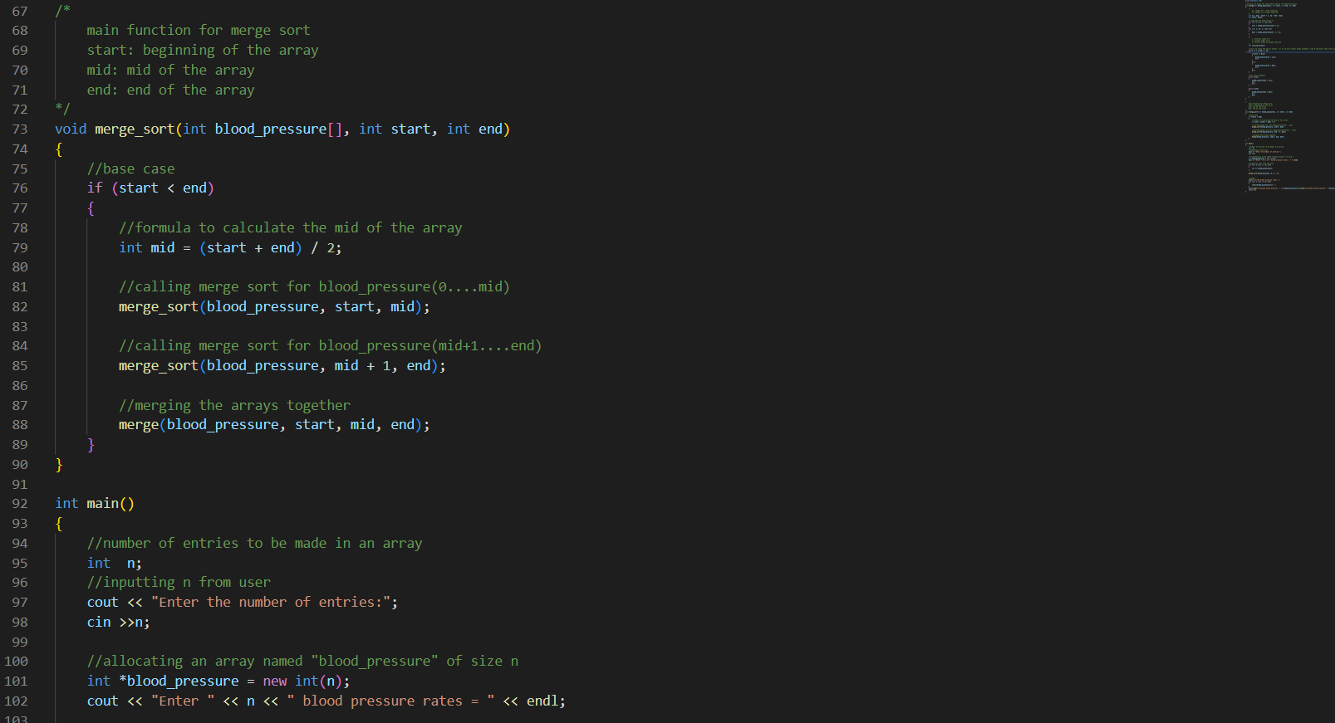

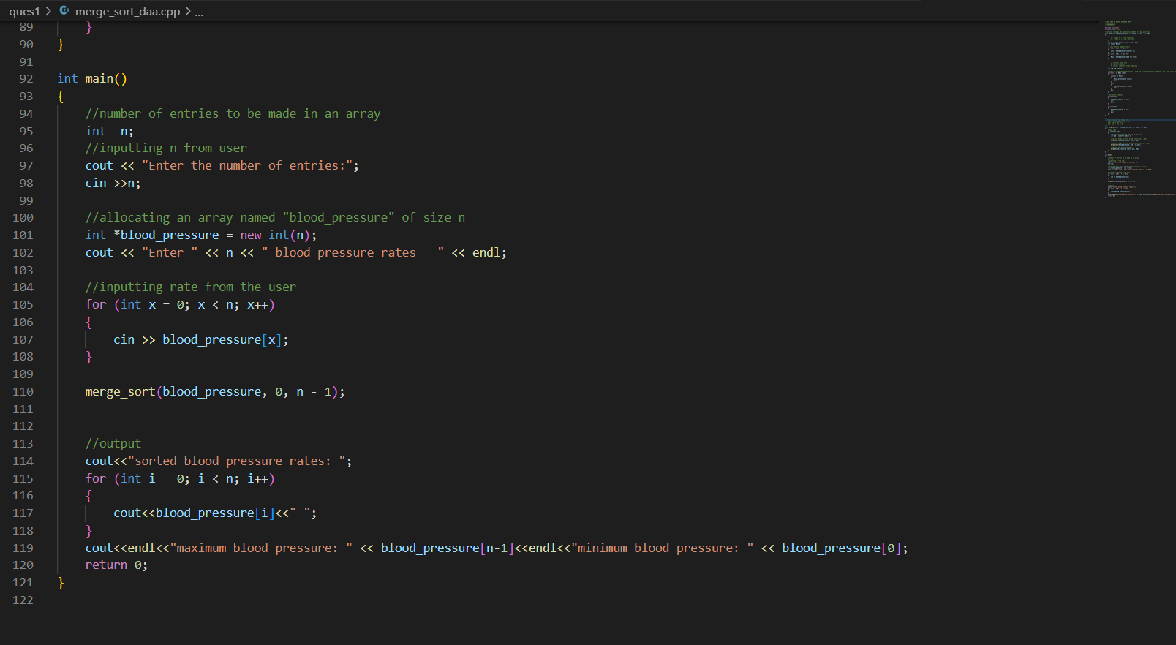

OUTPUT:

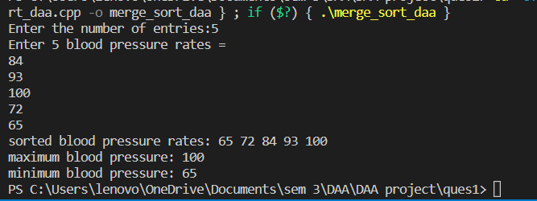

QUICK SORT

OVERVIEW:

QuickSort is a Divide and Conquer algorithm. It picks an element as a pivot and partitions the given array around the picked pivot.

ALGORITHM

QUICKSORT (array A, start, end)

{

**if** (start < end)

{

p = partition(A, start, end)

QUICKSORT (A, start, p - 1)

QUICKSORT (A, p + 1, end)

}

}

**Partition Algorithm:**

The partition algorithm rearranges the sub-arrays in a place.

PARTITION (array A, start, end)

{

  pivot ? A[end]

  i ? start-1

**for** j ? start to end -1

{

**do** **if** (A[j] < pivot)

{

   then i ? i + 1

swap A[i] with A[j]

    }

}

 swap A[i+1] with A[end]

**return** i+1

}

COMPLEXITY

TIME COMPLEXITY: O(n^2)

SPACE COMPLEXITY: O(n*logn)

CODE:

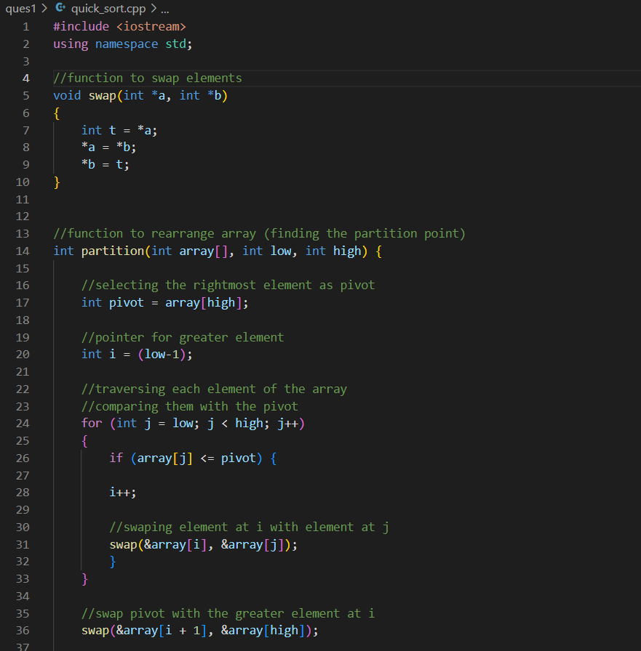

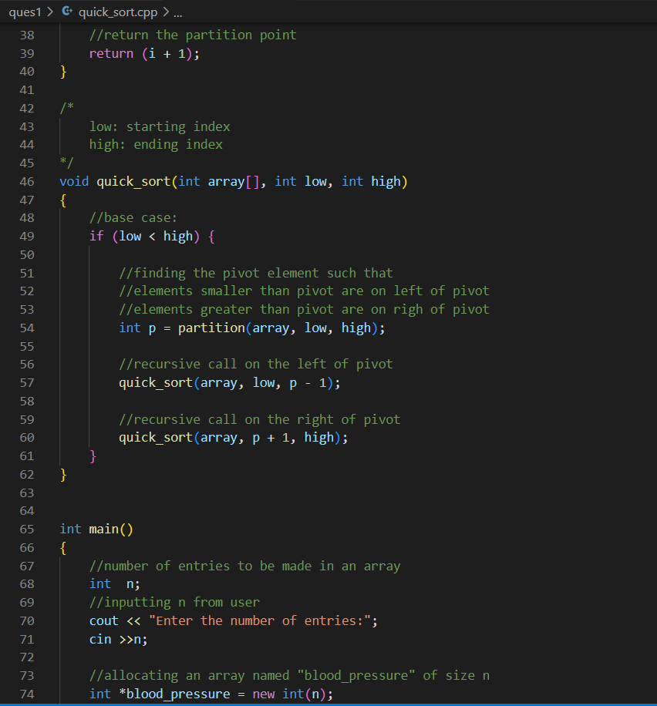

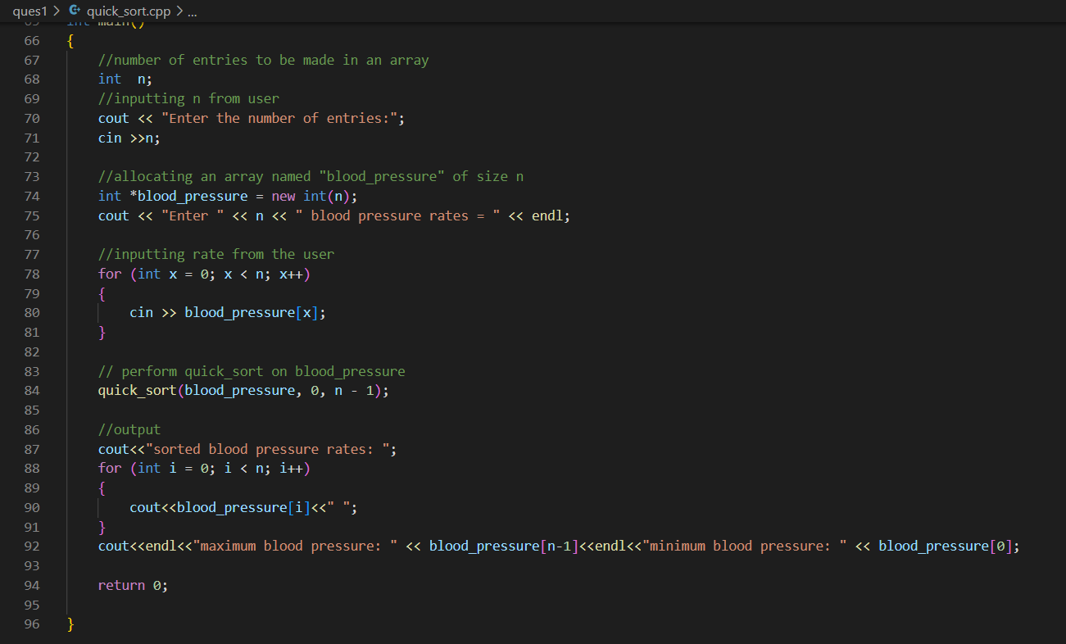

OUTPUT:

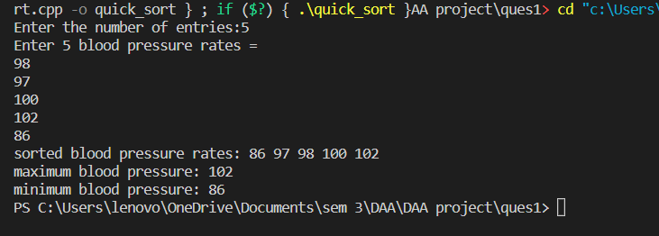

BUBBLE SORT

OVERVIEW:

Bubble Sort is the simplest sorting algorithm that works by repeatedly swapping the adjacent elements if they are in the wrong order. This algorithm is not suitable for large data sets as its average and worst-case time complexity is quite high.

ALGORITHM

begin BubbleSort(arr)

**for** all array elements

**if** arr[i] > arr[i+1]

         swap(arr[i], arr[i+1])

      end **if**

   end **for**

**return** arr

end BubbleSort

COMPLEXITY

Time Complexity: O(N^2)

Auxiliary Space: O(1)

CODE:

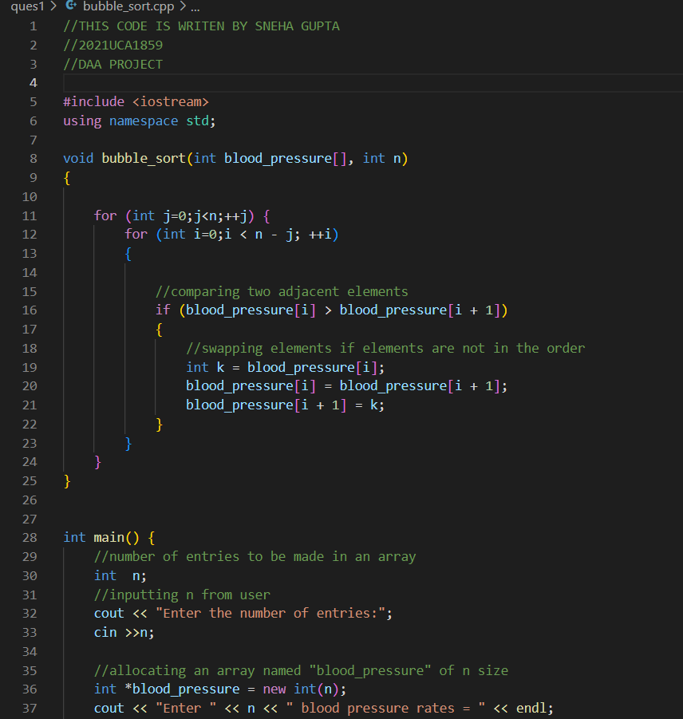

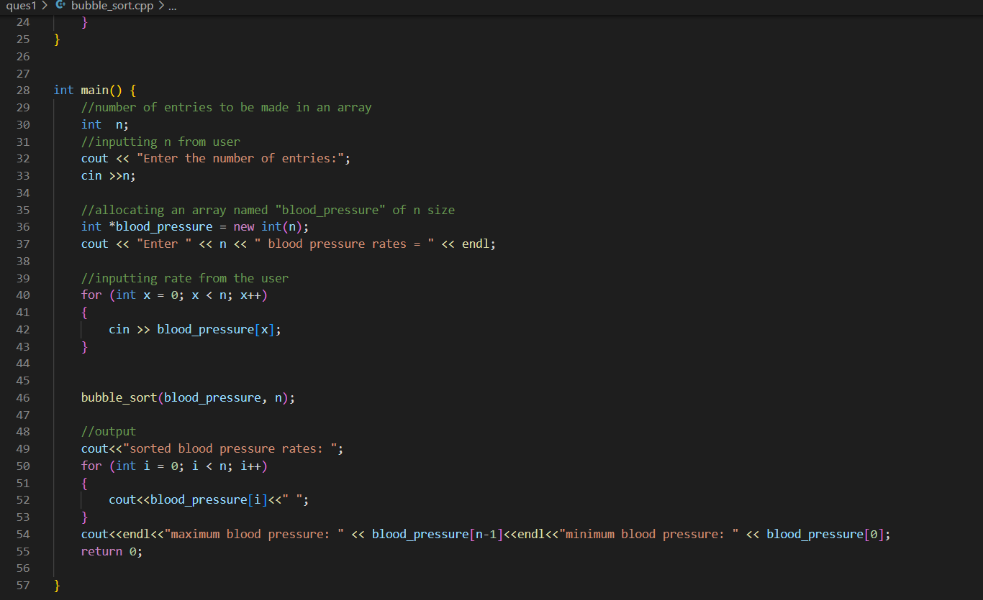

OUTPUT:

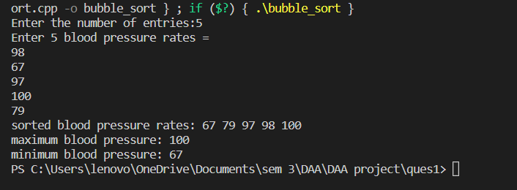

INSERTION SORT

OVERVIEW:

Insertion sort is a simple sorting algorithm that works similar to the way you sort playing cards in your hands. The array is virtually split into a sorted and an unsorted part. Values from the unsorted part are picked and placed at the correct position in the sorted part.

ALGORITHM

insertionSort(array)

mark first element as sorted

for each unsorted element X

'extract' the element X

for j <- lastSortedIndex down to 0

if current element j > X

move sorted element to the right by 1

break loop and insert X here

end insertionSort

COMPLEXITY

Time Complexity: O(N^2)

Auxiliary Space: O(1)

CODE:

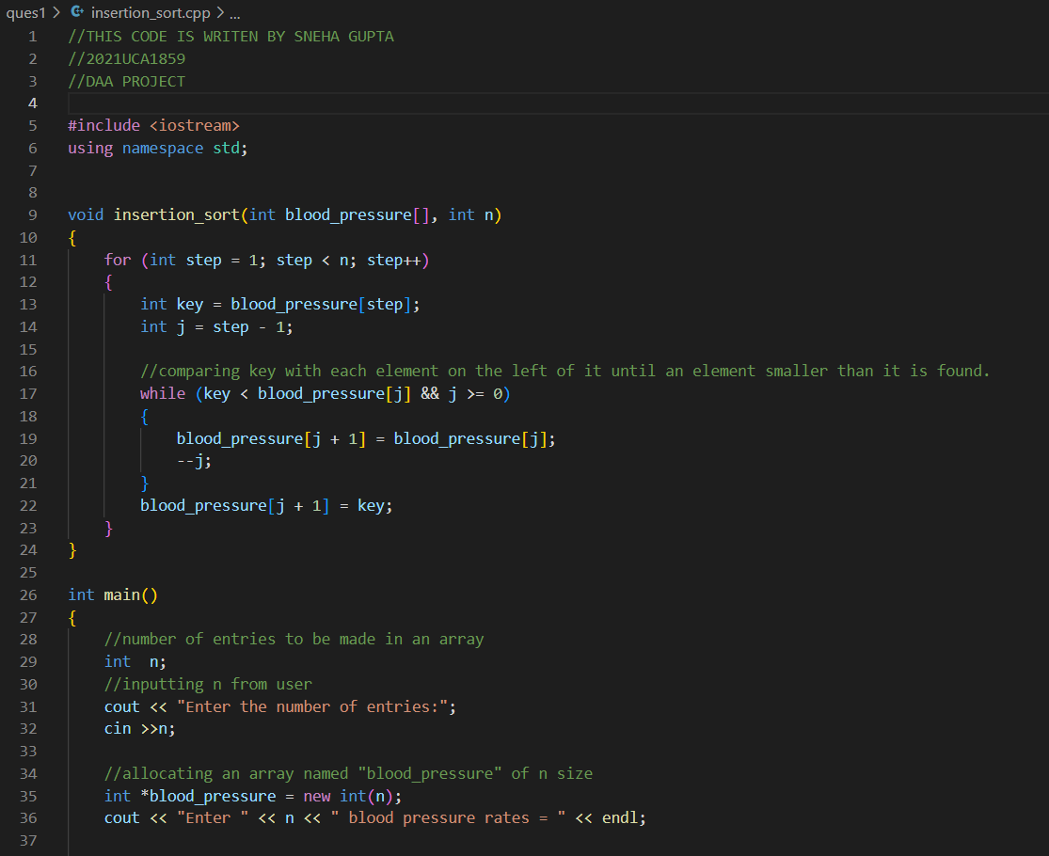

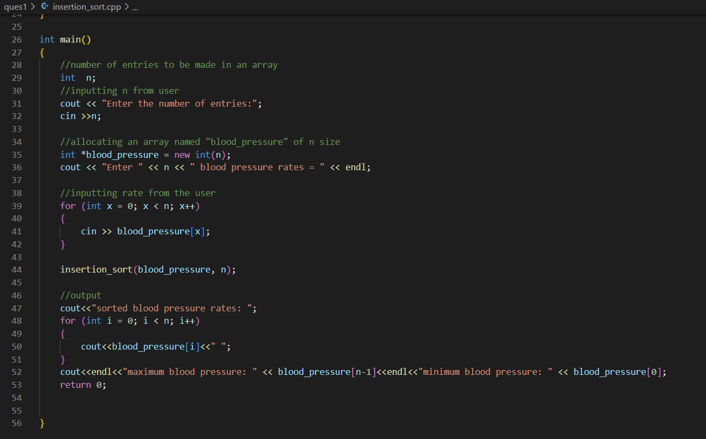

OUTPUT:

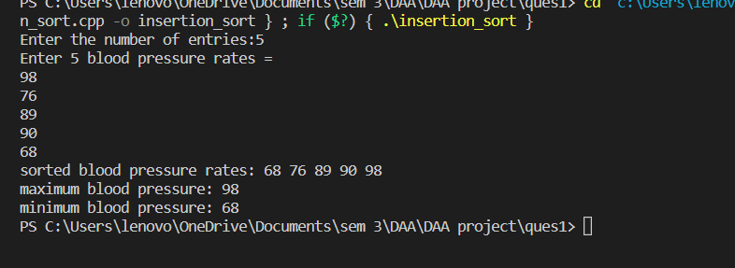

SELECTION SORT

OVERVIEW:

The selection sort algorithm sorts an array by repeatedly finding the minimum element (considering ascending order) from the unsorted part and putting it at the beginning.

The algorithm maintains two subarrays in a given array.

1. The subarray which already sorted.
2. The remaining subarray was unsorted.

In every iteration of the selection sort, the minimum element (considering ascending order) from the unsorted subarray is picked and moved to the sorted subarray.

ALGORITHM

selectionSort(array, size)

repeat (size - 1) times

set the first unsorted element as the minimum

for each of the unsorted elements

if element < currentMinimum

set element as new minimum

swap minimum with first unsorted position

end selectionSort

COMPLEXITY

Time Complexity: O(N^2)

Auxiliary Space: O(1)

CODE:

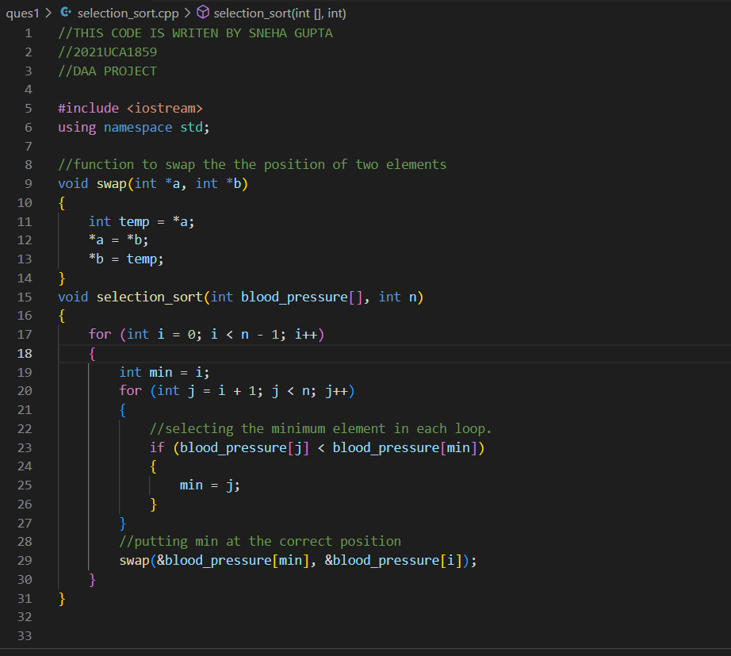

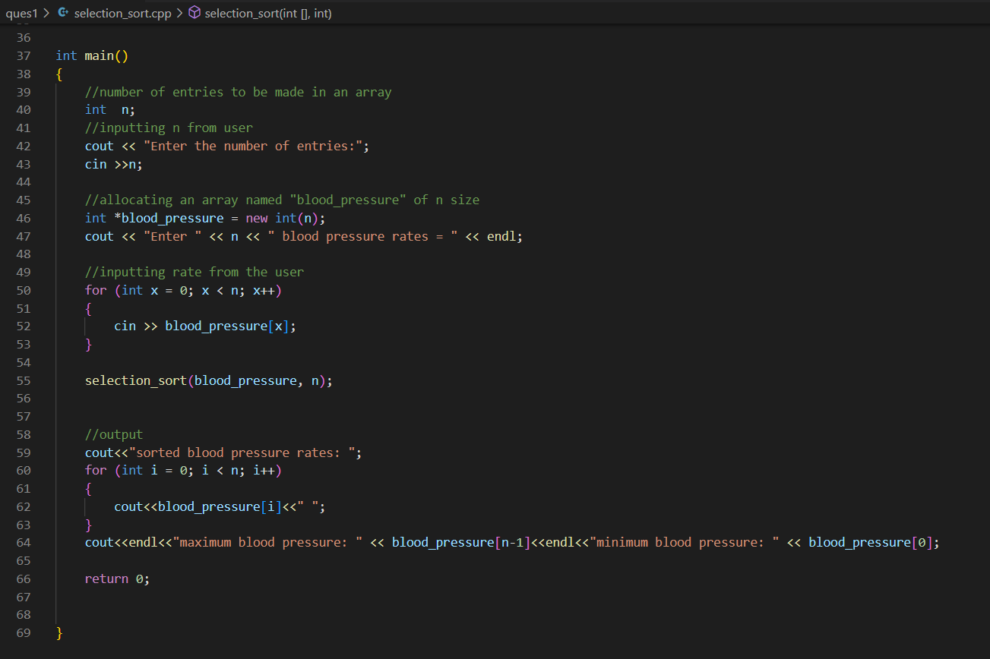

OUTPUT:

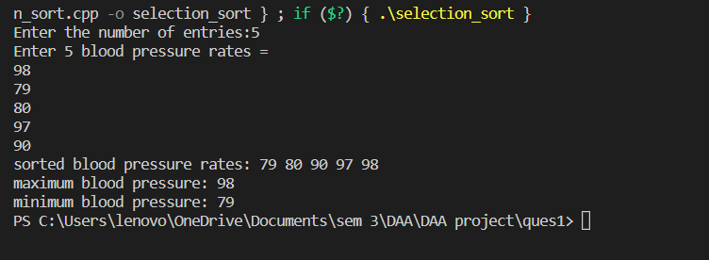

EXPERIMENT NUMBER: 02

Perform the following sorting algorithms-Radix sort, Count sort, Bucket sort, and Shell sort

OBJECTIVE:

A **sorting algorithm** is an algorithm made up of a series of instructions that takes an [array](https://brilliant.org/wiki/arrays/) as input, performs specified operations on the array, sometimes called a list, and outputs a sorted array. Sorting algorithms are often taught early in computer science classes as they provide a straightforward way to introduce other key computer science topics like [Big-O notation](https://brilliant.org/wiki/big-o-notation/), [divide-and-conquer](https://brilliant.org/wiki/divide-and-conquer/) methods, and data structures such as [binary trees](https://brilliant.org/wiki/binary-search-trees/), and [heaps](https://brilliant.org/wiki/binary-heap/). There are many factors to consider when [choosing a sorting algorithm](https://brilliant.org/wiki/sorting-algorithms/#choosing-a-sorting-algorithm) to use.

RADIX SORT

OVERVIEW:

Radix sort is an integer sorting algorithm that sorts data with integer keys by grouping the keys by individual digits that share the same significant position and value (place value). Radix sort uses counting sort as a subroutine to sort an array of numbers.

ALGORITHM

Basically, the radix sort is based on countsort.it applies count sort digit by digit.

First, we find the max among array elements.

then call count sort till max/pos>0 where position is initially=1 and incremented by 10 times.

make a count array having size 10 as unique. of digits are 0-9 or base is decimal. initialize all elements with 0.

Update count array with frequency of unit digit count i.e., count[arr[i]/pos)%10]++.finally update count[i]=count[i]+count[i-1].

Make output array having size same as input array and fill this output[--count[(arr[i]/pos)%10]]=arr[i]

copy contents of output array in input array.

Now apply count sort again on tens digit taking new array as input array

COMPLEXITY

Time Complexity: O(N)

Auxiliary Space: O(n+2^d)

CODE:

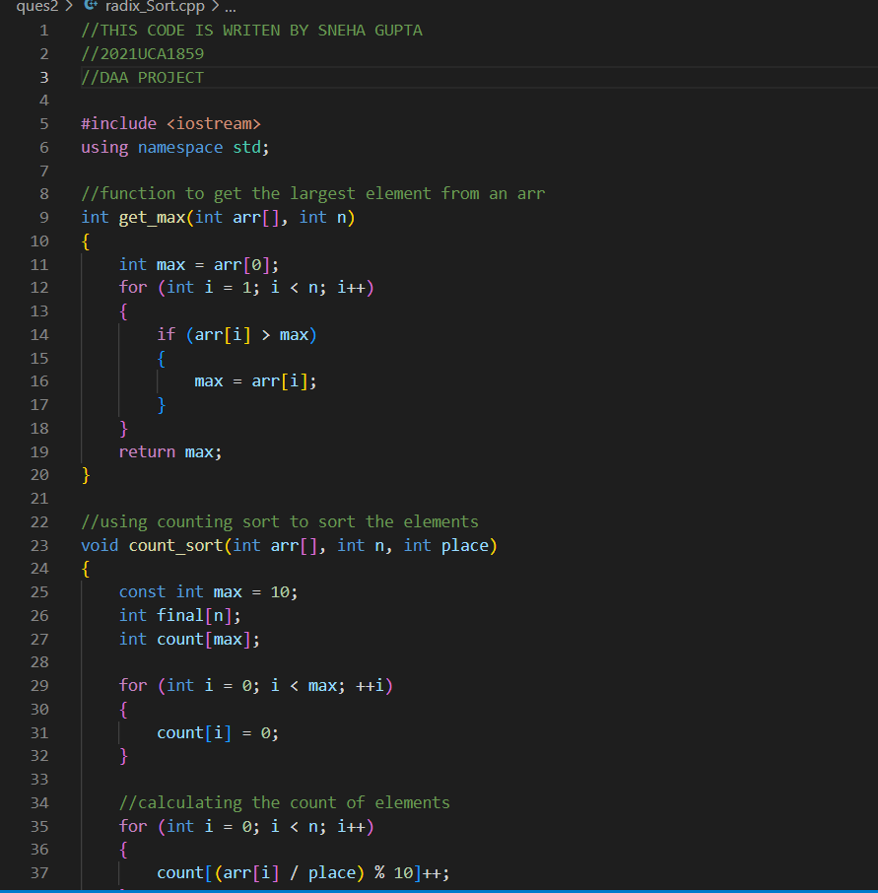

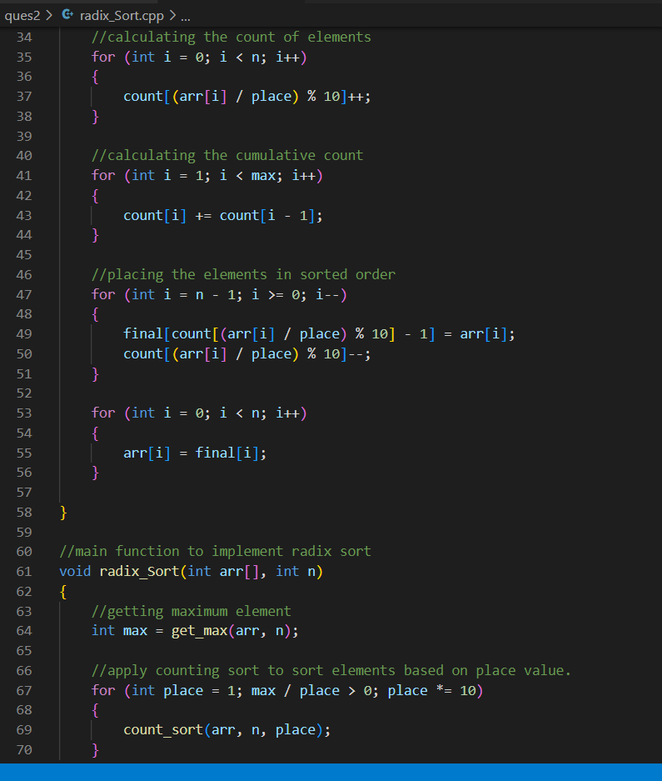

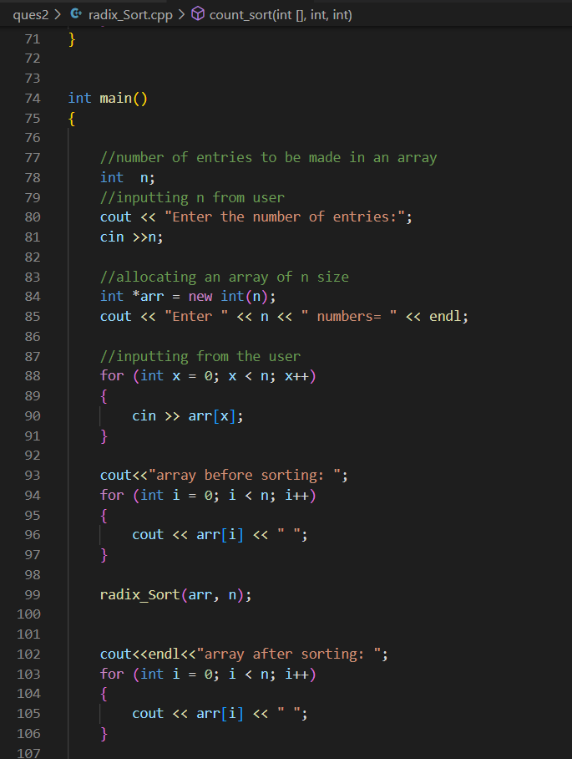

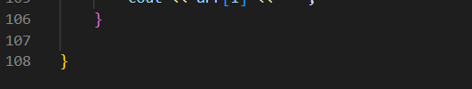

OUTPUT:

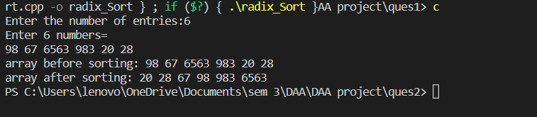

COUNTING SORT

OVERVIEW:

The objective behind counting sort is to determine the number of elements that are fewer than x for each input element x. This information is used to place element x in the right location in the output array. If five elements are less than x, then x must be assigned to the sixth place in the output array.

ALGORITHM

countingSort(array, size)

max <- find largest element in array

initialize count array with all zeros

for j <- 0 to size

find the total count of each unique element and

store the count at jth index in count array

for i <- 1 to max

find the cumulative sum and store it in count array itself

for j <- size down to 1

restore the elements to array

decrease count of each element restored by 1

COMPLEXITY

Time Complexity: O(N)

Auxiliary Space: O(N)

CODE:

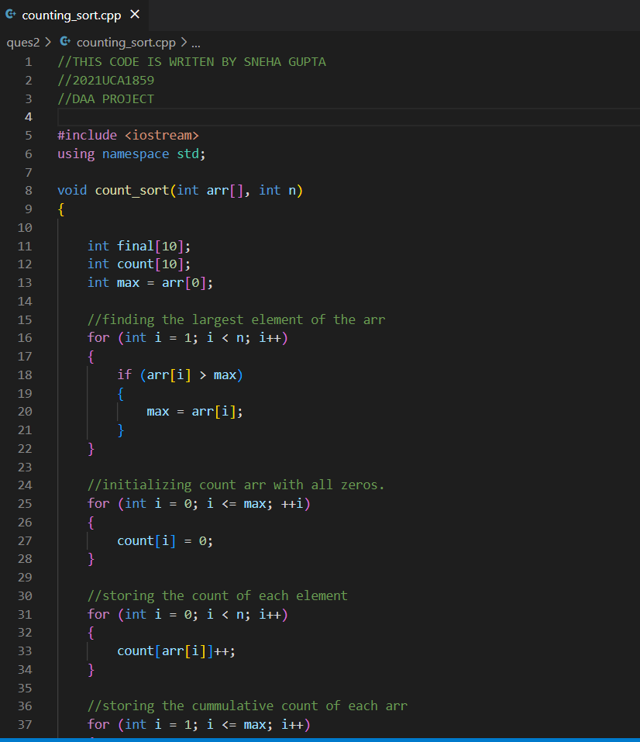

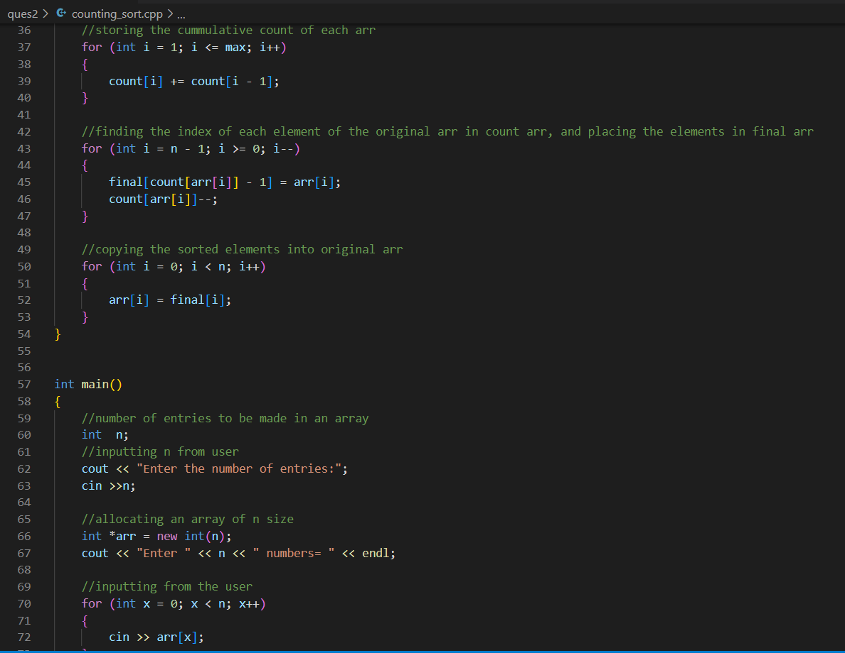

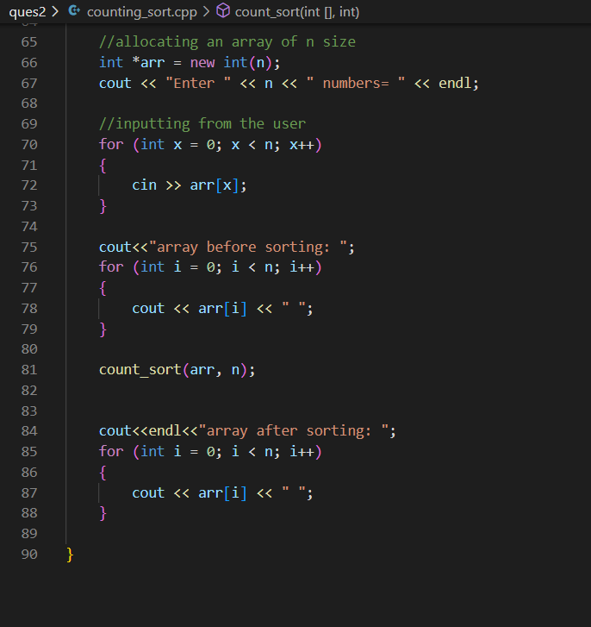

OUTPUT: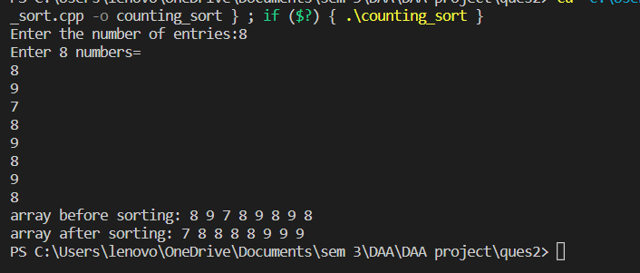

BUCKET SORT

OVERVIEW:

The working principle of bucket sort is to divide the given series of numbers into several buckets, sort the data in each bucket according to the requirement, and then merge the data again that outputs an array of sorted elements.

ALGORITHM

bucketSort()

create N buckets each of which can hold a range of values

for all the buckets

initialize each bucket with 0 values

for all the buckets

put elements into buckets matching the range

for all the buckets

sort elements in each bucket

gather elements from each bucket

end bucketSort

COMPLEXITY

Time Complexity: O(N^2)

Auxiliary Space: O(N+k)

CODE:

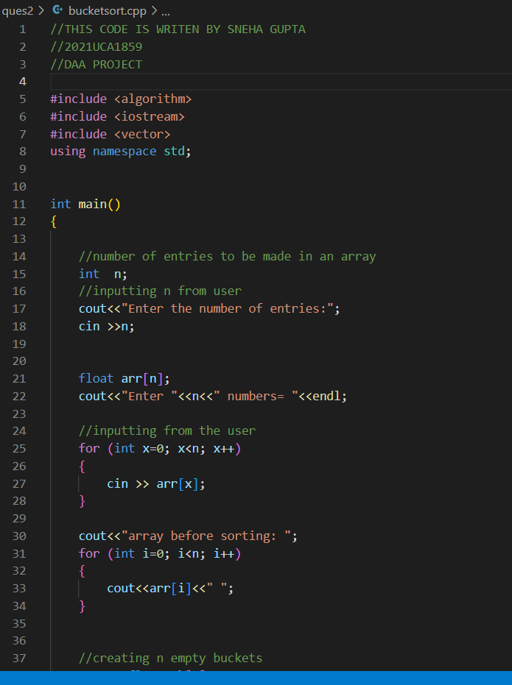

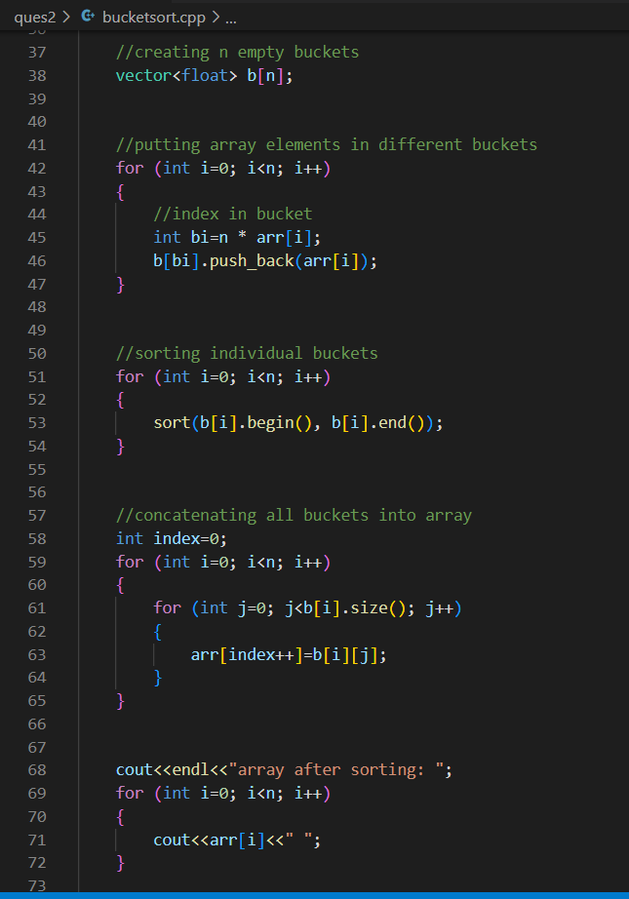

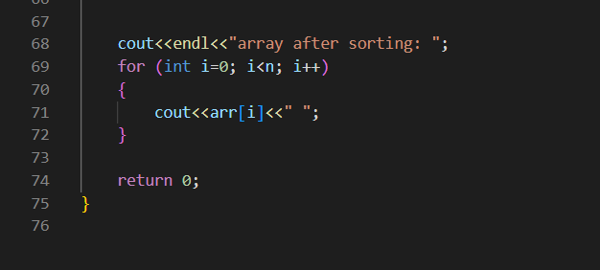

OUTPUT:

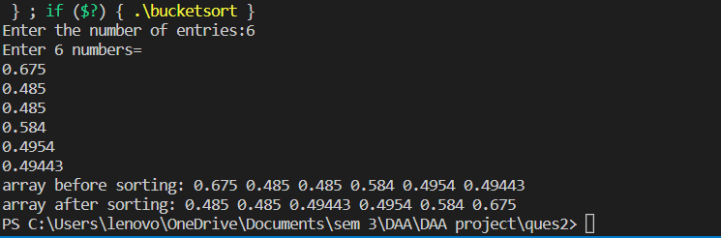

SHELL SORT

OVERVIEW:

Shell sort is a highly efficient sorting algorithm and is based on insertion sort algorithm. This algorithm avoids large shifts as in case of insertion sort, if the smaller value is to the far right and has to be moved to the far left.

ALGORITHM

shellSort(array, size)

for interval i <- size/2n down to 1

for each interval "i" in array

sort all the elements at interval "i"

end shellSort

COMPLEXITY

Time Complexity: O(N^2)

Auxiliary Space: O(1)

CODE:

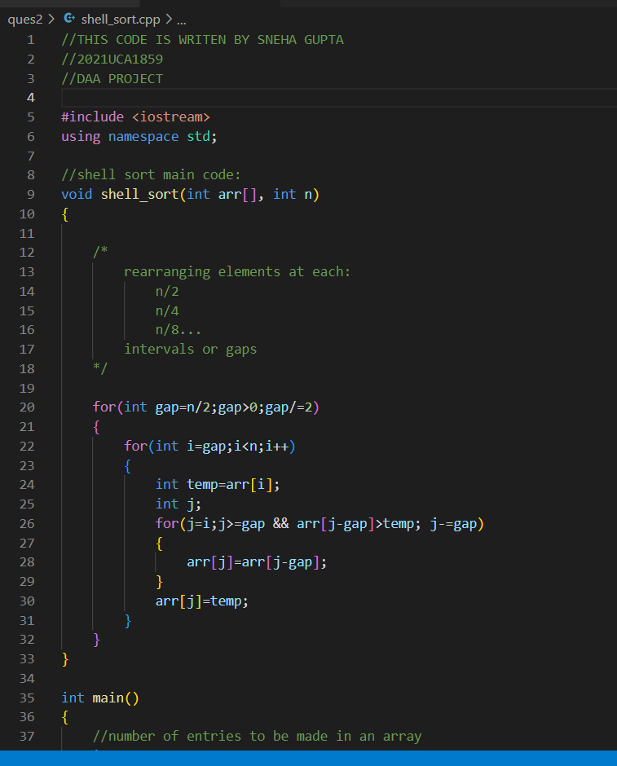

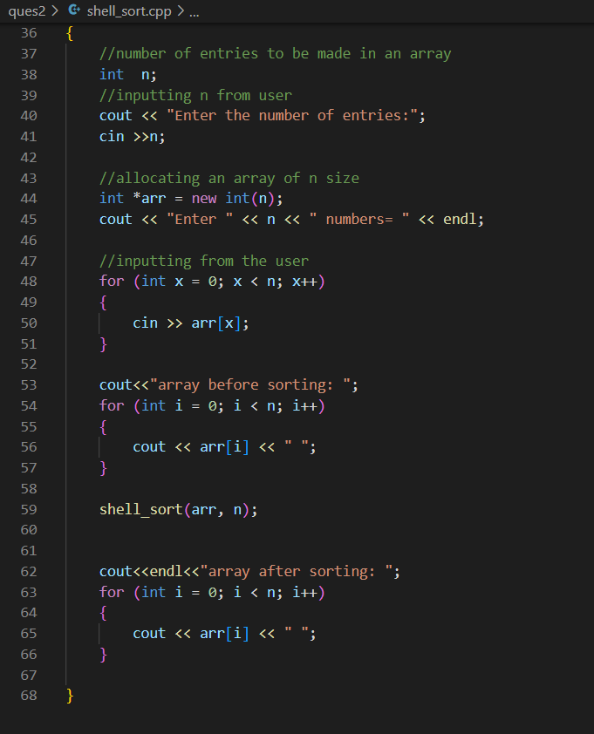

OUTPUT:

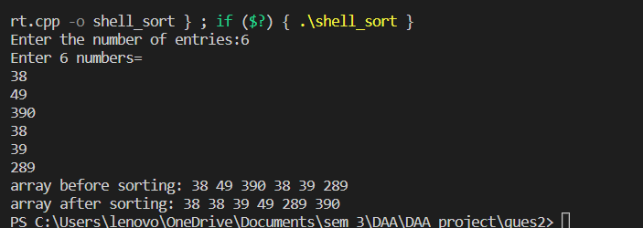

EXPERIMENT NUMBER: 03

Perform searching algorithm-Linear and Binary search.

OBJECTIVE:

Searching Algorithms are designed to check for an element or retrieve an element from any data structure where it is stored.

LINEAR SEARCH ALGORITHM

OVERVIEW:

Linear Search is defined as a sequential search algorithm that starts at one end and goes through each element of a list until the desired element is found, otherwise the search continues till the end of the data set. It is the easiest searching algorithm

ALGORITHM

LinearSearch(array, key)

for each item in the array

if item == value

return its index

COMPLEXITY

Time Complexity: O(N)

Auxiliary Space: O(1)

CODE:

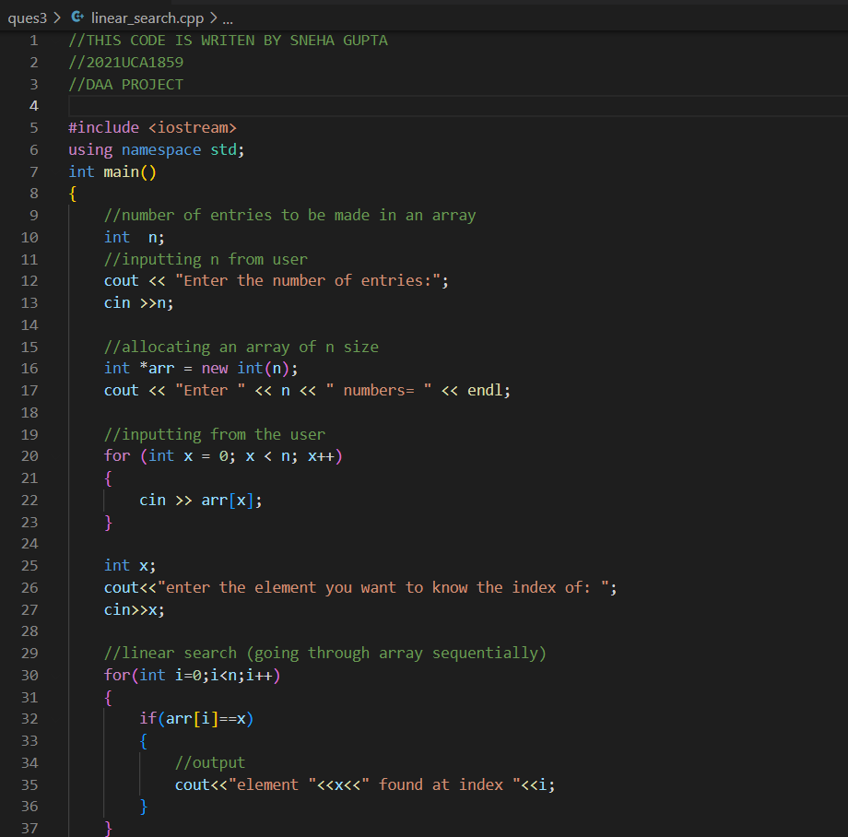

OUTPUT:

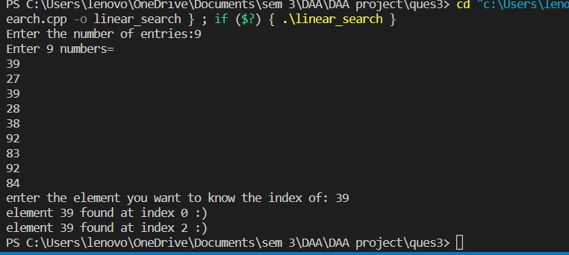

BINARY SEARCH ALGORITHM

OVERVIEW:

Binary Search is a searching algorithm for finding an element's position in a sorted array.

In this approach, the element is always searched in the middle of a portion of an array.

Binary search can be implemented only on a sorted list of items. If the elements are not sorted already, we need to sort them first.

ALGORITHM

binarySearch(arr, x, low, high)

if low > high

return False

else

mid = (low + high) / 2

if x == arr[mid]

return mid

else if x > arr[mid] // x is on the right side

return binarySearch(arr, x, mid + 1, high)

else // x is on the right side

return binarySearch(arr, x, low, mid - 1)

COMPLEXITY

Time Complexity: O(n logn)

Auxiliary Space: O(n logn)

CODE:

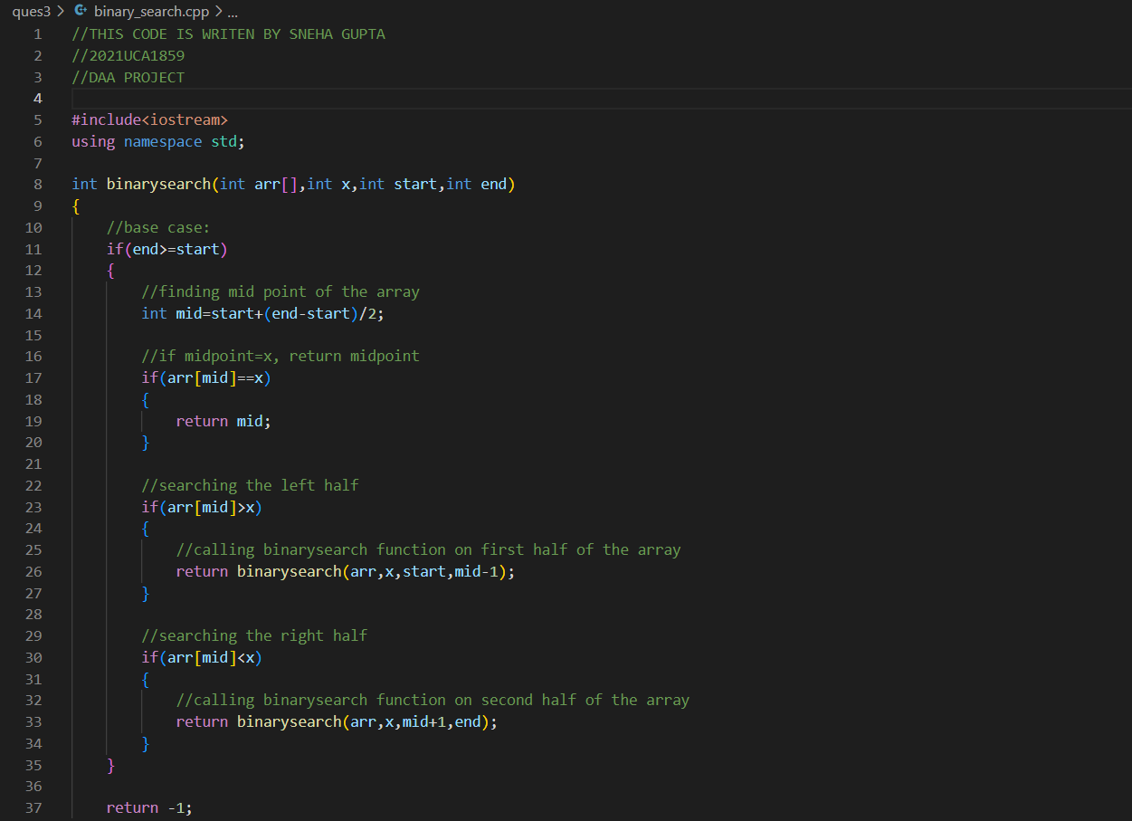

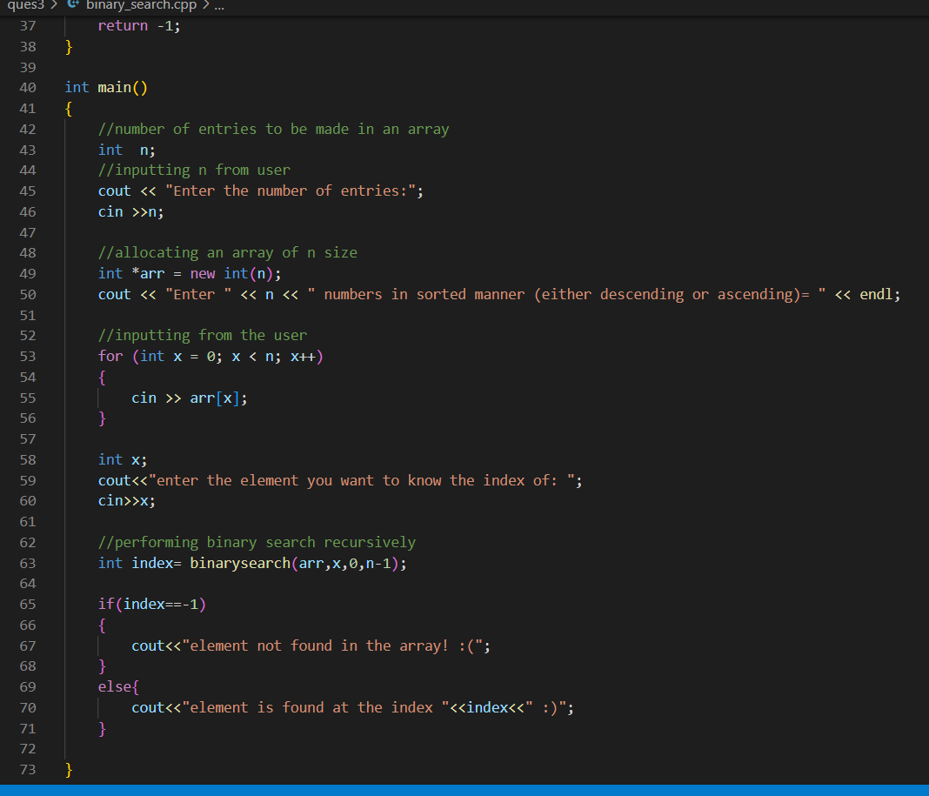

OUTPUT:

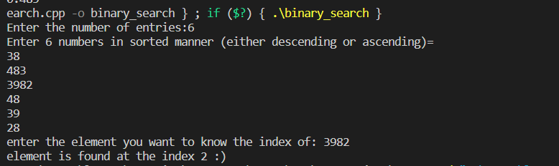

EXPERIMENT NUMBER: 04

Perform tower of Hanoi.

OBJECTIVE:

The objective of the game is to shift the entire stack of disks from one rod to another rod following these three rules : Only one disk can be moved at a time. Only the uppermost disk from one stack can be moved on to the top of another stack or an empty rod. Larger disks cannot be placed on the top of smaller disks

ALGORITHM:

* Create a function towerOfHanoi where pass the N (current number of disk), from_rod, to_rod, aux_rod.
* Make a function call for N – 1 th disk.
* Then print the current the disk along with from_rod and to_rod
* Again make a function call for N – 1 th disk.

COMPLEXITY

Time Complexity: O(2^n)

Auxiliary Space: O(n)

CODE:

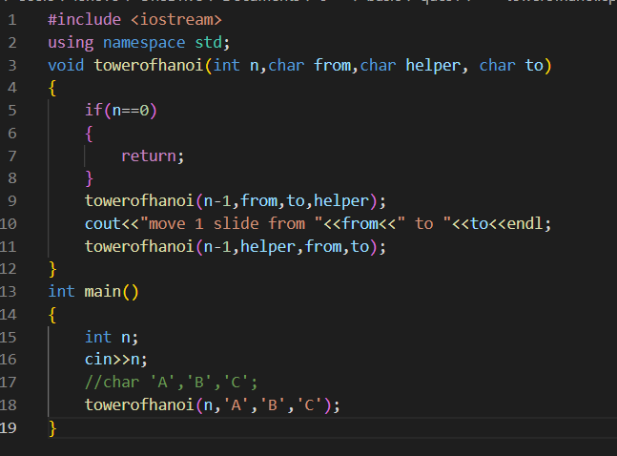

OUTPUT:

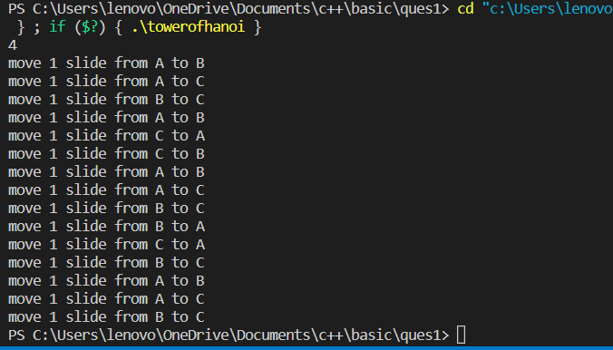

EXPERIMENT NUMBER: 05

Write a program for inserting elements in:

1. AVL tree
2. Red-Black Tree
3. BS

AVL TREE INSERTION ALGORITHM

OVERVIEW:

AVL tree is a self-balancing Binary Search Tree (BST) where the difference between heights of left and right subtrees cannot be more than one for all nodes.

ALGORITHM

* Perform the normal BST insertion.
* The current node must be one of the ancestors of the newly inserted node. Update the height of the current node.
* Get the balance factor (left subtree height – right subtree height) of the current node.
* If the balance factor is greater than 1, then the current node is unbalanced and we are either in the Left Left case or left Right case. To check whether it is left left case or not, compare the newly inserted key with the key in the left subtree root.
* If the balance factor is less than -1, then the current node is unbalanced and we are either in the Right Right case or Right-Left case. To check whether it is the Right Right case or not, compare the newly inserted key with the key in the right subtree root.

COMPLEXITY

Time Complexity: O(n*log(n))

Auxiliary Space: O(1)

­­­­

CODE:

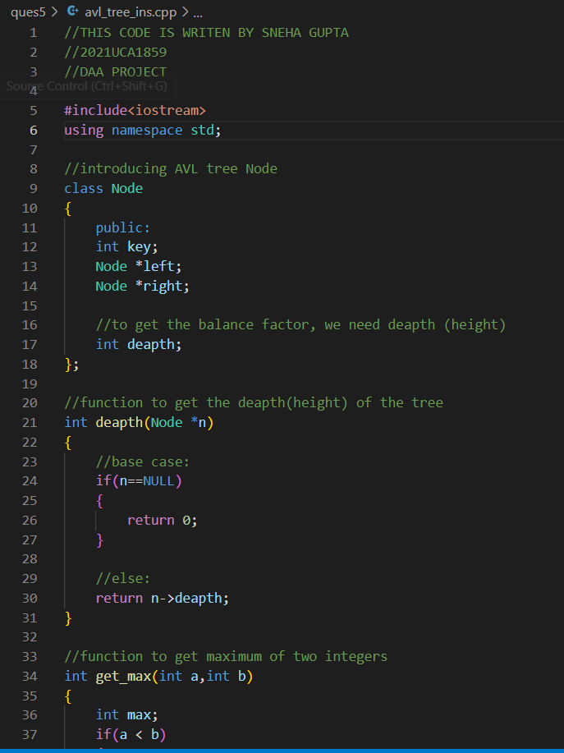

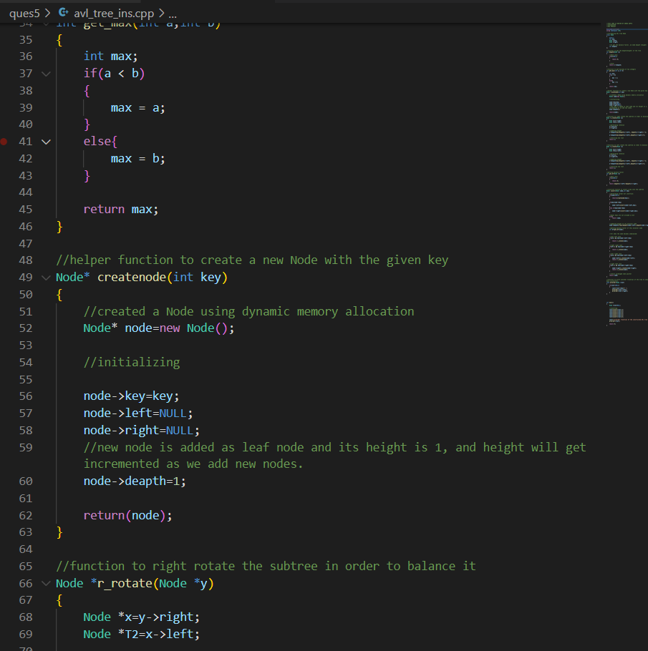

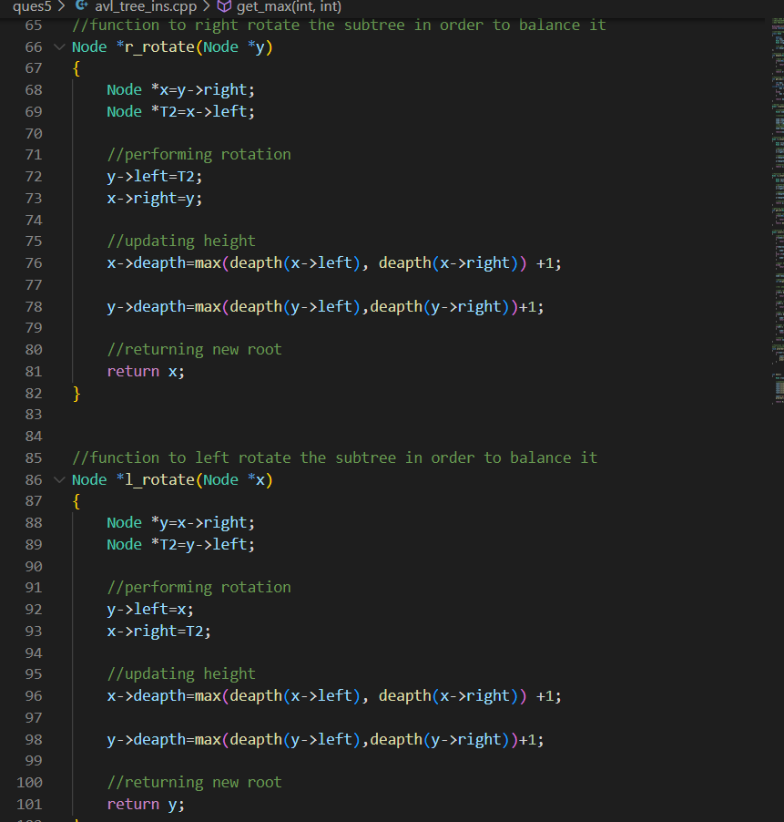

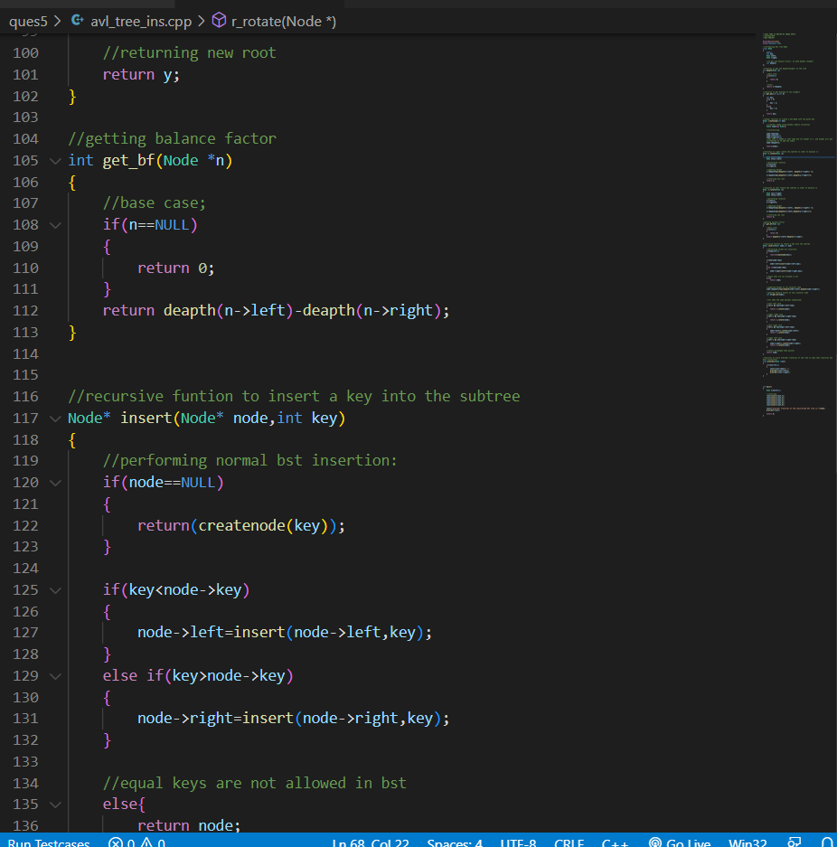

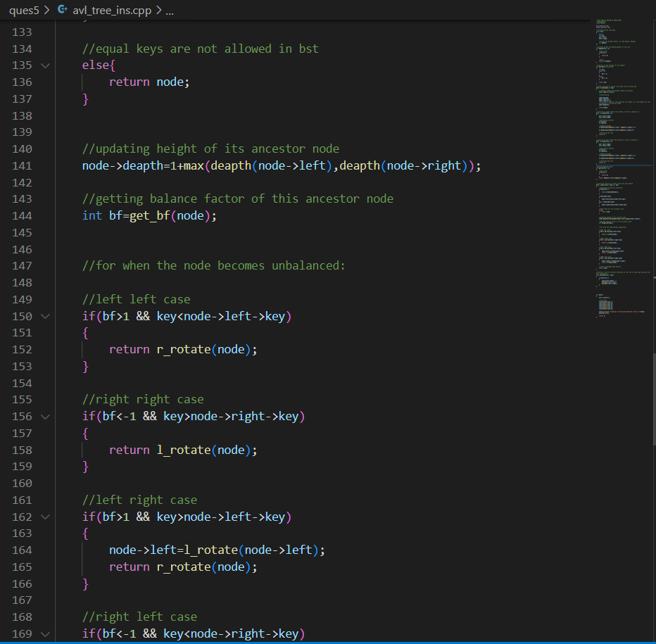

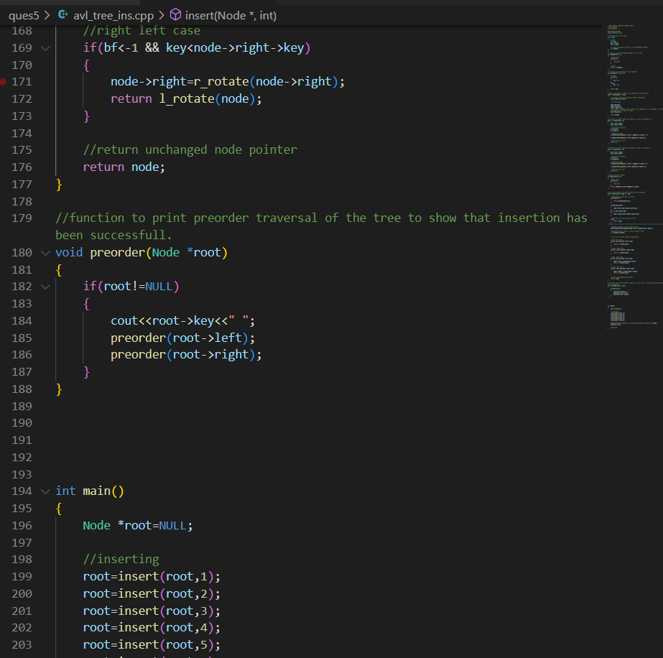

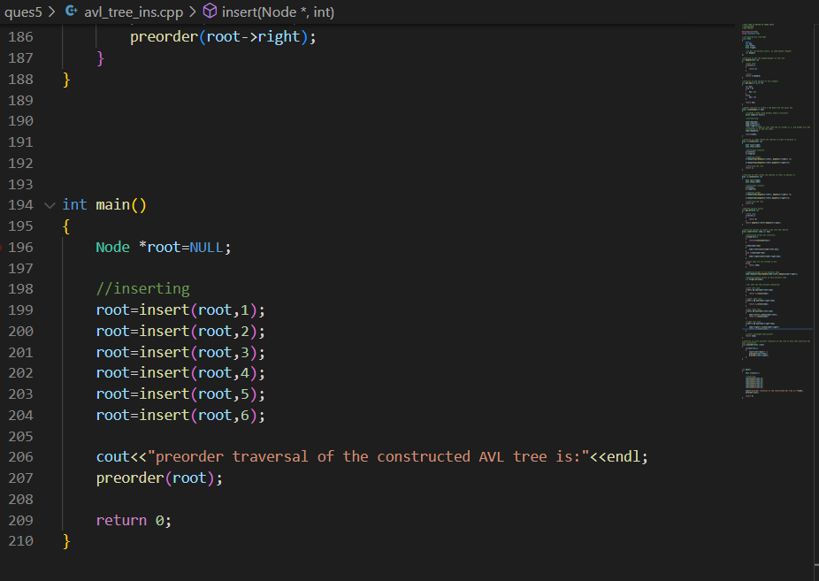

OUTPUT:

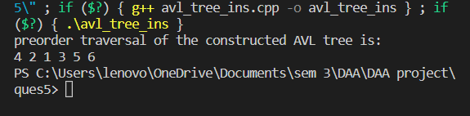

RED BLACK TREE INSERTION ALGORITHM

OVERVIEW:

Red-Black tree is a self-balancing binary search tree in which each node contains an extra bit for denoting the color of the node, either red or black.

ALGORITHM

**Let x be the newly inserted node.**

1. Perform standard BST insertion and make the colour of newly inserted nodes as RED.
2. If x is the root, change the colour of x as BLACK (Black height of complete tree increases by 1).
3. Do the following if the color of x’s parent is not BLACK and x is not the root.
   1. If x’s uncle is RED (Grandparent must have been black from property 4)
      1. Change the colour of parent and uncle as BLACK.
      2. Colour of a grandparent as RED.
      3. Change x = x’s grandparent, repeat steps 2 and 3 for new x.
   2. If x’s uncle is BLACK, then there can be four configurations for x, x’s parent (p) and x’s grandparent (g) (This is similar to AVL Tree)
      1. Left Left Case (p is left child of g and x is left child of p)
      2. Left Right Case (p is left child of g and x is the right child of p)
      3. Right Right Case (Mirror of case i)
      4. Right Left Case (Mirror of case ii)

**Re-coloring after rotations:**

* For Left Left Case and Right Right case, swap colors of grandparent and parent after rotations
* For Left Right Case and Right Left Case, swap colors of grandparent and inserted node after rotations

COMPLEXITY

Time Complexity: O(log(n))

Auxiliary Space: O(n)

CODE:

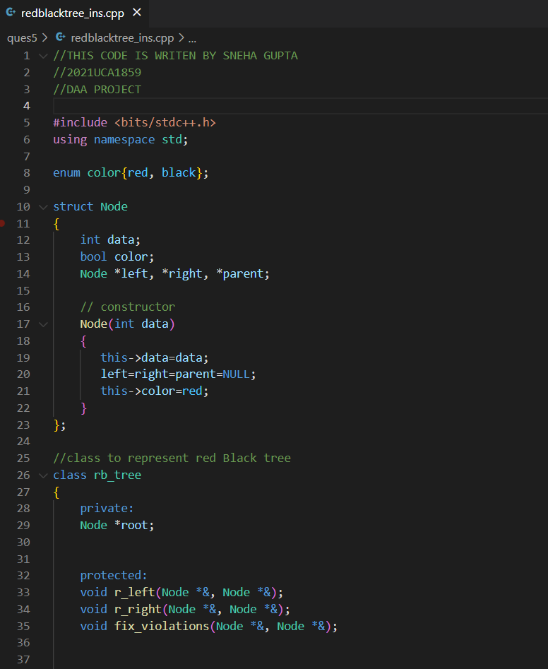

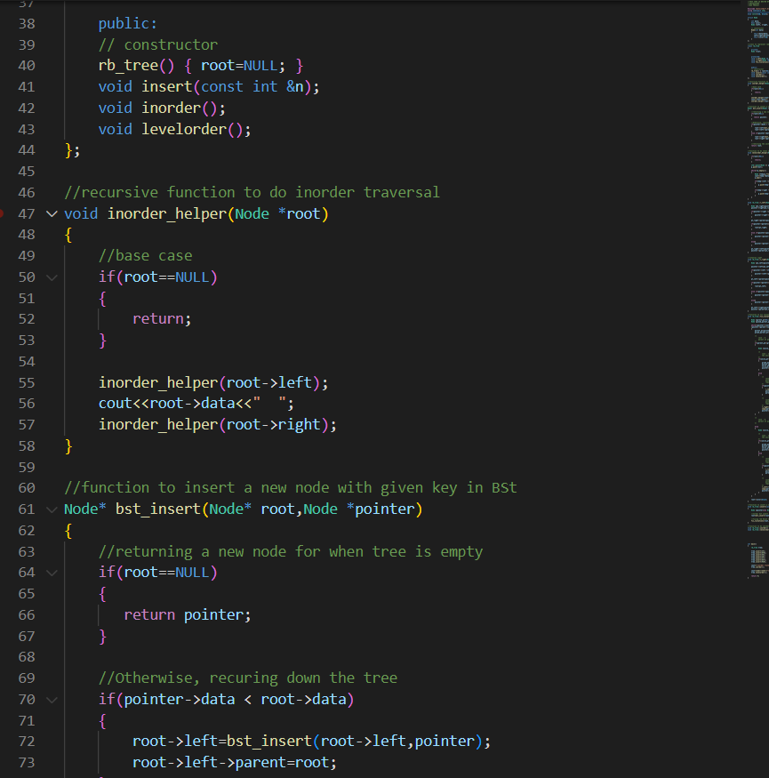

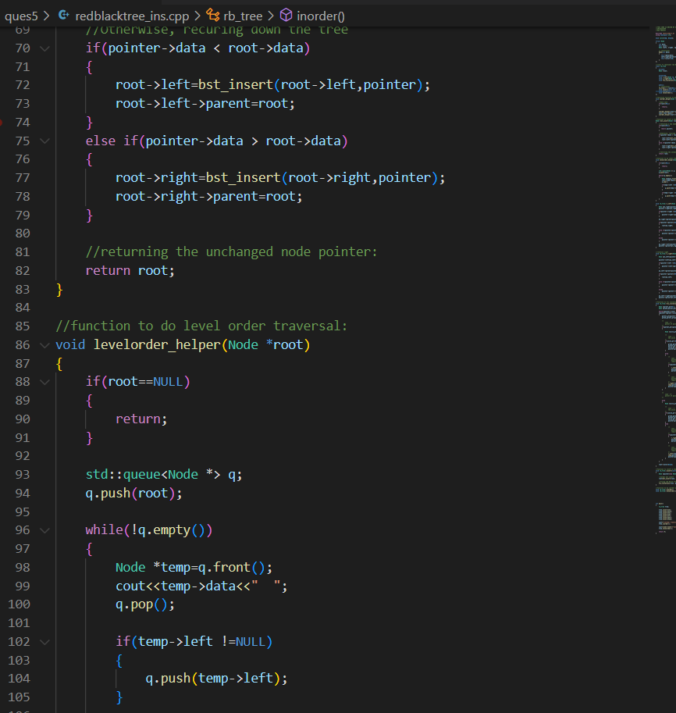

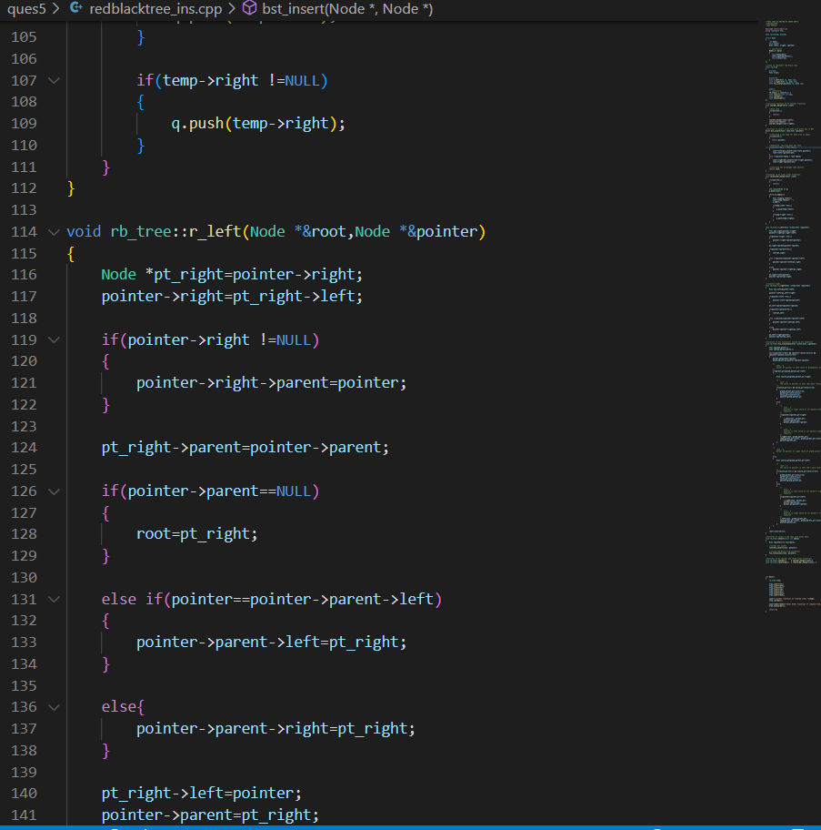

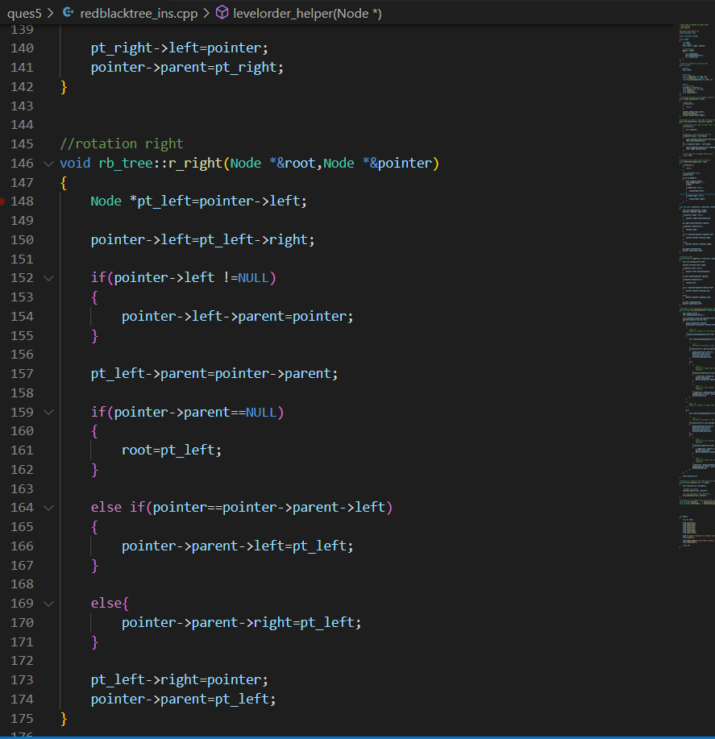

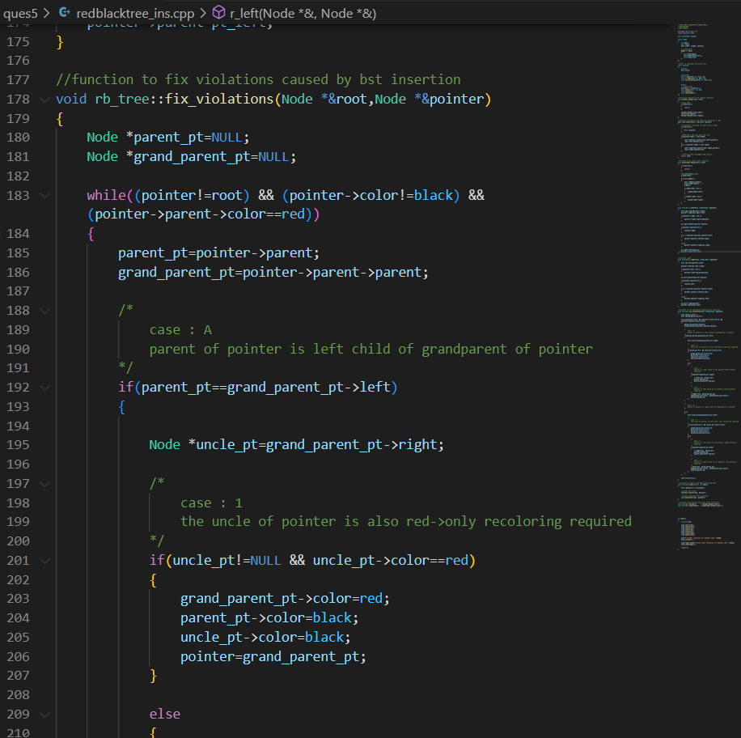

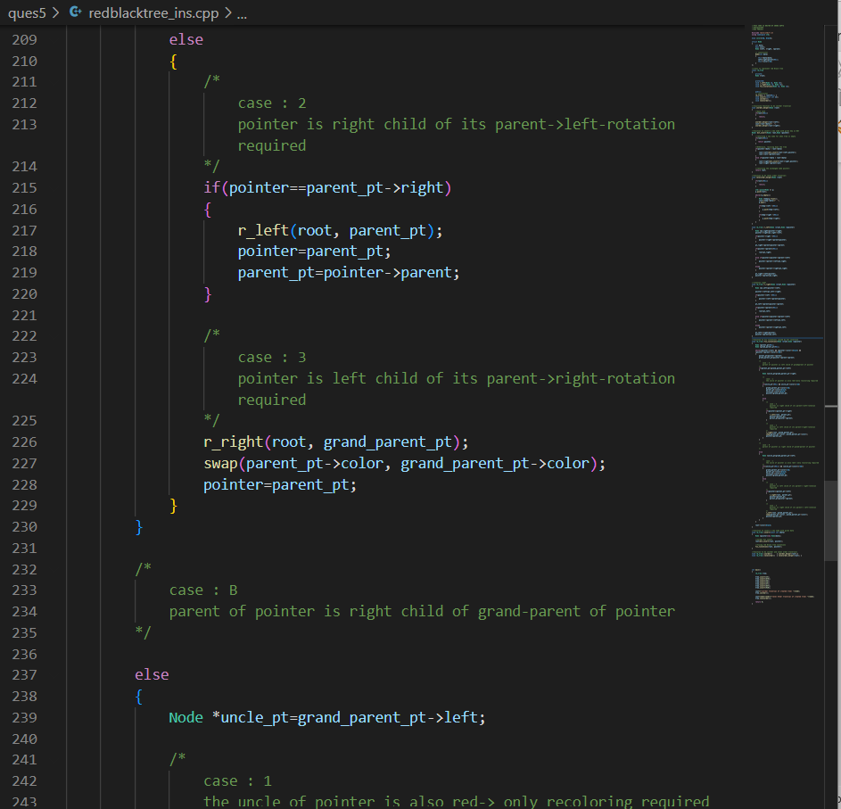

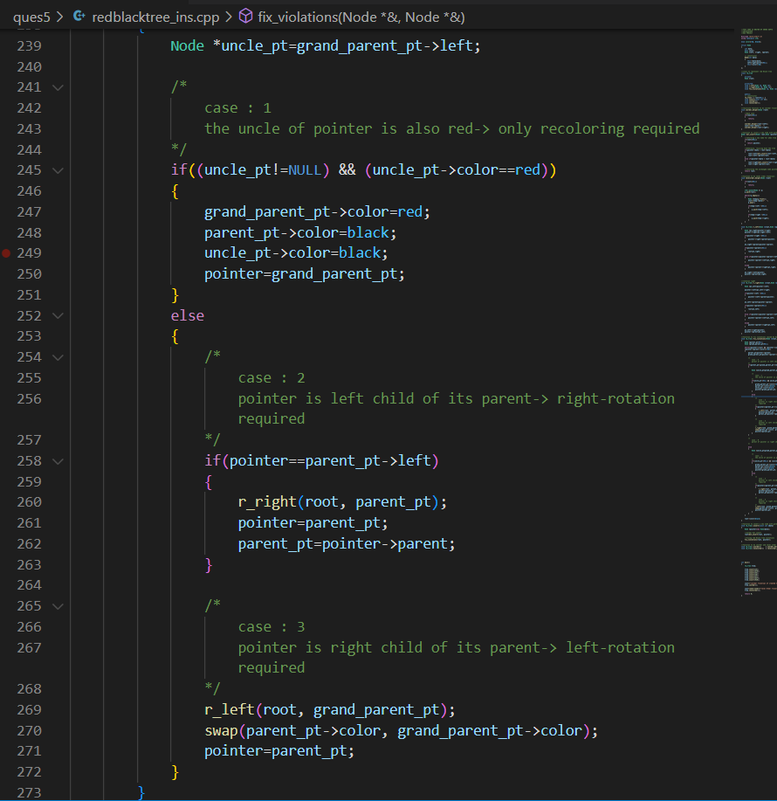

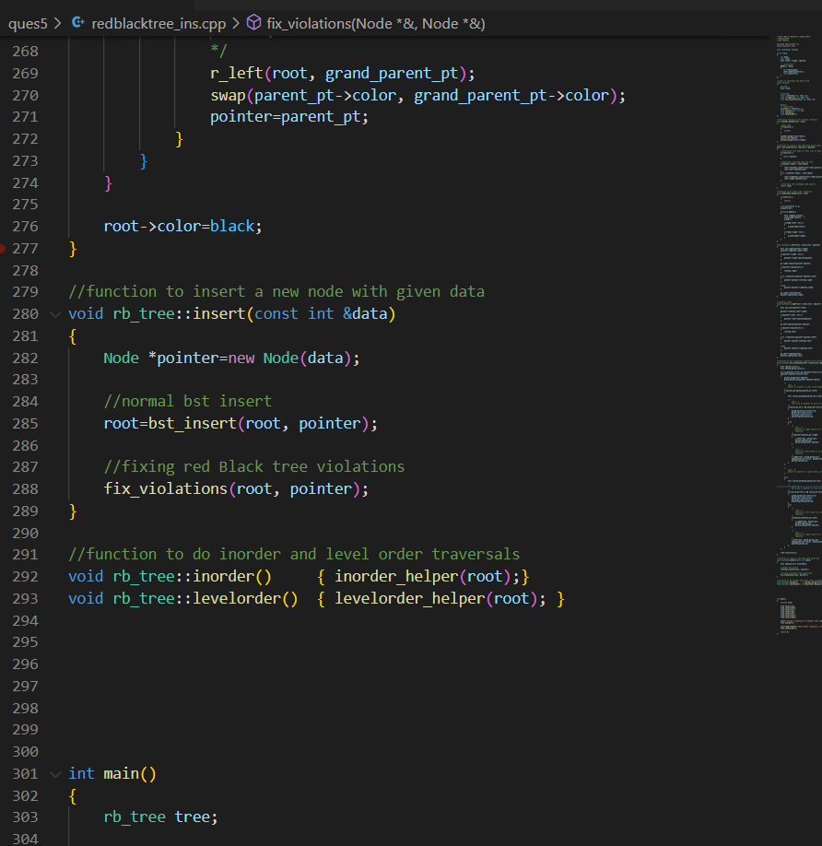

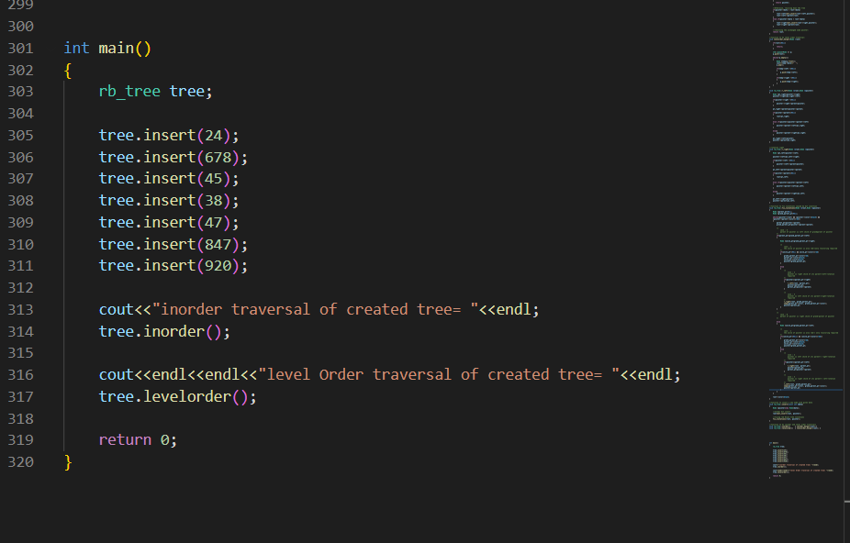

OUTPUT:

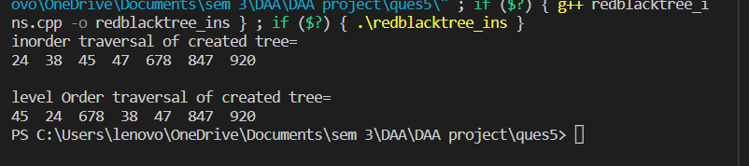

BINARY SEARCH TREE INSERTION ALGORITHM

OVERVIEW:

Binary search tree is a data structure that quickly allows us to maintain a sorted list of numbers.

* It is called a binary tree because each tree node has a maximum of two children.
* It is called a search tree because it can be used to search for the presence of a number in O(log(n)) time.

ALGORITHM

1. Create a new BST node and assign value.
2. insert (node, key)
   1. If root == NULL, return the new node.
   2. if root=>data < key call the insert function for root=>right and root->right = insert(root=>right, key)
   3. if root=>data > key call the insert function with root->left and root=>left = insert(root=>left, key)
3. Finally, return the root.

COMPLEXITY

Time Complexity: O(n)

Auxiliary Space: O(n)

CODE:

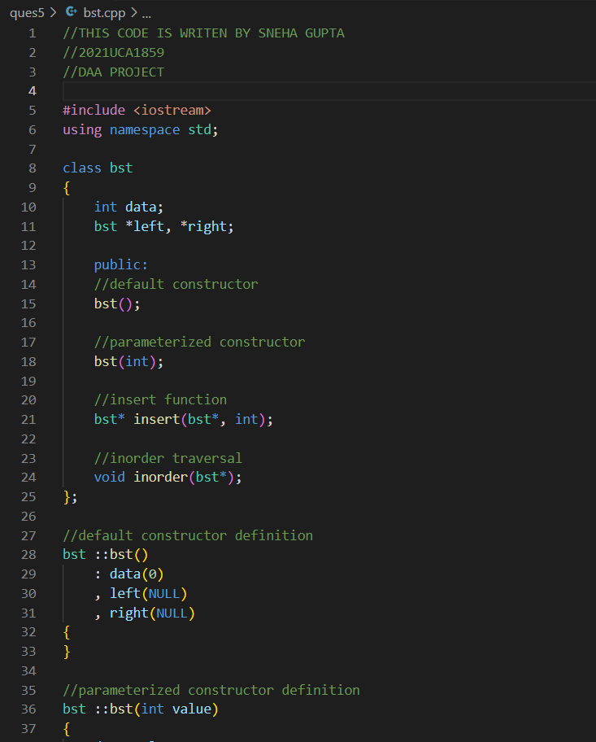

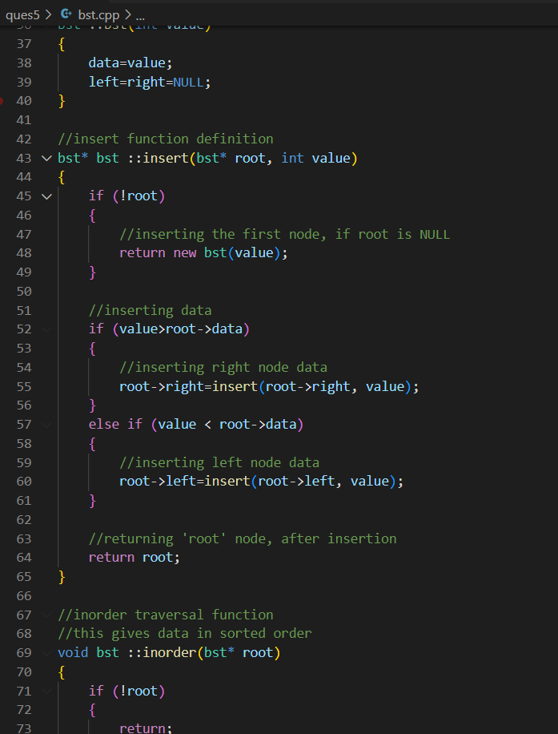

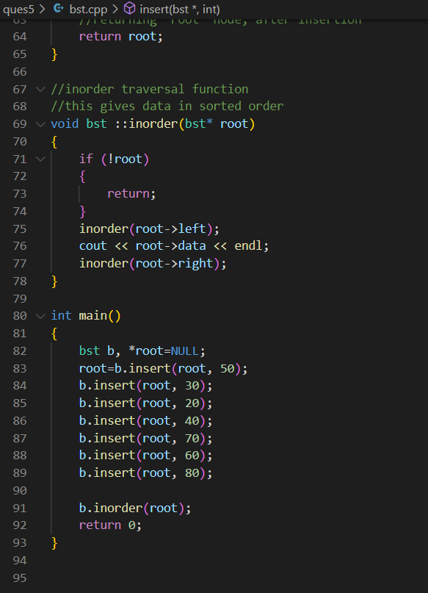

OUTPUT:

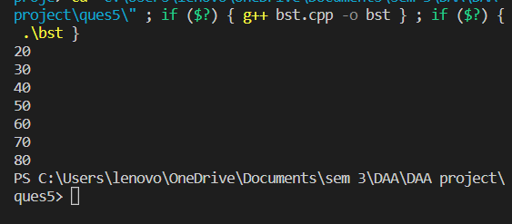

EXPERIMENT NUMBER: 06

Write a program for deleting elements in:

1. AVL tree
2. Red-Black Tree
3. BST

AVL TREE DELETION

OBJECTIVE:

AVL tree is a self-balancing Binary Search Tree (BST) where the difference between heights of left and right subtrees cannot be more than one for all nodes.

ALGORITHM

* Perform the normal BST deletion.
* The current node must be one of the ancestors of the deleted node. Update the height of the current node.
* Get the balance factor (left subtree height – right subtree height) of the current node.
* If balance factor is greater than 1, then the current node is unbalanced and we are either in Left Left case or Left Right case. To check whether it is Left Left case or Left Right case, get the balance factor of left subtree. If balance factor of the left subtree is greater than or equal to 0, then it is Left Left case, else Left Right case.
* If balance factor is less than -1, then the current node is unbalanced and we are either in Right Right case or Right Left case. To check whether it is Right Right case or Right Left case, get the balance factor of right subtree. If the balance factor of the right subtree is smaller than or equal to 0, then it is Right Right case, else Right Left case.

COMPLEXITY

Time Complexity: O(logn)

Auxiliary Space: O(n)

CODE:

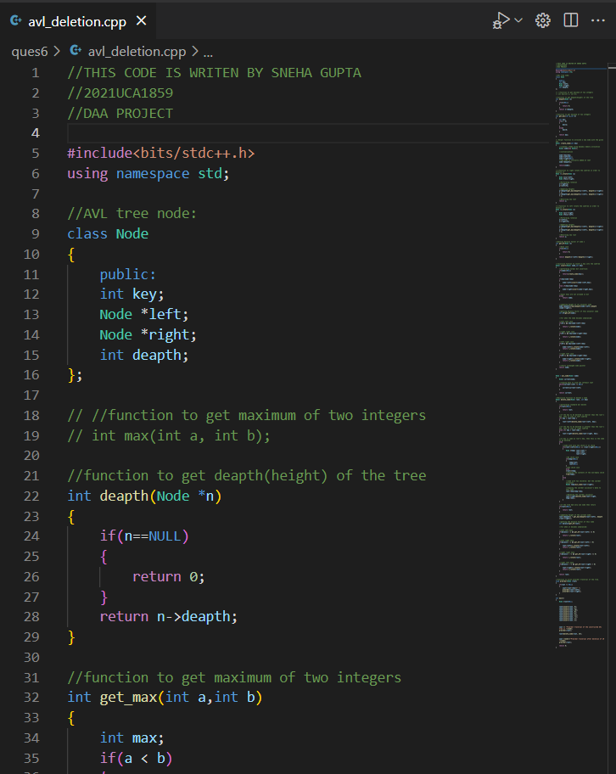

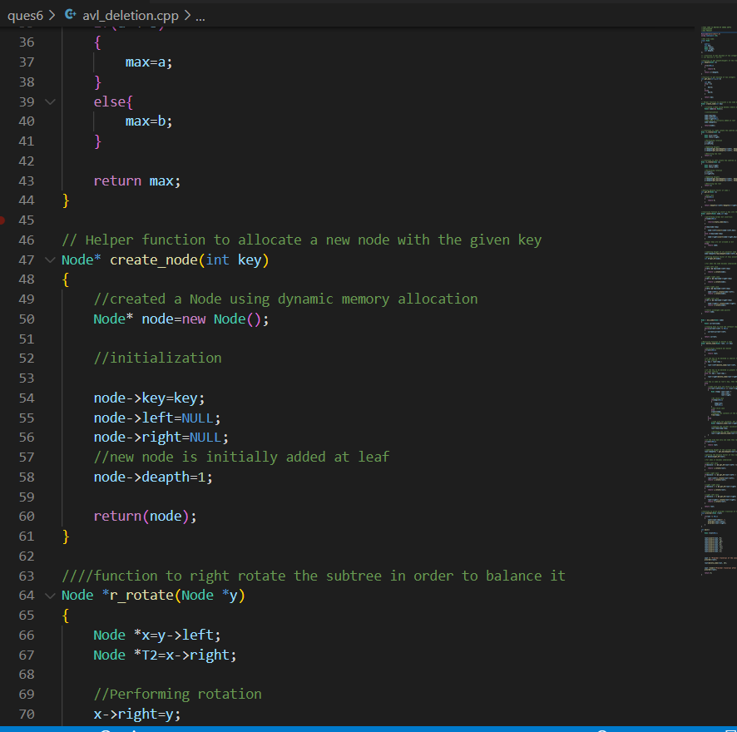

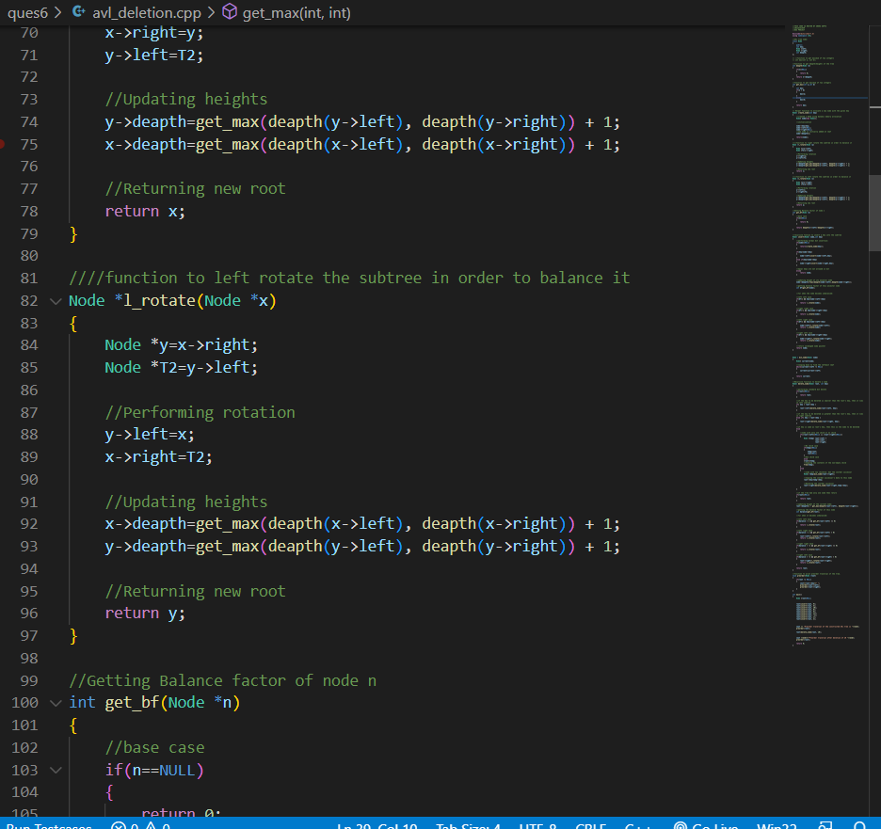

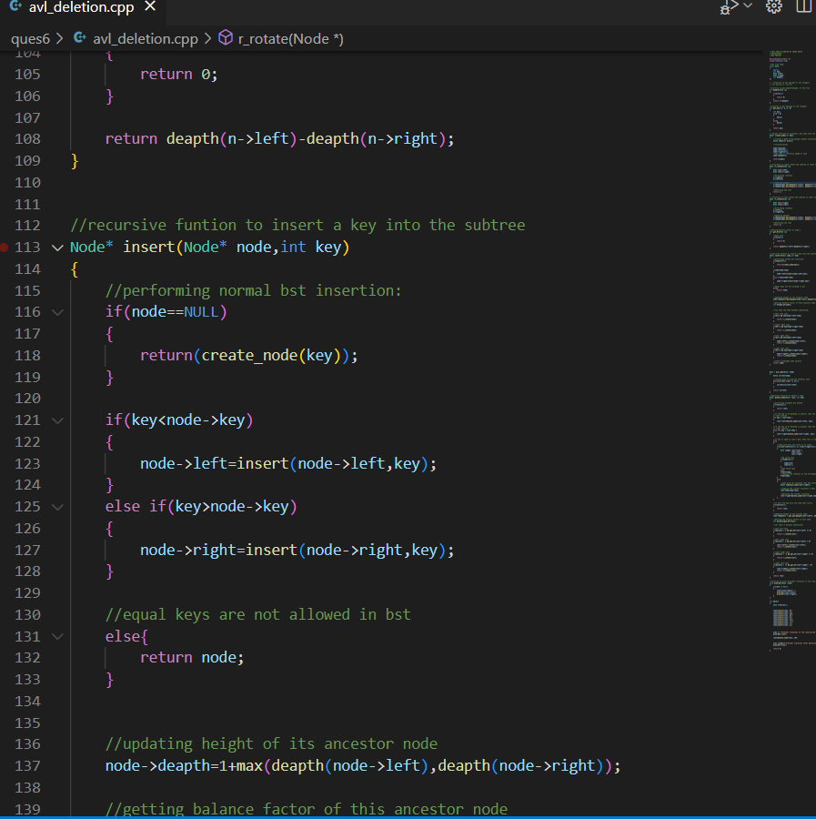

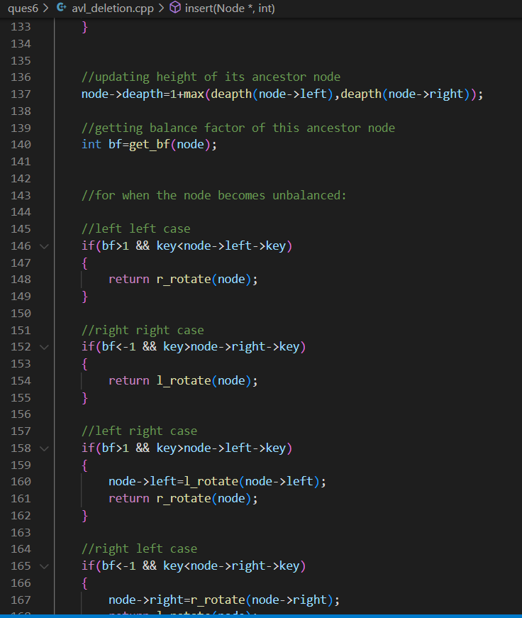

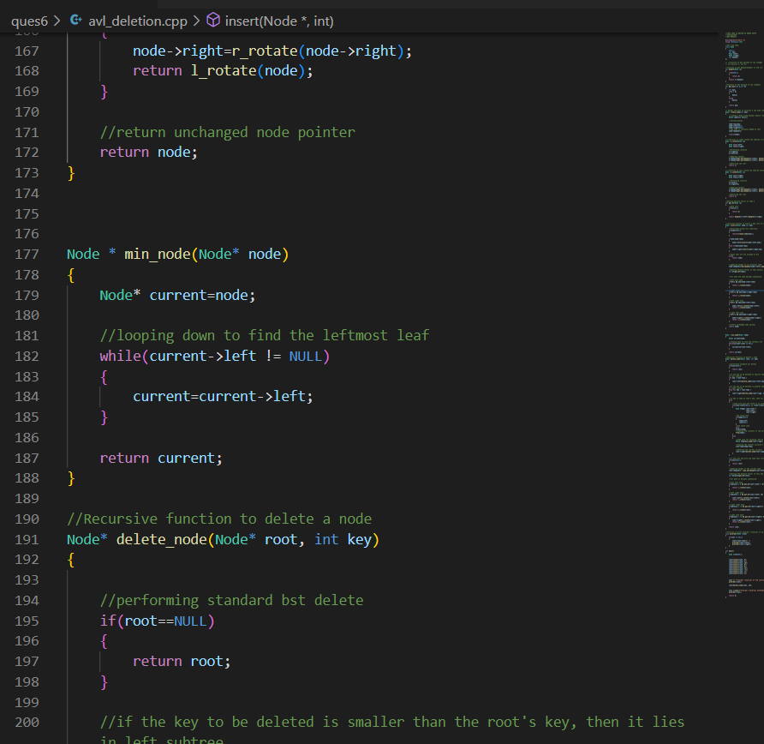

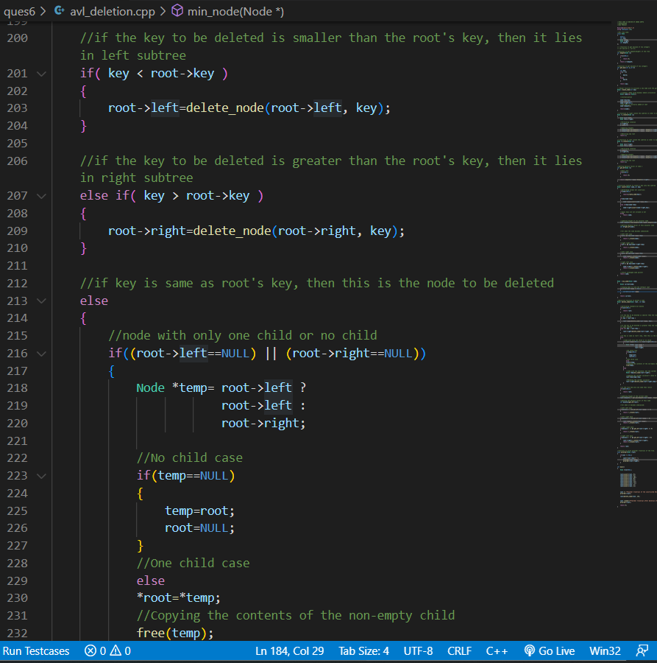

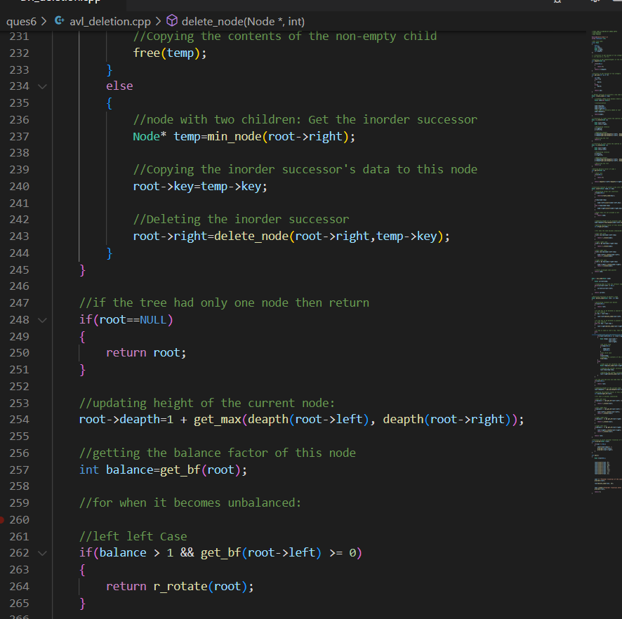

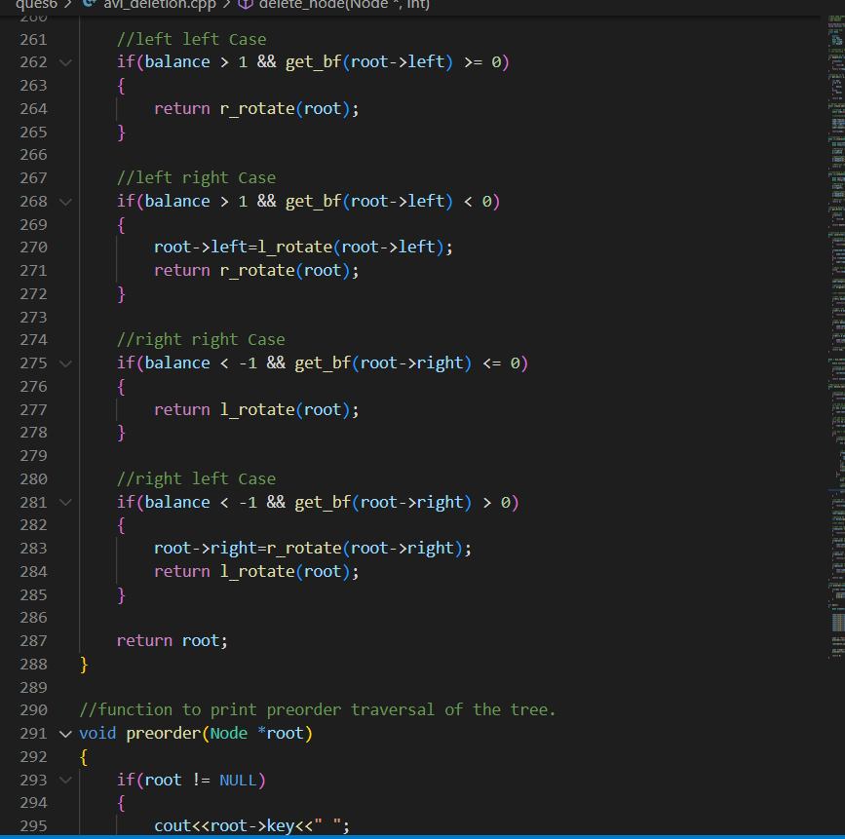

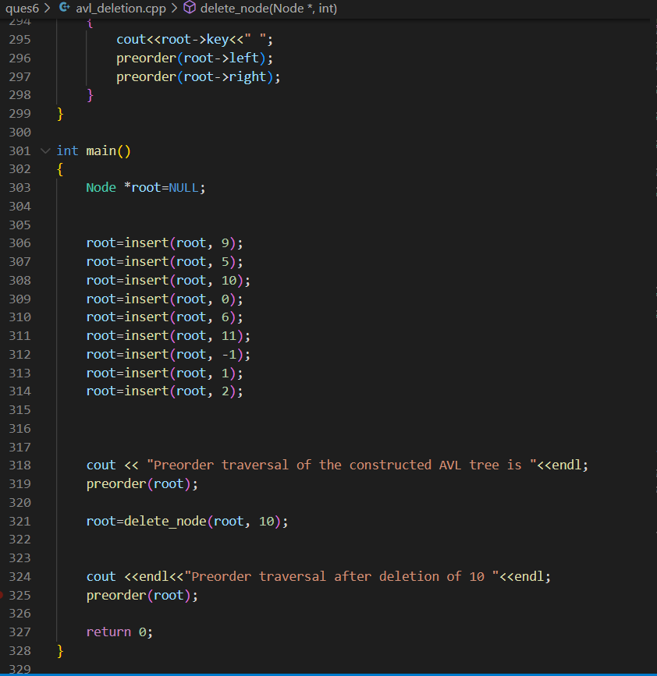

OUTPUT:

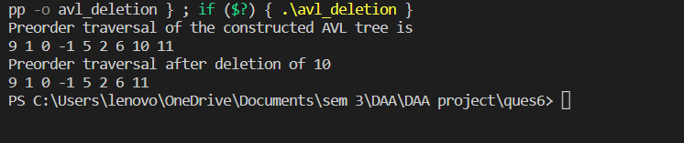

RED BLACK TREE DELETION

OBJECTIVE:

A red-black tree is a kind of self-balancing binary search tree where each node has an extra bit, and that bit is often interpreted as the color (red or black). These colors are used to ensure that the tree remains balanced during insertions and deletions. Although the balance of the tree is not perfect, it is good enough to reduce the searching time and maintain it around O(log n) time, where n is the total number of elements in the tree. This tree was invented in 1972 by Rudolf Bayer.

ALGORITHM

1. **Do the following until the x is not the root of the tree and the color of x is BLACK**
2. **If x is the left child of its parent then,**
   1. Assign w to the sibling of x. Assigning w
   2. If the sibling of x is RED,

**Case-I:**

* + 1. Set the color of the right child of the parent of x as BLACK.
    2. Set the color of the parent of x as RED. Color change
    3. Left-Rotate the parent of x. Left-rotate
    4. Assign the rightChild of the parent of x to w. Reassign w
  1. If the color of both the right and the leftChild of w is BLACK,

**Case-II:**

* + 1. Set the color of w as RED
    2. Assign the parent of x to x.
  1. Else if the color of the rightChild of w is BLACK

**Case-III:**

* + 1. Set the color of the leftChild of w as BLACK
    2. Set the color of w as RED Color change
    3. Right-Rotate w. Right rotate
    4. Assign the rightChild of the parent of x to w. Reassign w
  1. If any of the above cases do not occur, then do the following.

**Case-IV:**

* + 1. Set the color of w as the color of the parent of x.
    2. Set the color of the parent of parent of x as BLACK.
    3. Set the color of the right child of w as BLACK. Color change
    4. Left-Rotate the parent of x. Left-rotate
    5. Set x as the root of the tree. Set x as root

1. **Else same as above with right changed to left and vice versa.**
2. **Set the color of x as BLACK.**

COMPLEXITY

Time Complexity: O(logn)

Auxiliary Space: O(n)

CODE:

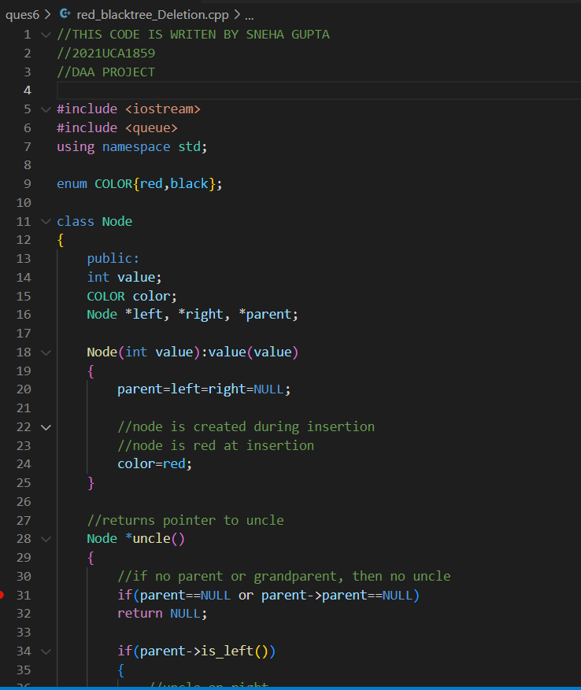

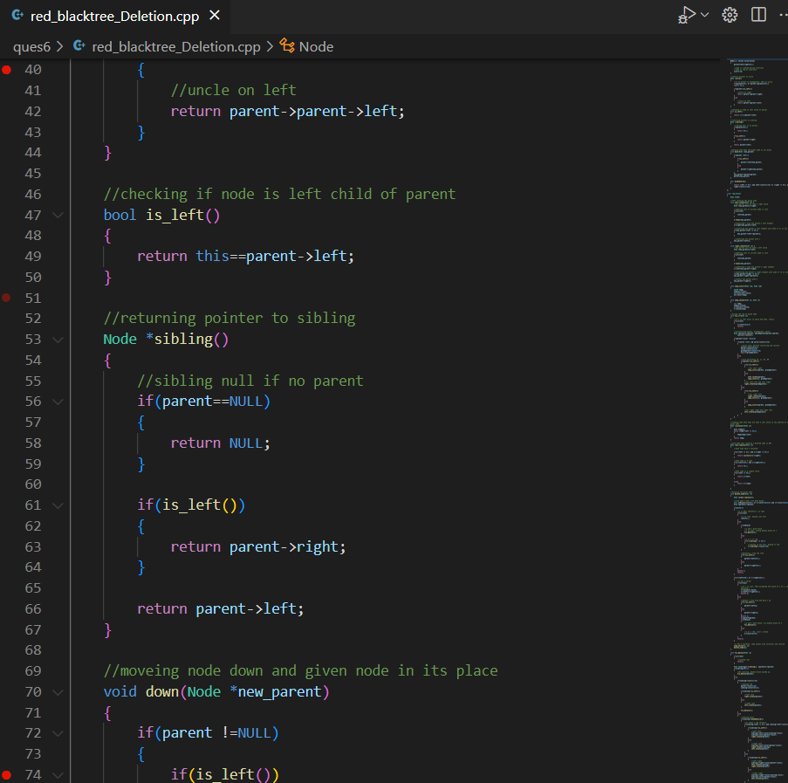

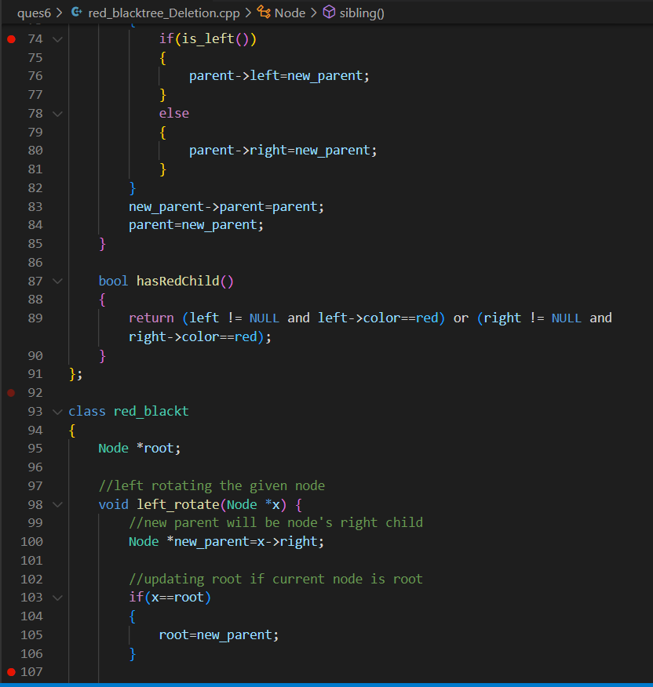

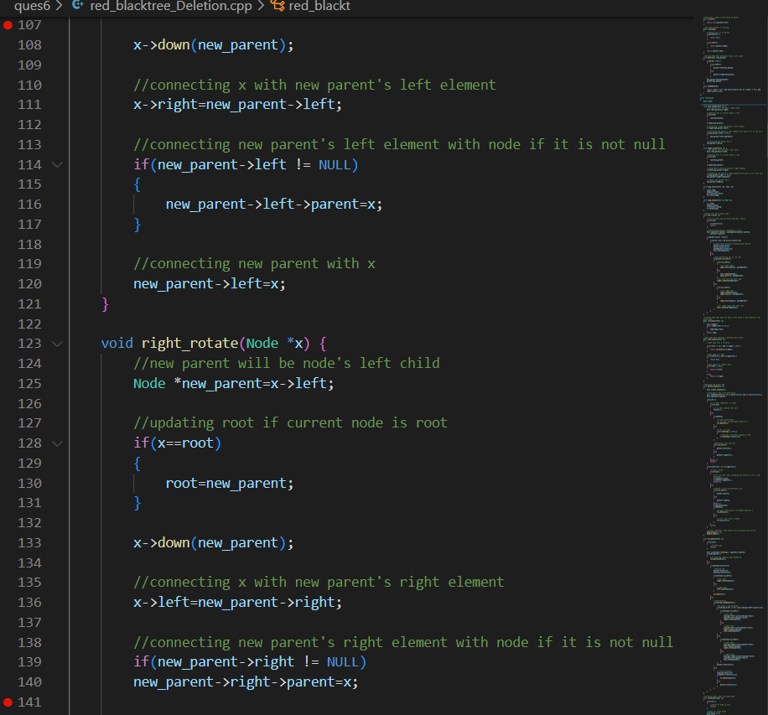

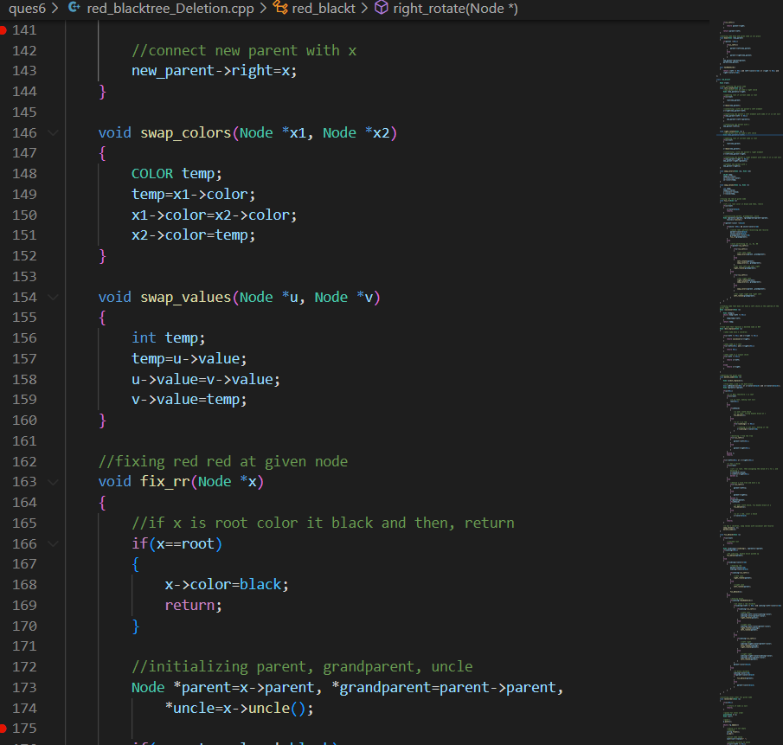

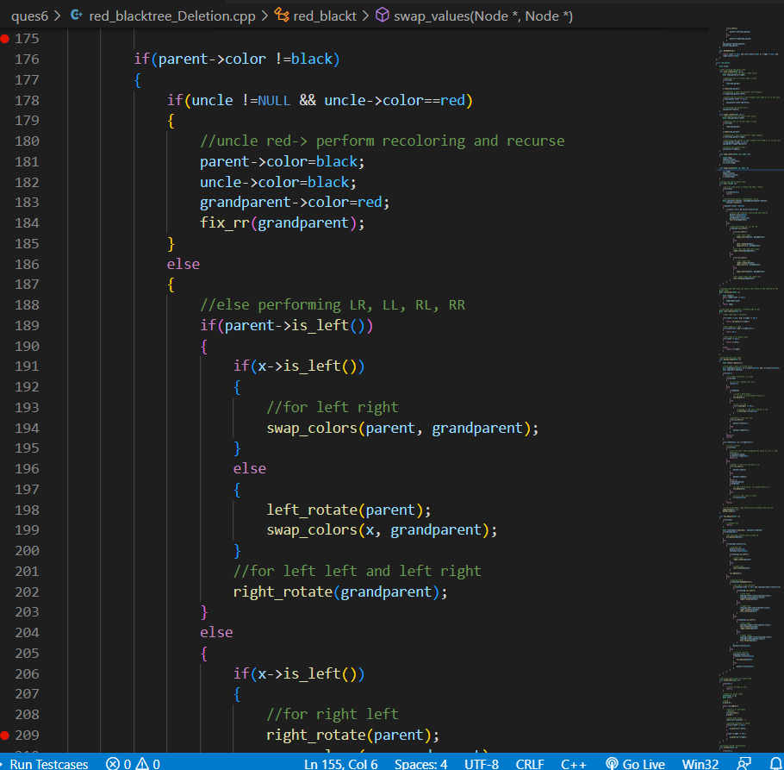

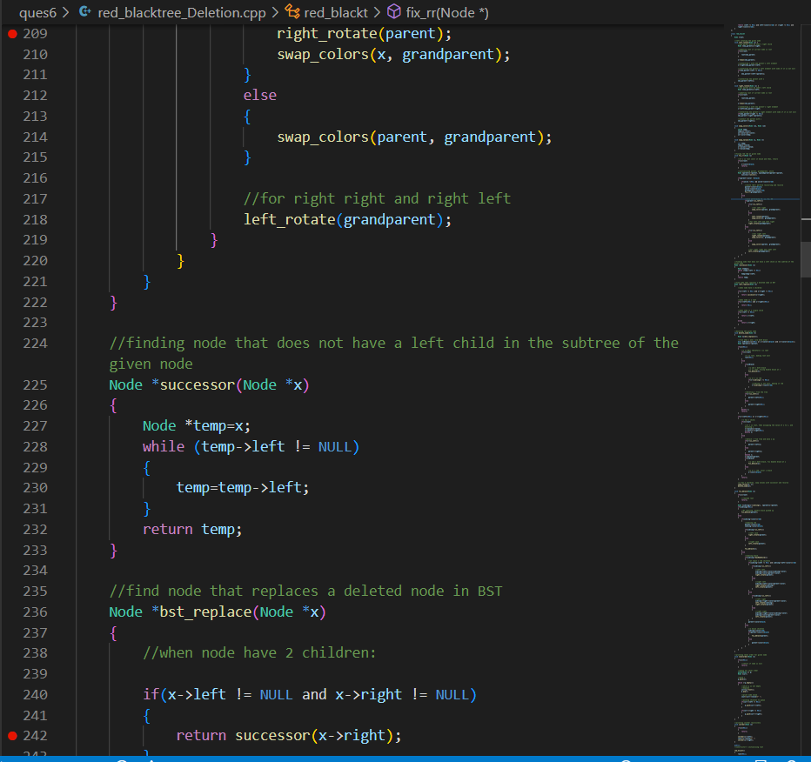

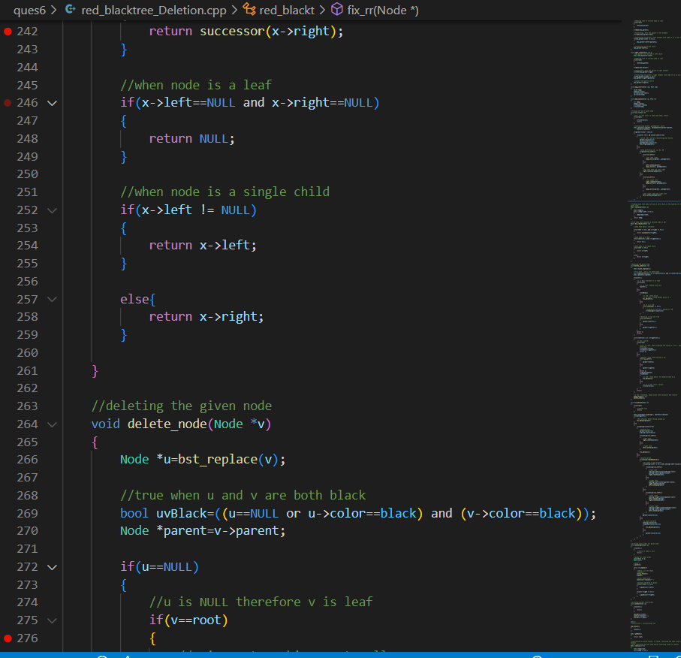

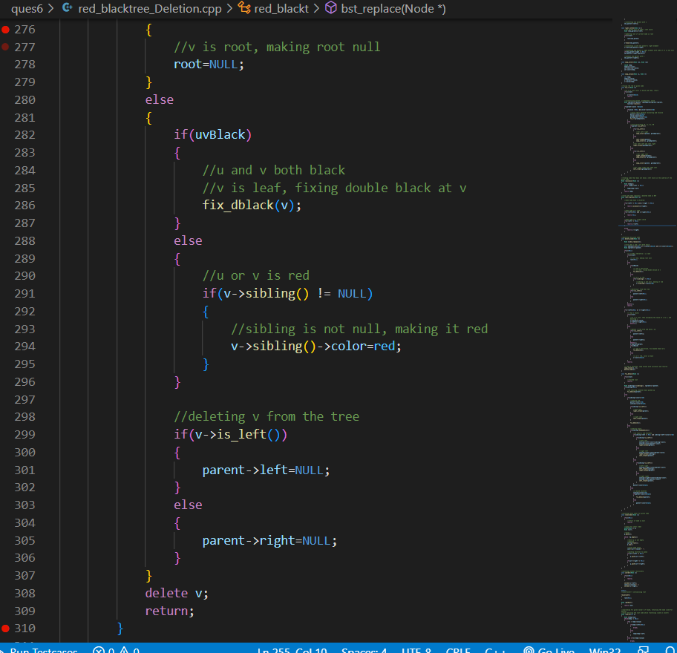

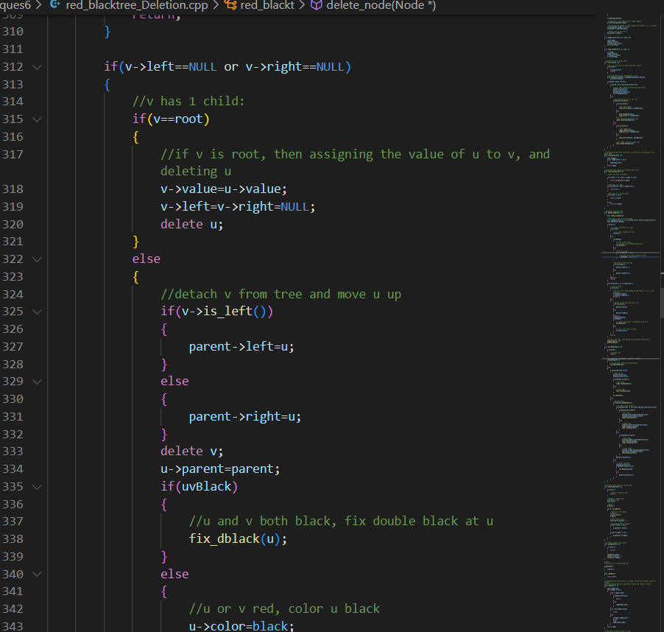

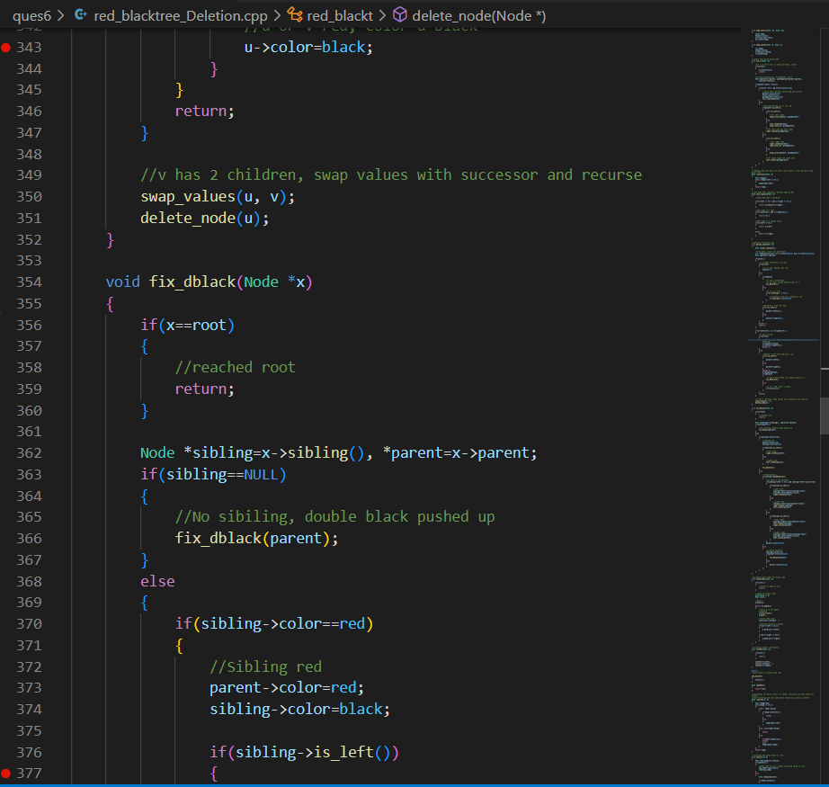

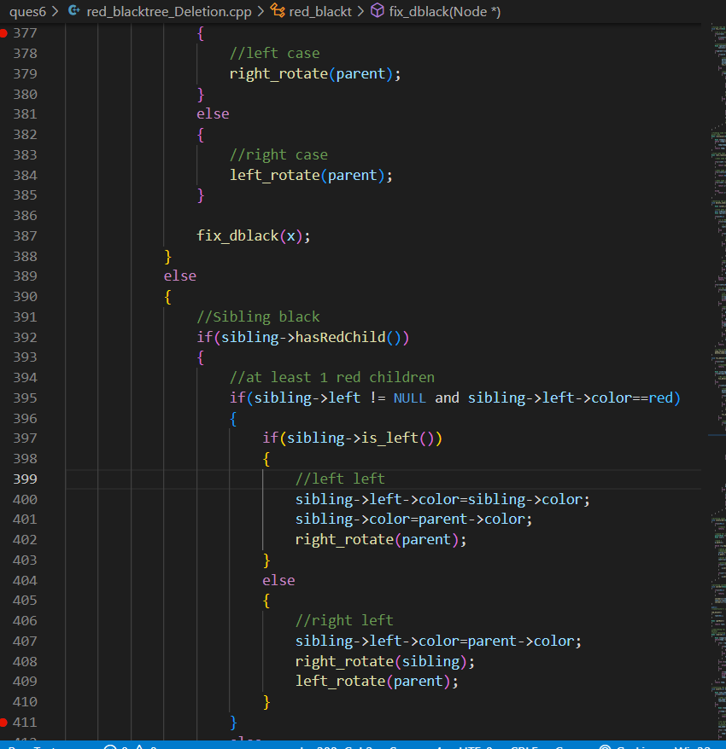

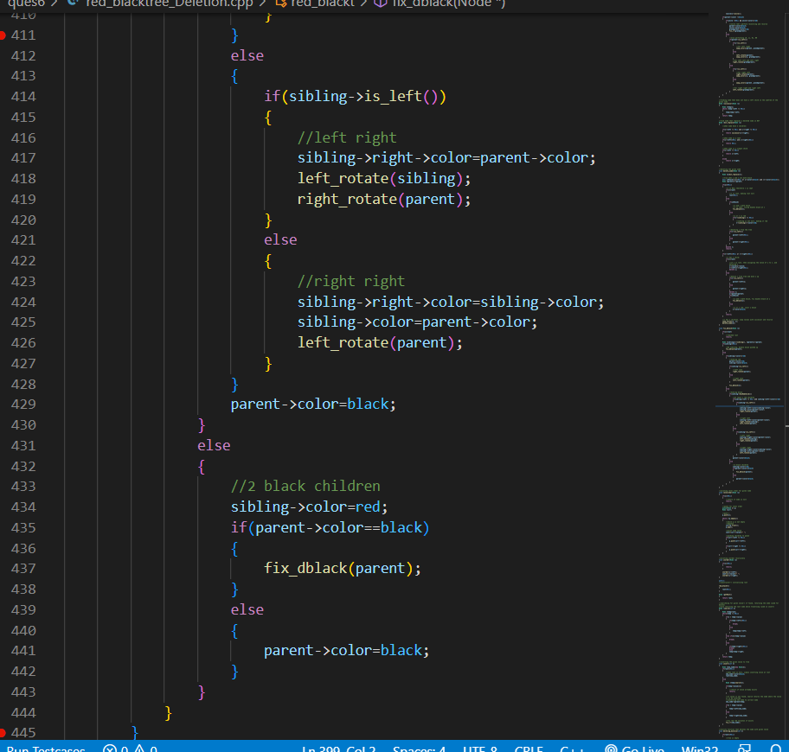

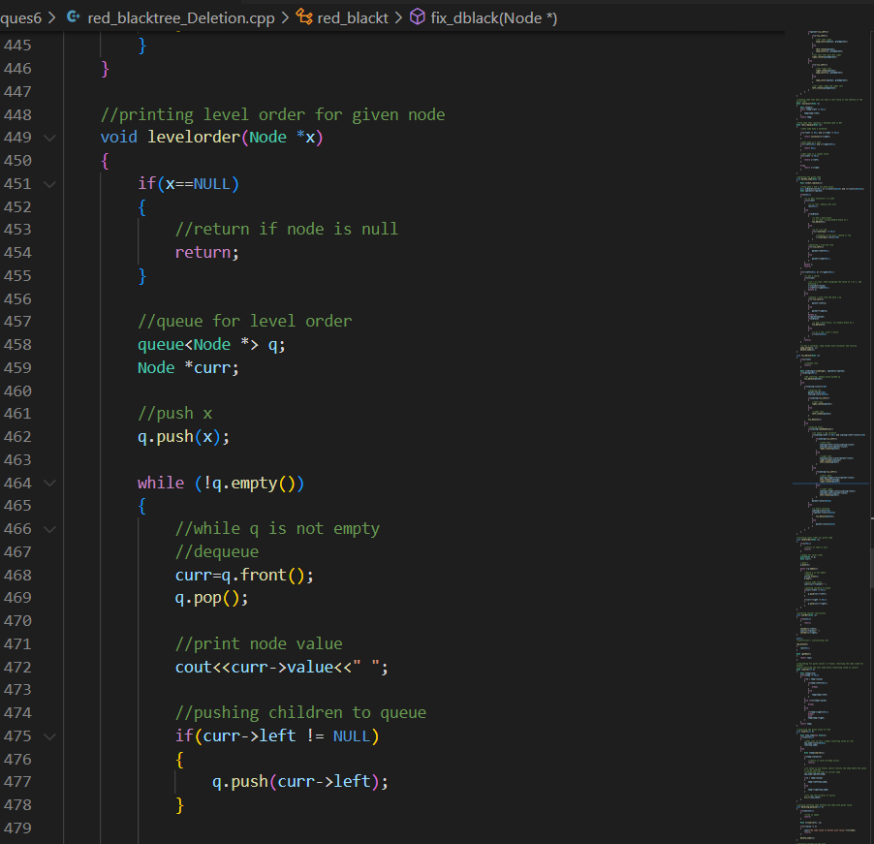

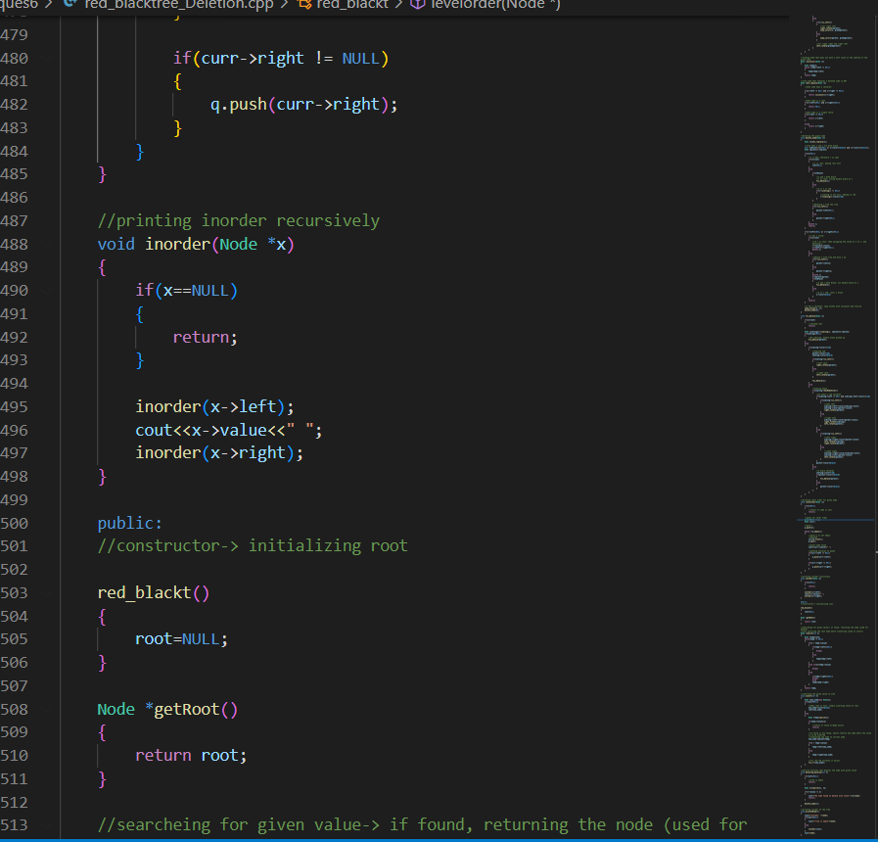

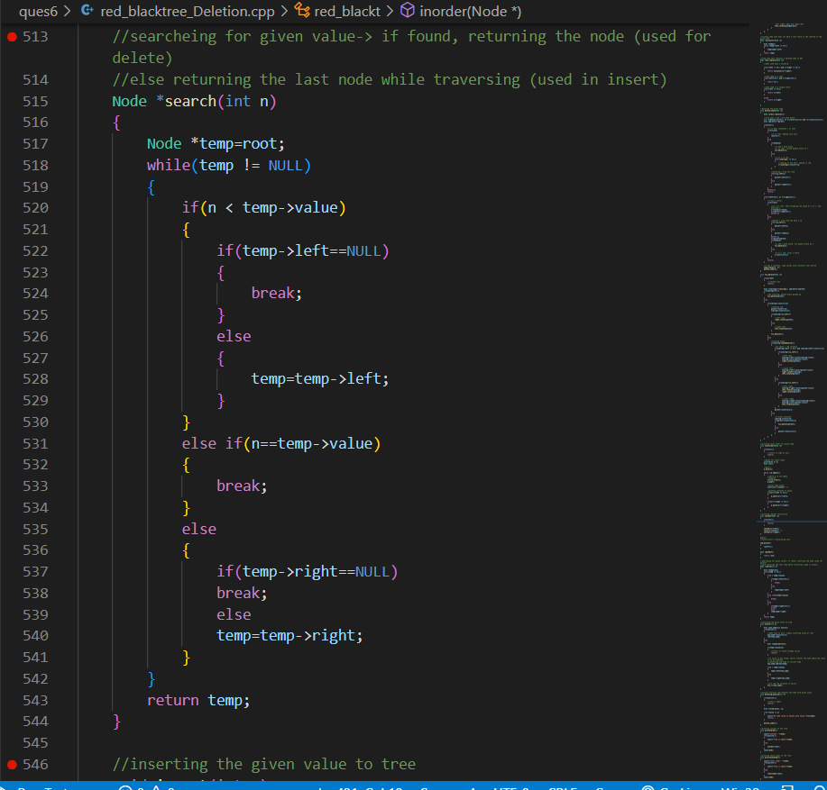

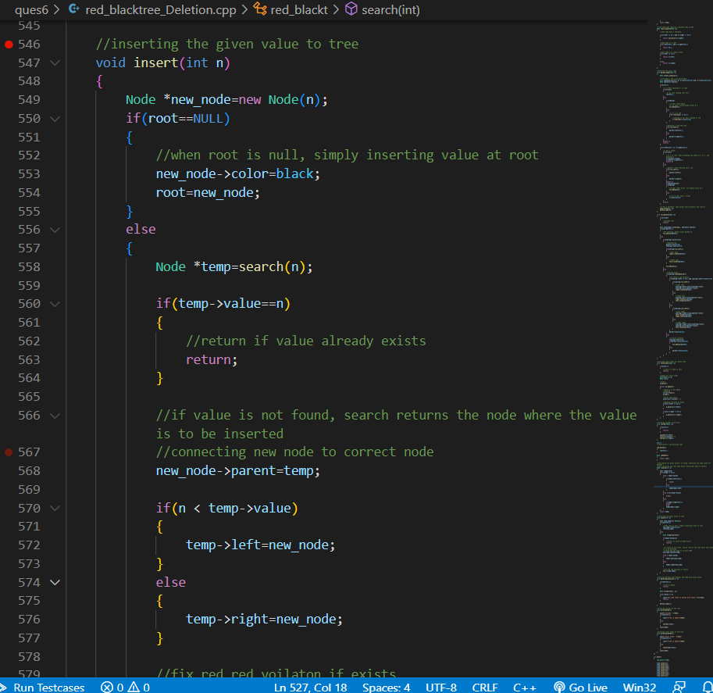

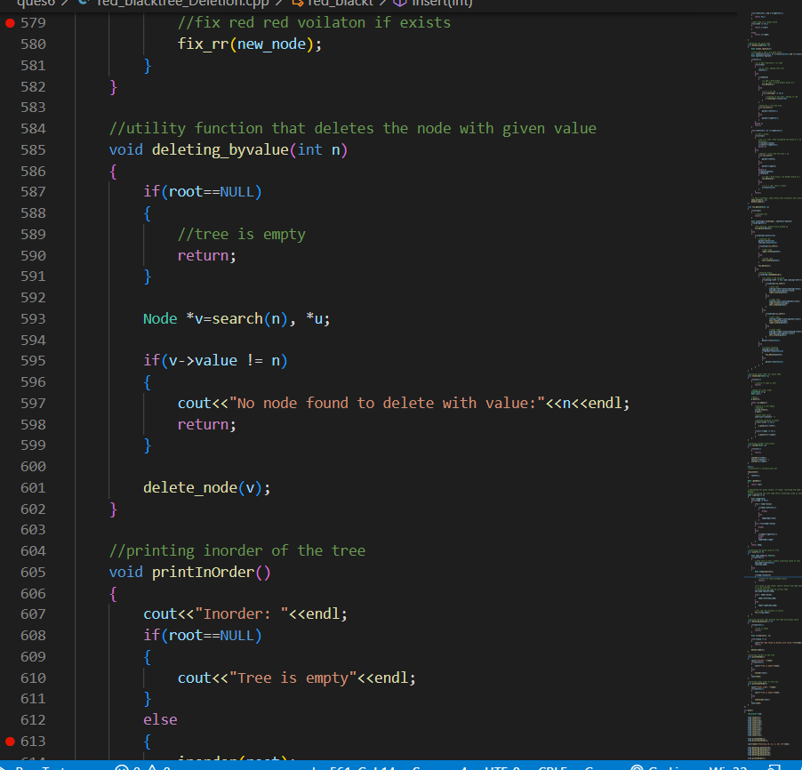

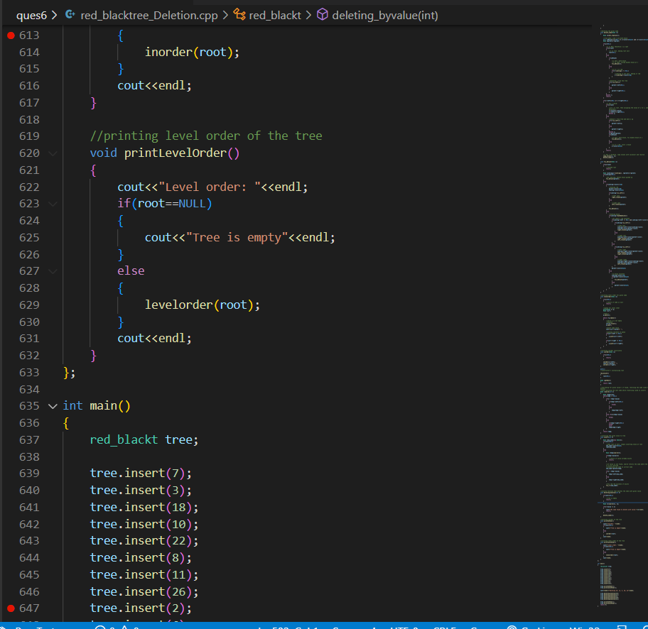

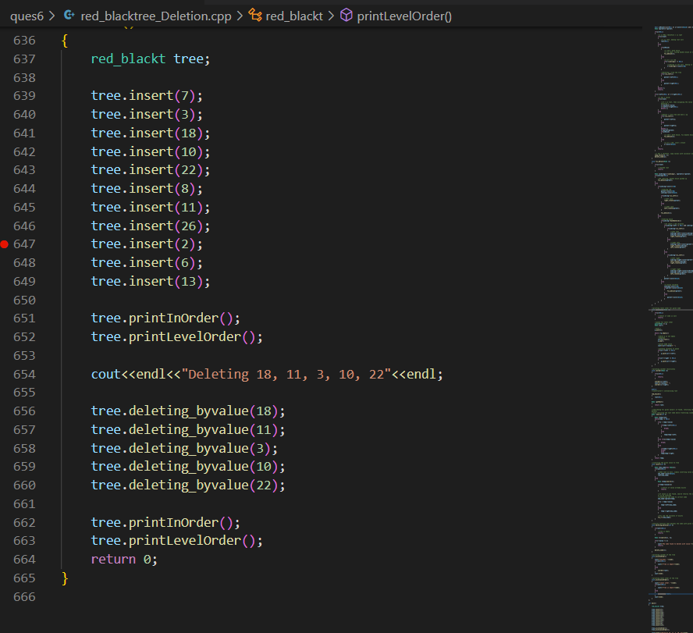

OUTPUT:

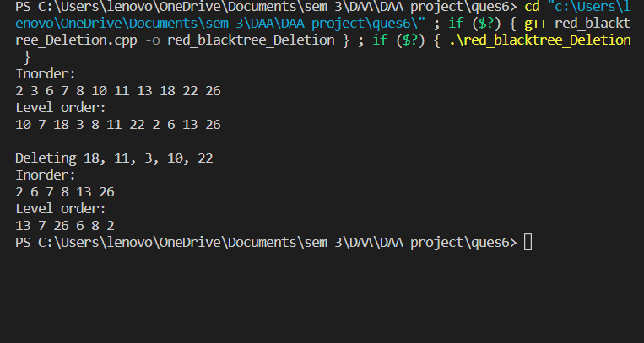­­­­­­­­­­

BINARY SEARCH TREE DELETION

OBJECTIVE:

A binary Search Tree is a node-based binary tree data structure which has the following properties:

* The left subtree of a node contains only nodes with keys lesser than the node’s key.
* The right subtree of a node contains only nodes with keys greater than the node’s key.
* The left and right subtree each must also be a binary search tree.
* There must be no duplicate nodes.

ALGORITHM

***Node to be deleted is the*** ***leaf:*** Simply remove from the tree.

**2) *Node to be deleted has only one child:*** Copy the child to the node and delete the child

**3) *Node to be deleted has two children:***Find inorder successor of the node. Copy contents of the inorder successor to the node and delete the inorder successor. Note that inorder predecessor can also be used.

COMPLEXITY

Time Complexity: O(n)

Auxiliary Space: O(n)

CODE:

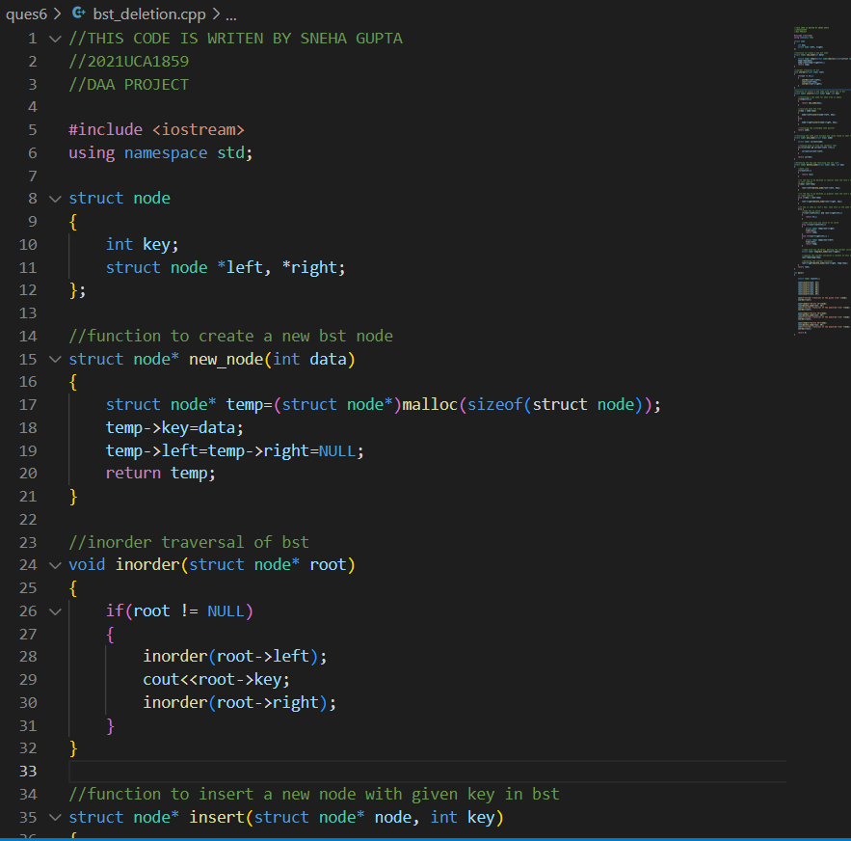

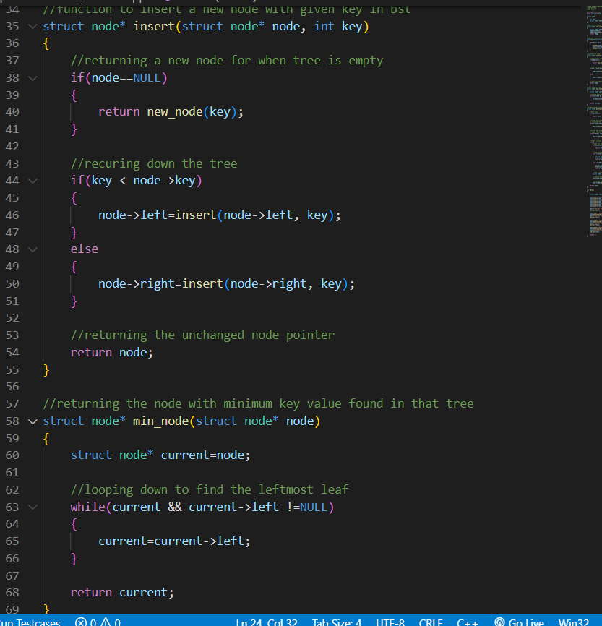

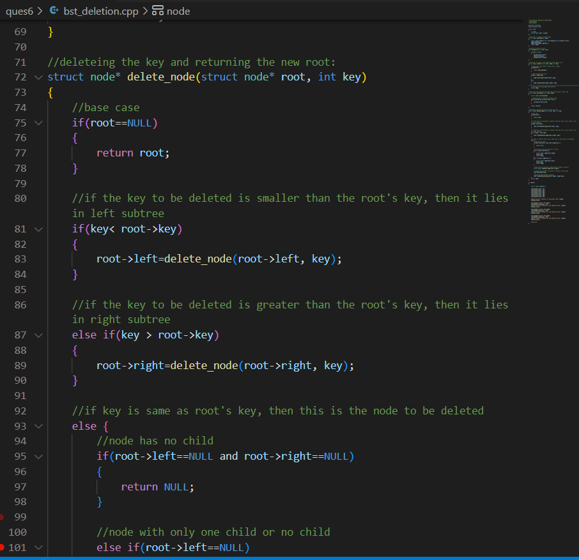

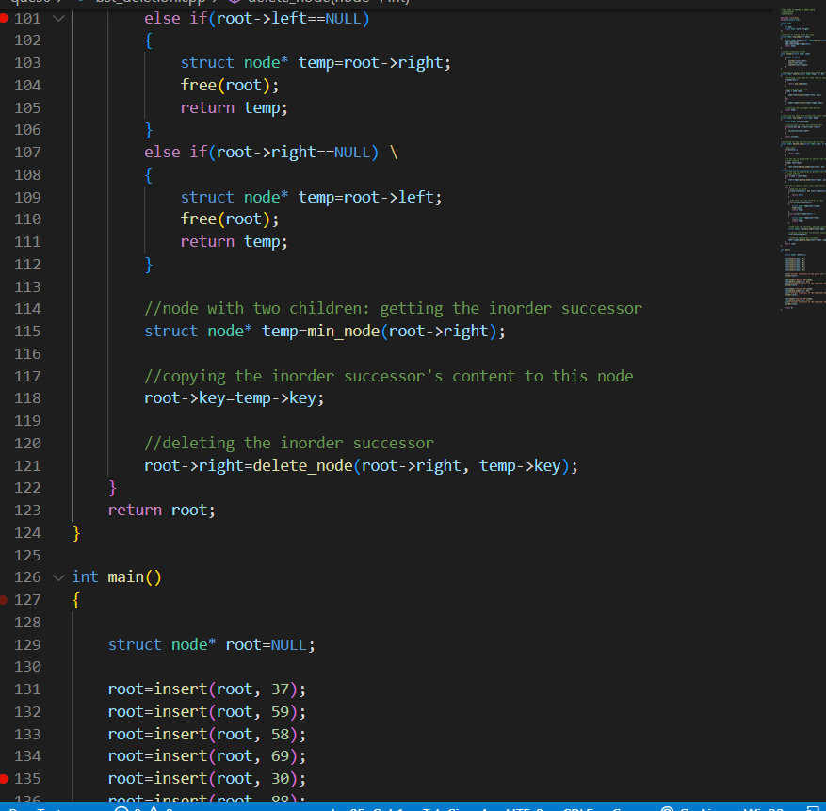

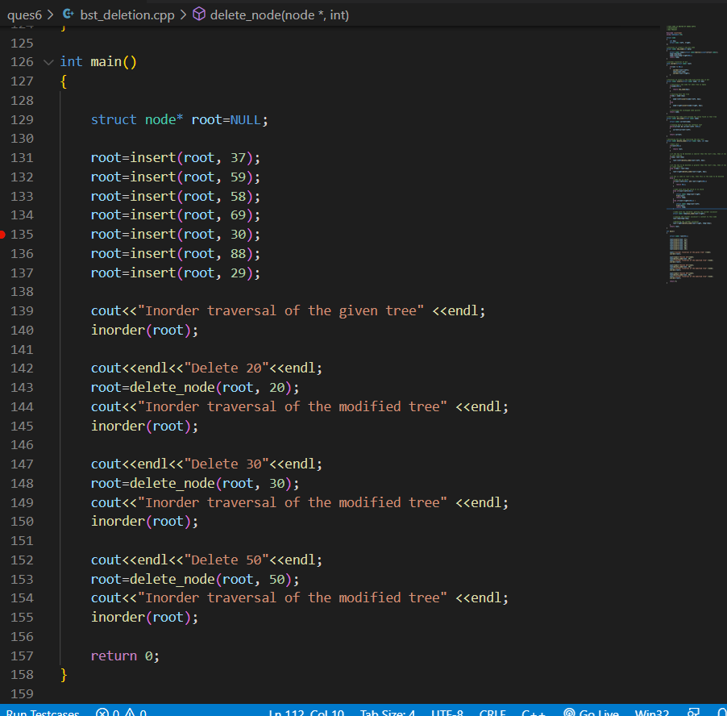

OUTPUT:

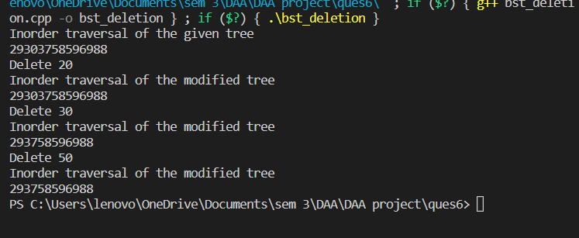

EXPERIMENT NUMBER: 07

Given the root of a binary tree, return the maximum height of the tree. A binary tree's maximum height is the number of nodes along the longest path from the root node down to the farthest leaf node.

OVERVIEW:

Given a binary tree, the task is to find the height of the tree. Height of the tree is the number of edges in the tree from the root to the deepest node, Height of the empty tree is **0**.

ALGORITHM

* Recursively do a Depth-first search.
* If the tree is empty then return -1
* Otherwise, do the following
  + Get the max depth of the left subtree recursively  i.e. call maxDepth( tree->left-subtree)
  + Get the max depth of the right subtree recursively  i.e. call maxDepth( tree->right-subtree)
  + Get the max of max depths of **left**and **right** subtrees and **add 1**to it for the current node.
    - Maxdepth=max(maxdepth of left subtree, maxdepth of right subtree)+1
* Return max_depth.

COMPLEXITY

Time Complexity: O(n)

Auxiliary Space: O(n)

CODE:

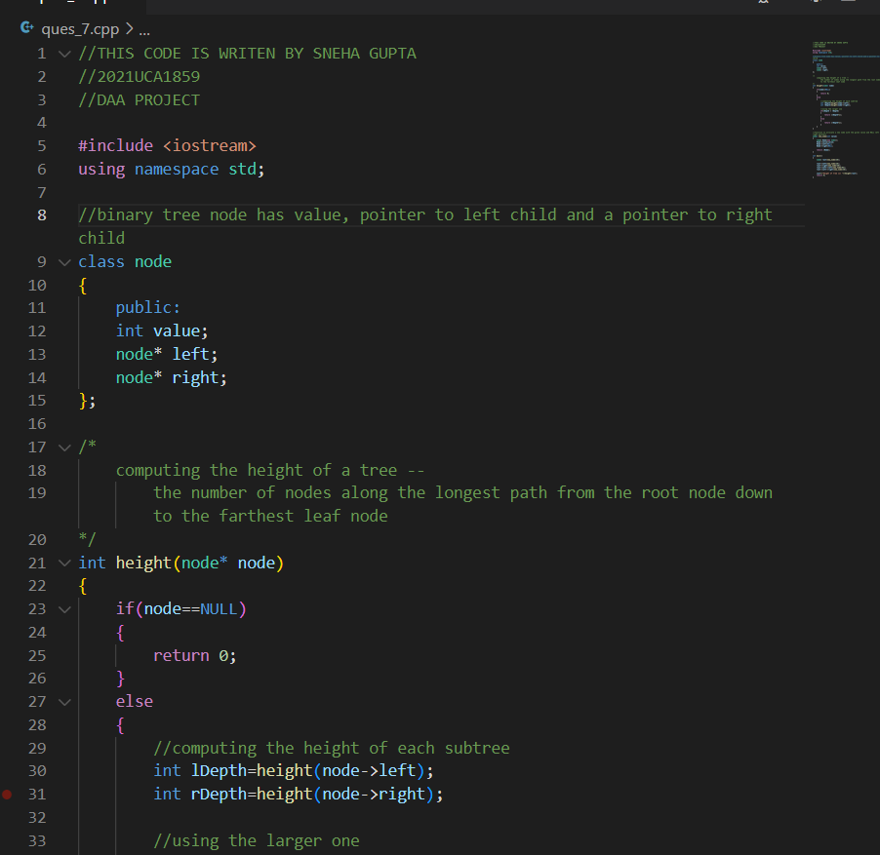

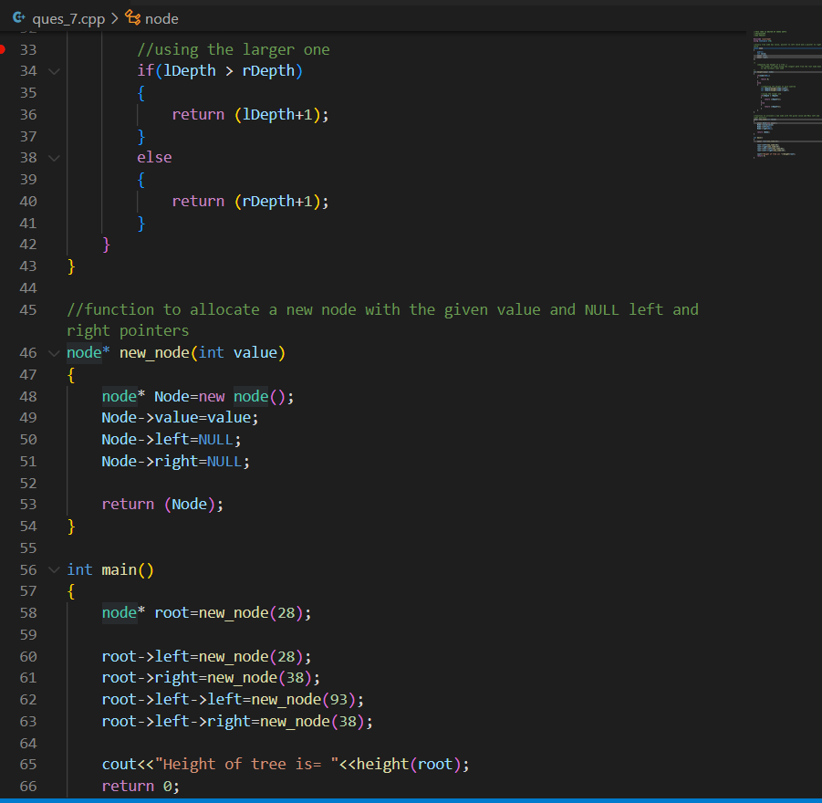

OUTPUT:

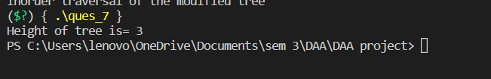

EXPERIMENT NUMBER: 08

Find maximum and minimum of array using the dynamic programing.

OVERVIEW:

Given an array of size **N.**The task is to find the maximum and the minimum element of the array using the minimum number of comparisons.

ALGORITHM

Pair MaxMin(array, array_size)  
    if array_size = 1  
        return element as both max and min  
    else if arry_size = 2  
        one comparison to determine max and min  
         return that pair  
    else    /* array_size  > 2 */  
        recur for max and min of left half  
        recur for max and min of right half  
        one comparison determines true max of the two candidates  
        one comparison determines true min of the two candidates  
        return the pair of max and min

COMPLEXITY

Time Complexity: O(n)

Auxiliary Space: O(logn)

CODE:

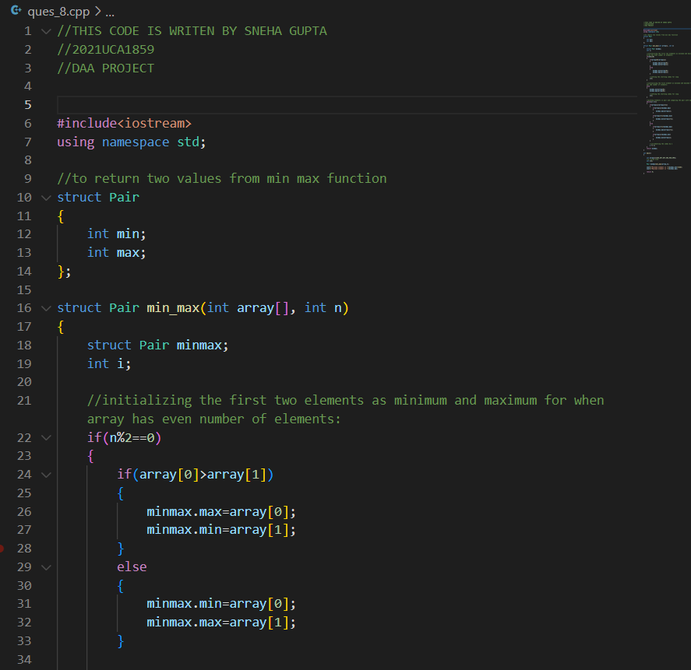

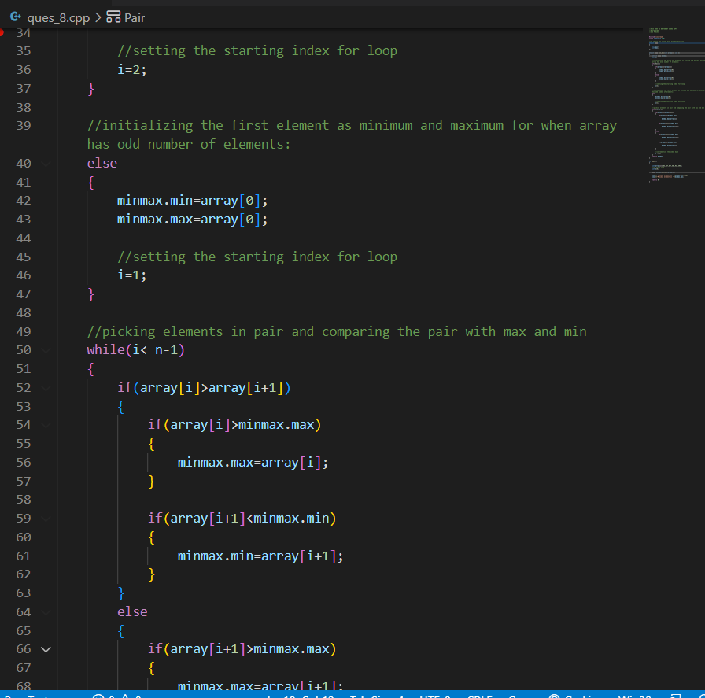

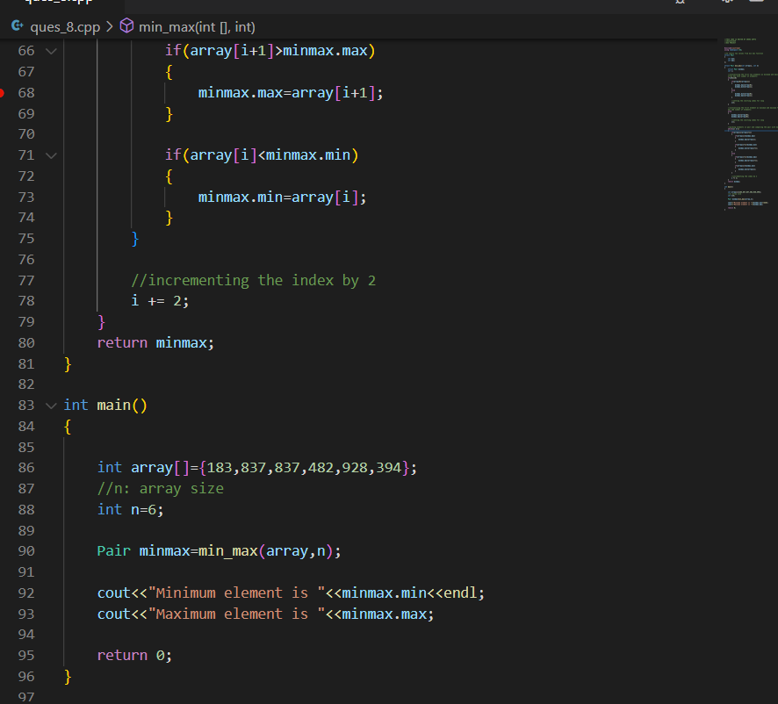

OUTPUT 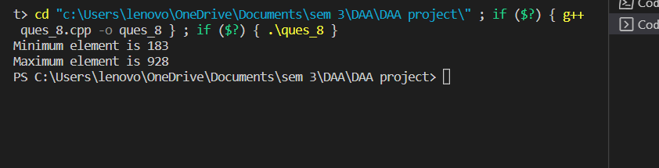

EXPERIMENT NUMBER: 09

Given a set of N jobs where each job i has a deadline and profit associated with it. Each job takes 1 unit of time to complete and only one job can be scheduled at a time. We earn the profit associated with the job if and only if the job is completed by its deadline. Find the number of jobs done and the maximum profit

OVERVIEW:

In job sequencing problem, the objective is to find a sequence of jobs, which is completed within their deadlines and gives maximum profit.

ALGORITHM

* Sort all jobs in decreasing order of profit.
* Iterate on jobs in decreasing order of profit.For each job , do the following :
  + Find a time slot i, such that slot is empty and i < deadline and i is greatest.Put the job in   
    this slot and mark this slot filled.
  + If no such i exists, then ignore the job.

COMPLEXITY

Time Complexity: O(N^2)

Auxiliary Space: O(N)

CODE:

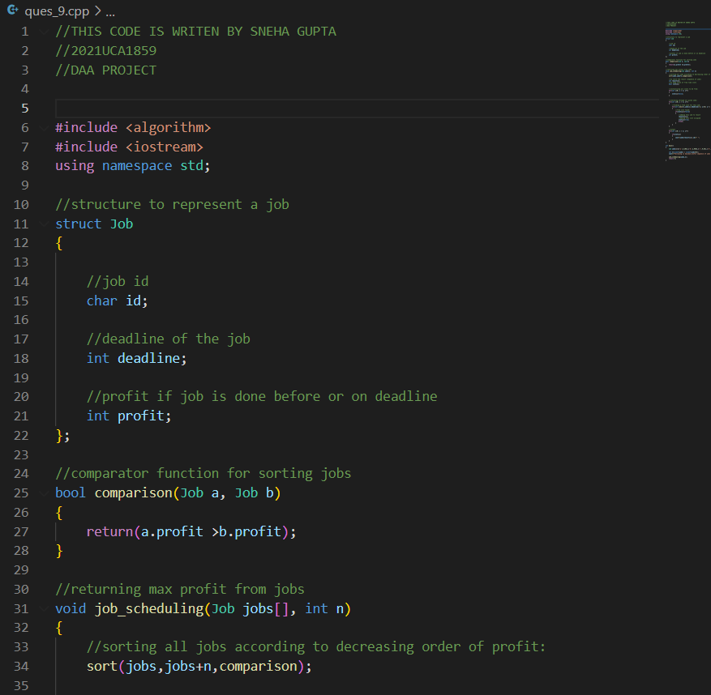

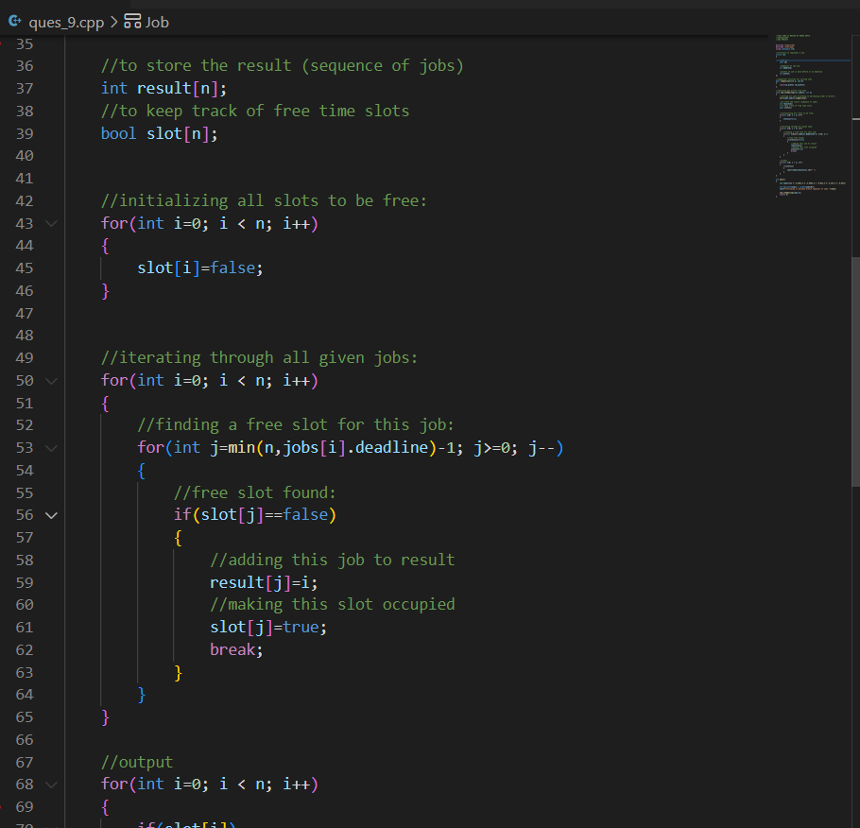

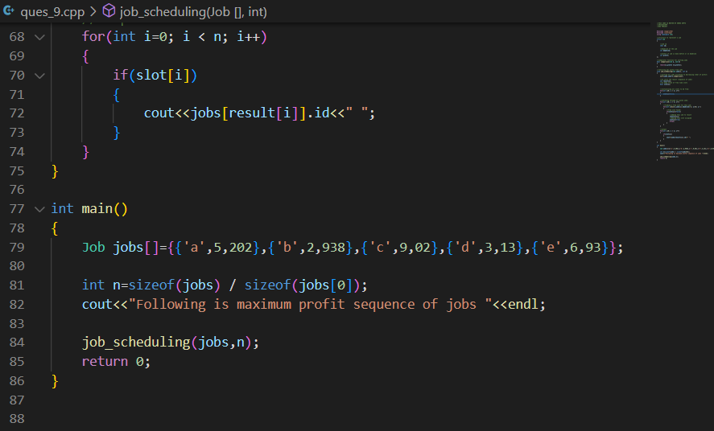

OUTPUT:

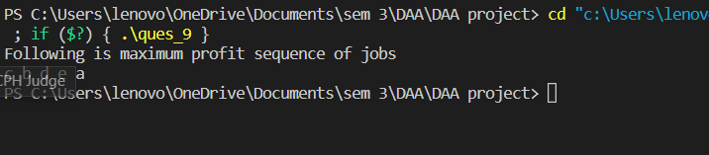

EXPERIMENT NUMBER: 10

Given weights and values of N items, we need to put these items in a knapsack of capacity W to get the maximum total value in the knapsack. Note: Unlike 0/1 knapsack, you are allowed to break the item.

OVERVIEW:

Given the weights and values of N items, in the form of {value, weight} put these items in a knapsack of capacity W to get the maximum total value in the knapsack. In Fractional Knapsack, we can break items for maximizing the total value of the knapsack

ALGORITHM

* Calculate the ratio(value/weight) for each item.
* Sort all the items in decreasing order of the ratio.
* Initialize **res =0**, curr_cap = given_cap.
* Do the following for every item “i” in the sorted order:
  + If the weight of the current item is less than or equal to the remaining capacity then add the value of that item into the result
  + Else add the current item as much as we can and break out of the loop.
* Return **res**.

COMPLEXITY

Time Complexity: O(N*logN)

Auxiliary Space: O(N)

CODE:

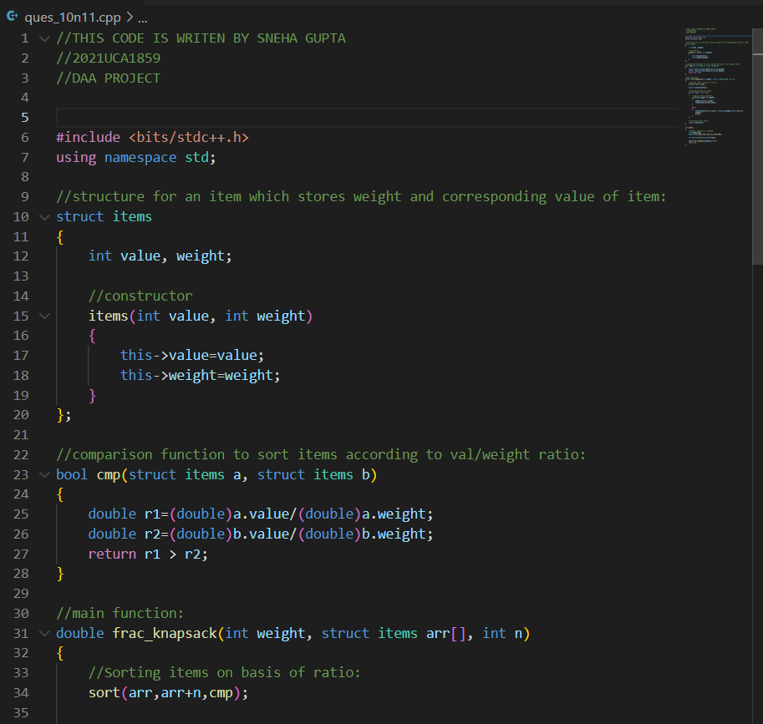

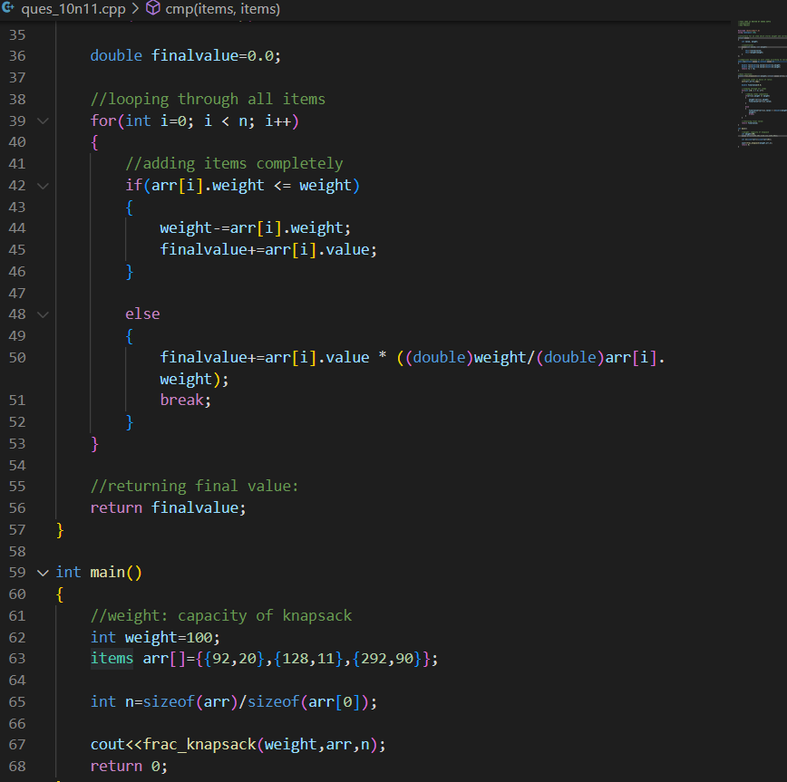

OUTPUT:

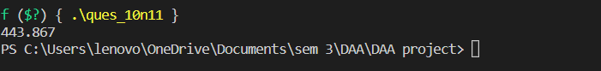

EXPERIMENT NUMBER: 11

Write a program for the fractional and dynamic knapsack problem

FRACTIONAL KNAPSACK

OVERVIEW:

Given the weights and values of N items, in the form of {value, weight} put these items in a knapsack of capacity W to get the maximum total value in the knapsack. In Fractional Knapsack, we can break items for maximizing the total value of the knapsack

ALGORITHM

ALGORITHM

* Calculate the ratio(value/weight) for each item.
* Sort all the items in decreasing order of the ratio.
* Initialize **res =0**, curr_cap = given_cap.
* Do the following for every item “i” in the sorted order:
  + If the weight of the current item is less than or equal to the remaining capacity then add the value of that item into the result
  + Else add the current item as much as we can and break out of the loop.
* Return **res**.

COMPLEXITY

Time Complexity: O(N*logN)

Auxiliary Space: O(N)

CODE:





OUTPUT:



0/1 KNAPSACK

OVERVIEW:

Given weights and values of n items, put these items in a knapsack of capacity W to get the maximum total value in the knapsack. In other words, given two integer arrays val[0..n-1] and wt[0..n-1] which represent values and weights associated with n items respectively. Also given an integer W which represents knapsack capacity, find out the maximum value subset of val[] such that sum of the weights of this subset is smaller than or equal to W. You cannot break an item, either pick the complete item or don’t pick it (0-1 property).

ALGORITHM

Input weight and value arrays

Input max capacity of knapsack

int knapSack(W, array w, array v, n)

int K[n + 1][W + 1] //dynamic table

for i = 0 to n

for wt = 0 to W

if (i == 0 or wt == 0)

Do K[i][wt] = 0

else if (w[i - 1] <= wt)

K[i][wt] = max(v[i - 1] + K[i - 1][wt - w[i - 1]], K[i -1][wt]) //dynamic formula

else

K[i][wt] = K[i - 1][wt]

return K[n][W]

Complexity:

O(n*W) // W is max cap and n is number of items

COMPLEXITY

Time Complexity: O(N*W)

Auxiliary Space: O(W)

CODE:

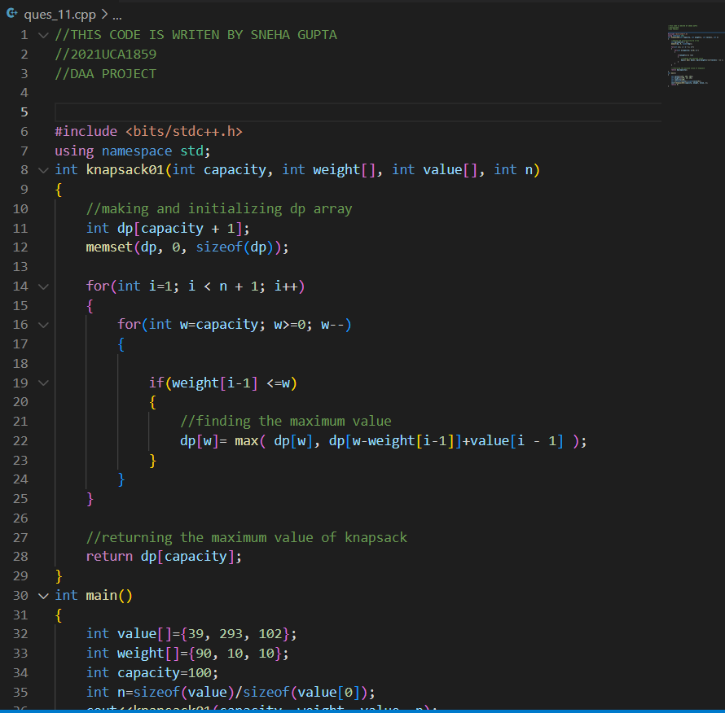

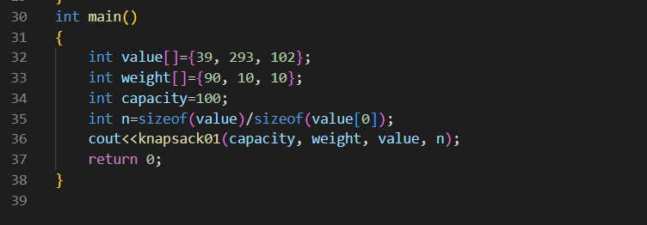

OUTPUT:

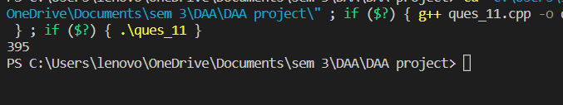

EXPERIMENT NUMBER: 12

Implement Minimum Spanning trees: Prim’s algorithm and Kruskal’s algorithm

Input a directed graph G = (V, E) where vertices V are represented as alphabetical numbers. Run the DFS-based topological ordering algorithm on the graph. Whenever you have a choice of vertices to explore, always pick the one that is alphabetically first.

Let G = (V, E) be a directed graph. Vertices u and v are strongly connected if there are u v and v u paths in G. A strongly connected component is a set of vertices C ⊆ V such that u, v is strongly connected for all u, v ∈ C (and no other vertices are strongly connected to a vertex u ∈ C.) Design an algorithm to identify all strongly connected components in G

PRIMS ALGORITHM FOR MINIMUM SPANNING TREE

OVERVIEW:

Prim's algorithm is a [minimum spanning tree](https://www.programiz.com/dsa/spanning-tree-and-minimum-spanning-tree#minimum-spanning) algorithm that takes a graph as input and finds the subset of the edges of that graph which

* form a tree that includes every vertex
* has the minimum sum of weights among all the trees that can be formed from the graph

ALGORITHM

The pseudocode for prim's algorithm shows how we create two sets of vertices U and V-U. U contains the list of vertices that have been visited and V-U the list of vertices that haven't. One by one, we move vertices from set V-U to set U by connecting the least weight edge.

T = ∅;

U = { 1 };

while (U ≠ V)

let (u, v) be the lowest cost edge such that u ∈ U and v ∈ V - U;

T = T ∪ {(u, v)}

U = U ∪ {v}

COMPLEXITY

Time Complexity: O(V^2)

Auxiliary Space: O(V)

CODE:

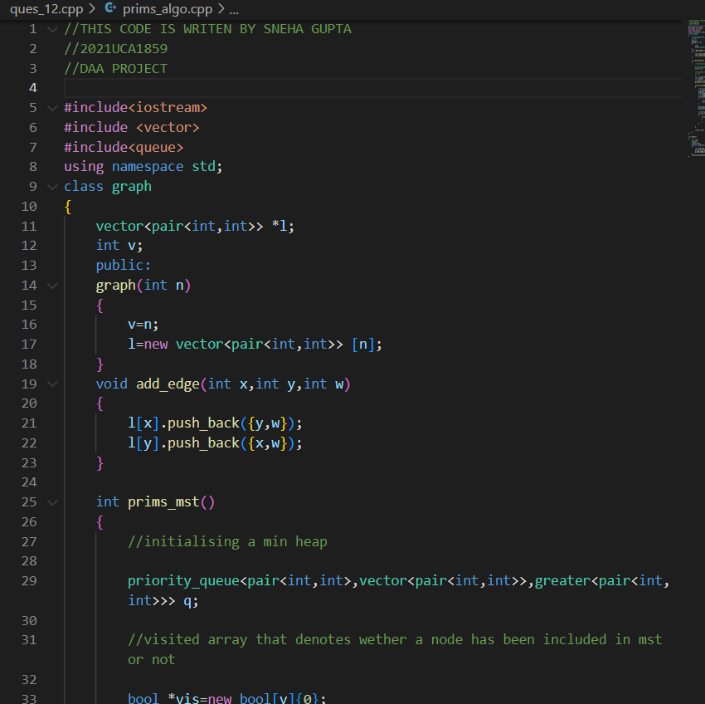

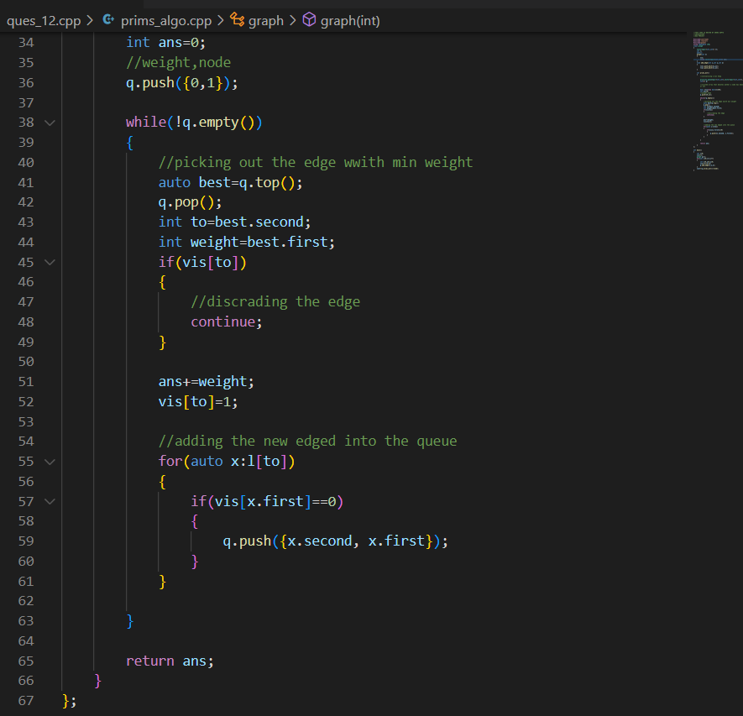

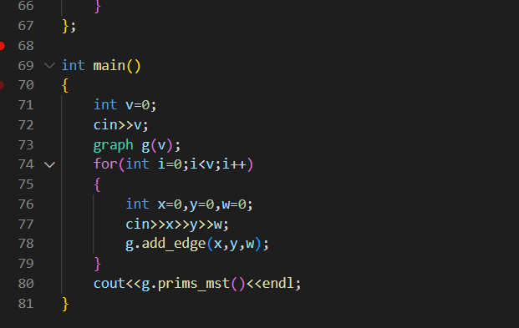

OUTPUT:

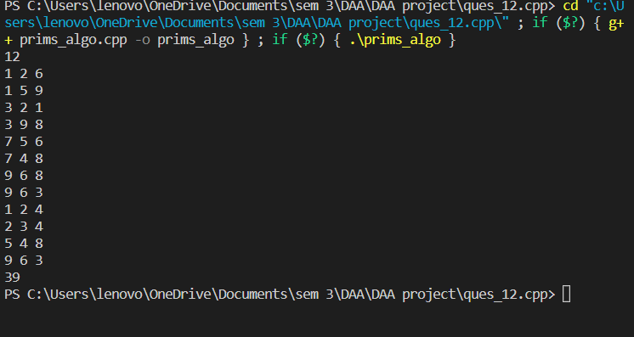

KRUSKAL ALGORITHM FOR MINIMUM SPANNING TREE

OVERVIEW:

Kruskal's algorithm is a [minimum spanning tree](https://www.programiz.com/dsa/spanning-tree-and-minimum-spanning-tree#minimum-spanning) algorithm that takes a graph as input and finds the subset of the edges of that graph which

* form a tree that includes every vertex
* has the minimum sum of weights among all the trees that can be formed from the graph

ALGORITHM

Any minimum spanning tree algorithm revolves around checking if adding an edge creates a loop or not.

The most common way to find this out is an algorithm called [Union FInd](https://www.cs.duke.edu/courses/cps100e/fall09/notes/UnionFind.pdf). The Union-Find algorithm divides the vertices into clusters and allows us to check if two vertices belong to the same cluster or not and hence decide whether adding an edge creates a cycle.

KRUSKAL(G):

A = ∅

For each vertex v ∈ G.V:

MAKE-SET(v)

For each edge (u, v) ∈ G.E ordered by increasing order by weight(u, v):

if FIND-SET(u) ≠ FIND-SET(v):

A = A ∪ {(u, v)}

UNION(u, v)

return A

COMPLEXITY

Time Complexity: O(ELogE + ELogV)

Auxiliary Space: O(V+E)

CODE:

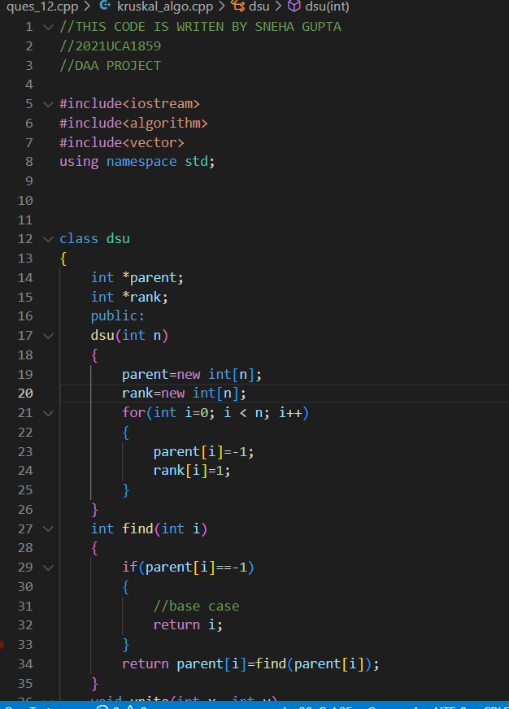

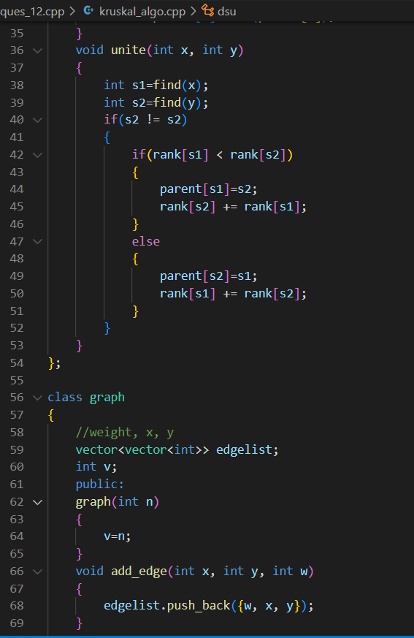

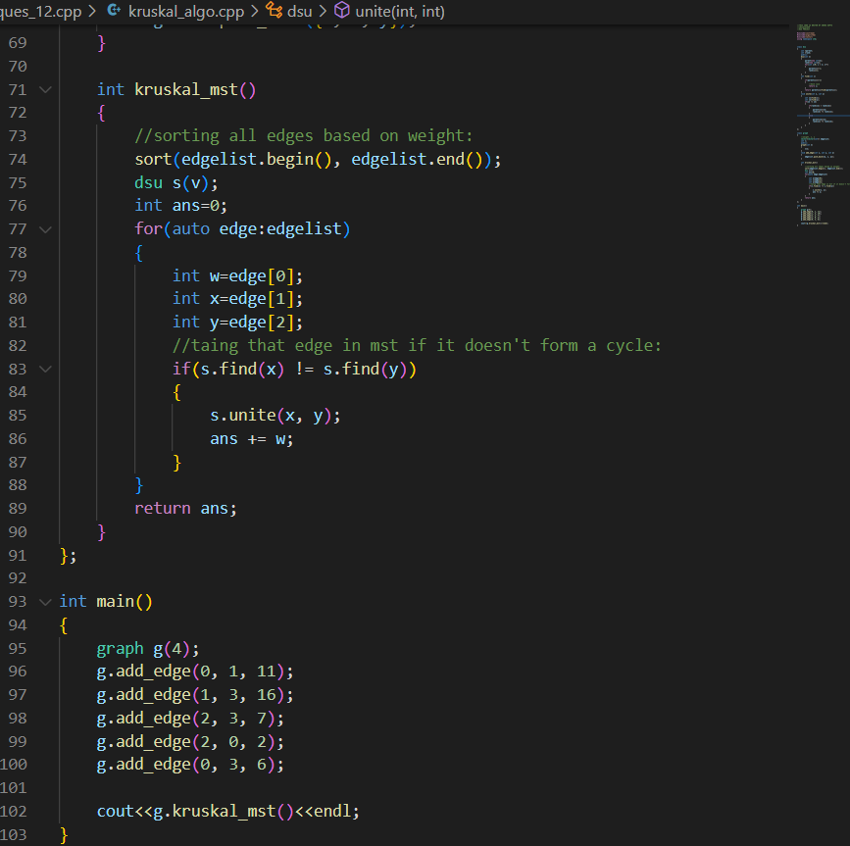

OUTPUT:

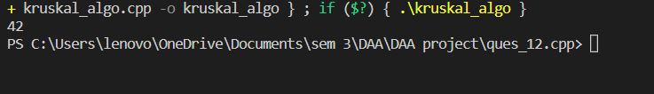

EXPERIMENT NUMBER: 13

Given a sequence of matrices, find the most efficient way to multiply these matrices together. The efficient way is the one that involves the least number of multiplications.

The dimensions of the matrices are given in an array arr[] of size N (such that N = number of matrices + 1) where the ith matrix has the dimensions (arr[i-1] x arr[i]).

OVERVIEW:

Matrix chain multiplication (or the matrix chain ordering problem) is an optimization problem concerning the most efficient way to multiply a given sequence of matrices. The problem is not actually to perform the multiplications, but merely **to decide the sequence of the matrix multiplications involved**.

ALGORITHM

* Create a recursive function that takes **i** and **j** as parameters that determines the range of a group.
  + Iterate from **k = i to j** to partition the given range into two groups.
  + Call the recursive function for these groups.
  + Return the minimum value among all the partitions as the required minimum number of multiplications to multiply all the matrices of this group.
* The minimum value returned for the range **0** to **N-1** is the required answer.

COMPLEXITY

Time Complexity: O(N^3)

Auxiliary Space: O(N^2)

CODE:

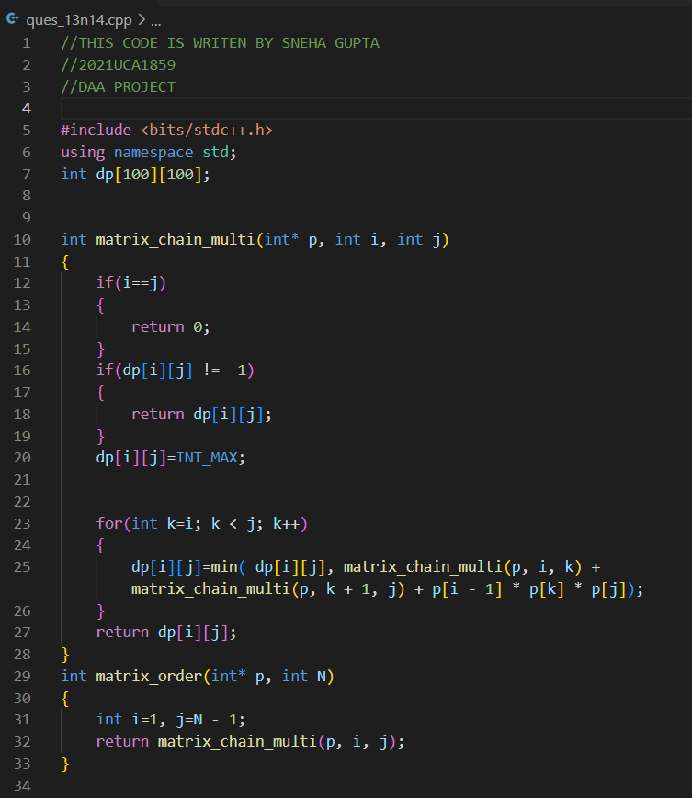

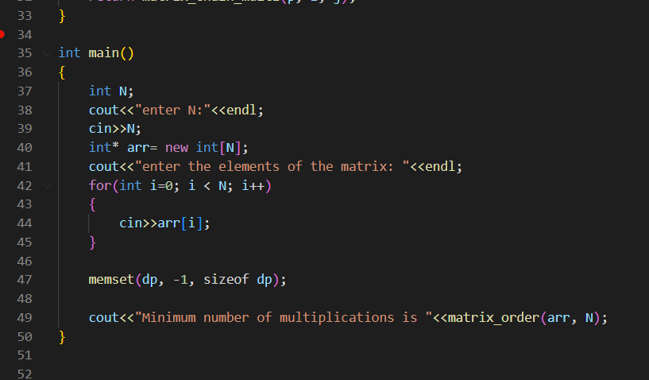

OUTPUT:

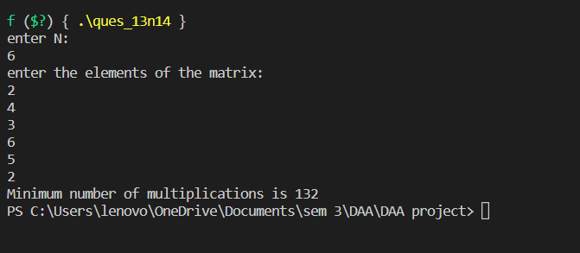

EXPERIMENT NUMBER: 14

Write a program to implement Strassen’s Matrix Multiplication.

Implement Matrix chain multiplication (MCM) using dynamic programming, you need to estimate the minimum number of operations and assign the parentheses for multiplying multiple matrices.

Input:

6 (Number of matrices, followed by matrix size)

2 4

4 3

3 6

6 5

5 2

2 1

Output: 23XX22 (Number of operations)

(A1 ((A2 A3) (A4 (A5 A6))))

STRASSEN’S MATRIX MULTIPLICATION

OVERVIEW:

Strassen's Matrix multiplication **can be performed only on square matrices where n is a power of 2**. Order of both of the matrices are n × n. Divide X, Y and Z into four (n/2)×(n/2) matrices as represented below − Z=[IJKL] X=[ABCD] and Y=[EFGH]

ALGORITHM

Using Strassen’s Algorithm compute the following −

M1:=(A+C)×(E+F)M1:=(A+C)×(E+F)

M2:=(B+D)×(G+H)M2:=(B+D)×(G+H)

M3:=(A−D)×(E+H)M3:=(A−D)×(E+H)

M4:=A×(F−H)M4:=A×(F−H)

M5:=(C+D)×(E)M5:=(C+D)×(E)

M6:=(A+B)×(H)M6:=(A+B)×(H)

M7:=D×(G−E)M7:=D×(G−E)

Then,

I:=M2+M3−M6−M7I:=M2+M3−M6−M7

J:=M4+M6J:=M4+M6

K:=M5+M7K:=M5+M7

L:=M1−M3−M4−M5

COMPLEXITY

Time Complexity: O(N^log7)

Auxiliary Space: O(N^2)

CODE:

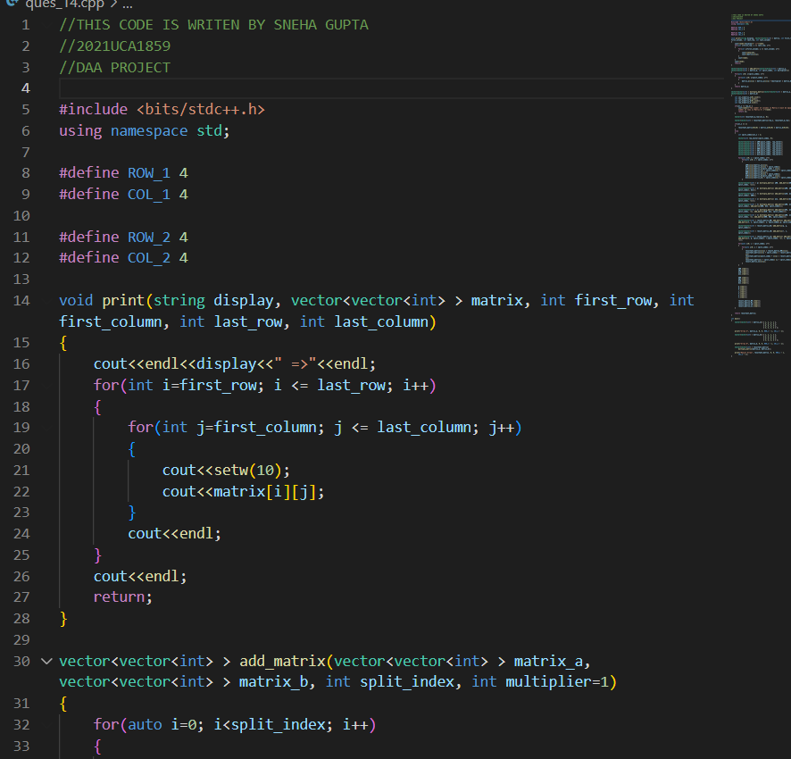

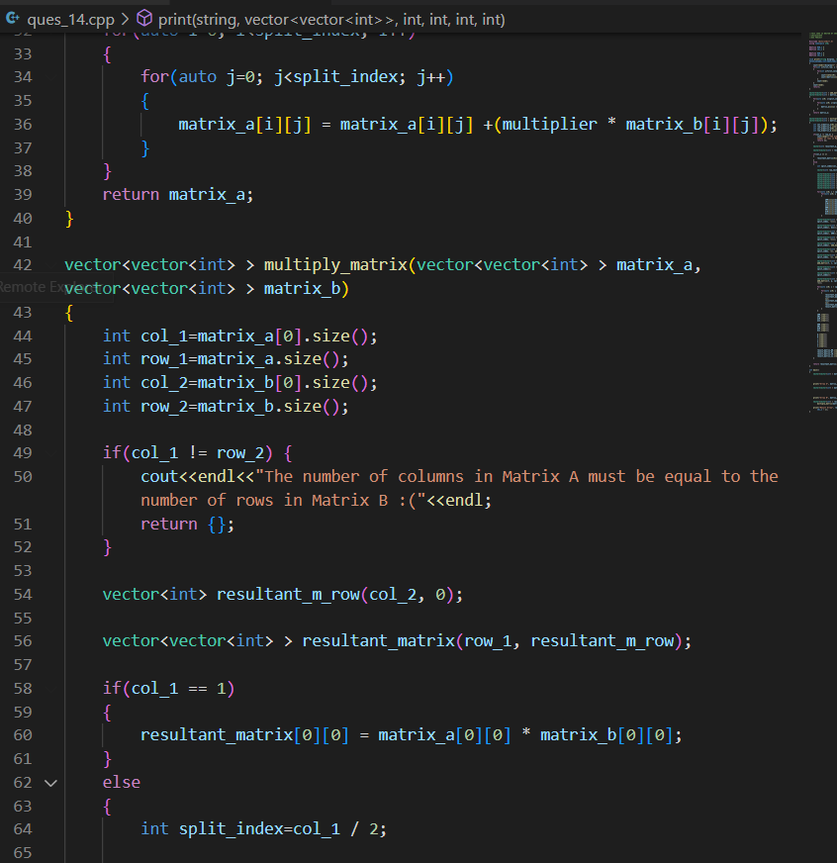

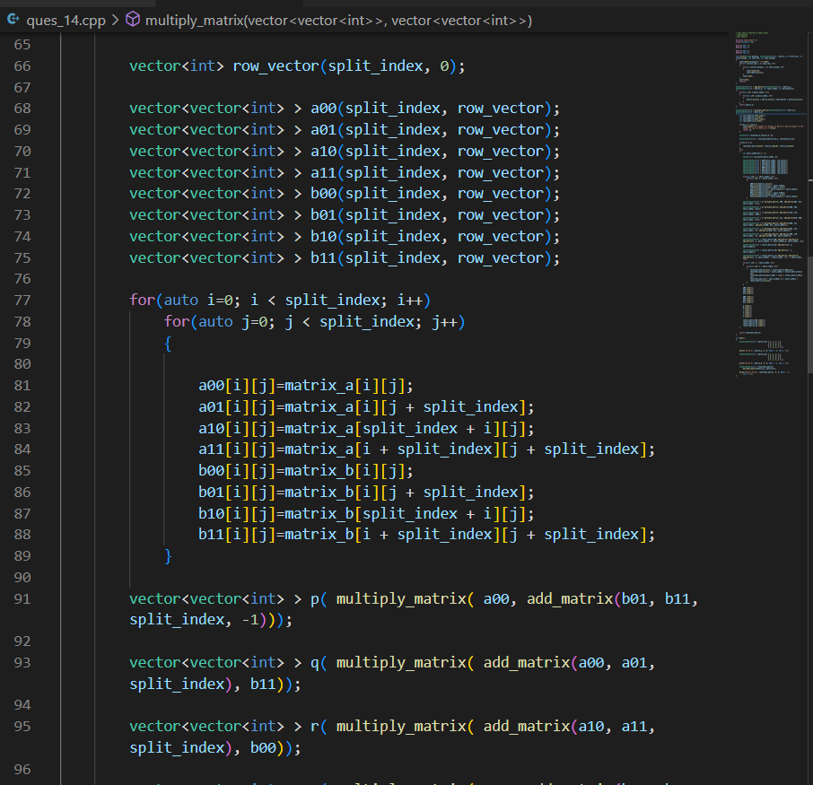

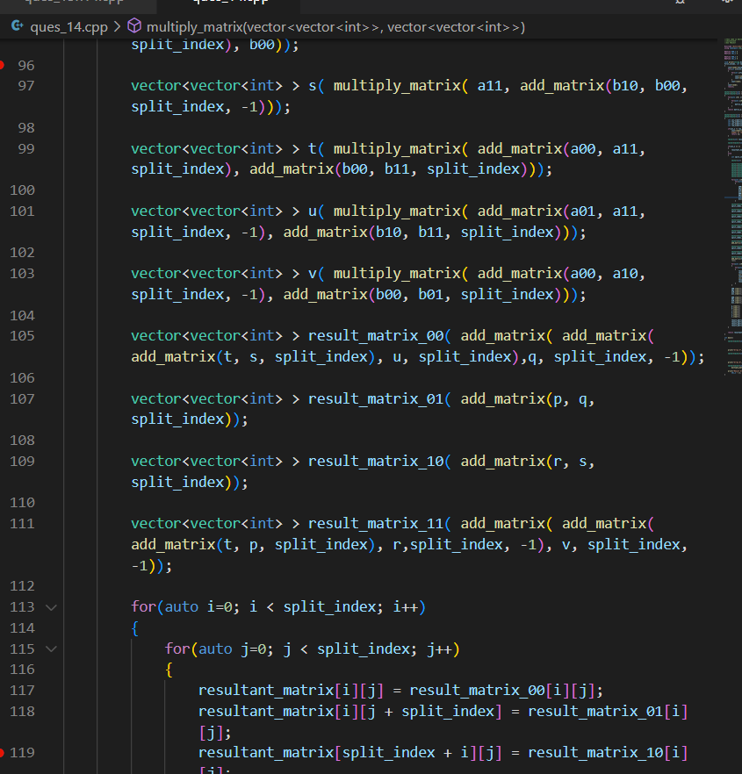

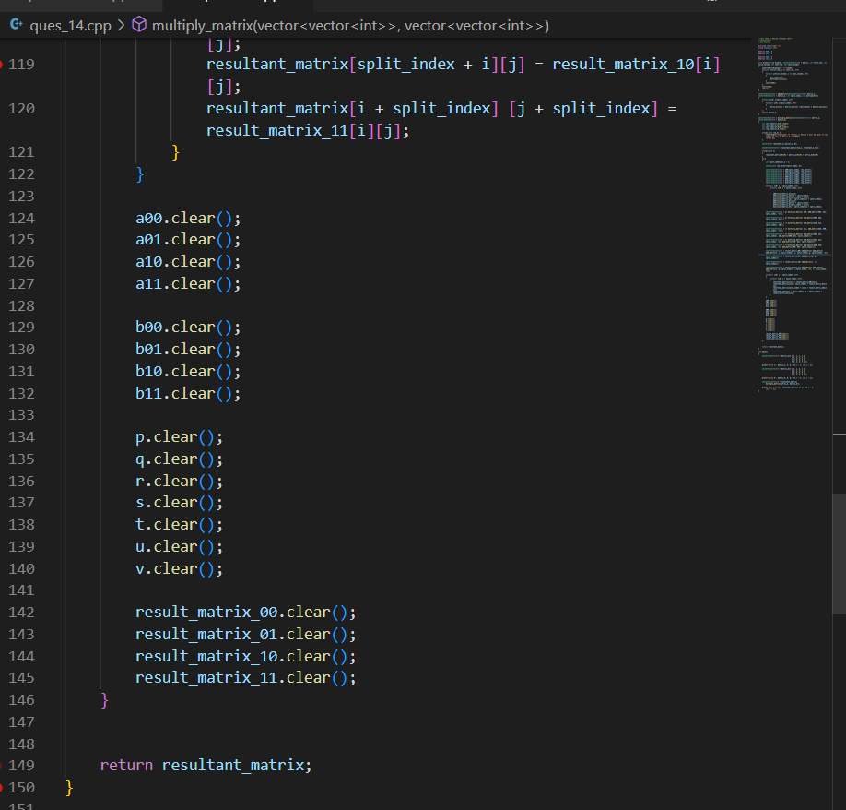

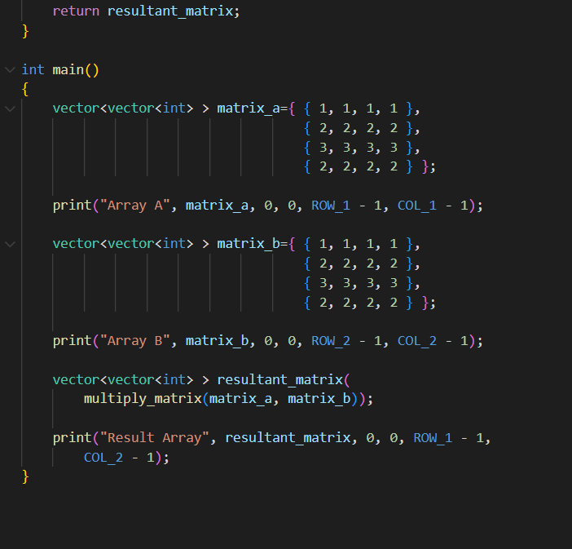

OUTPUT:

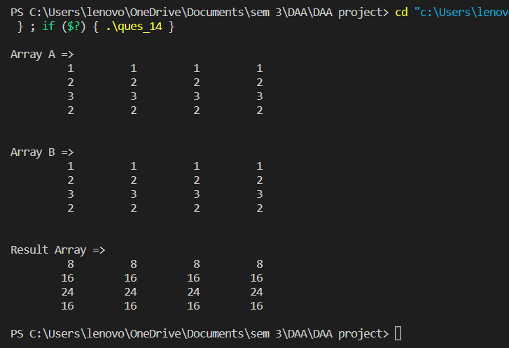

MATRIX CHAIN MULTIPLICATION

OVERVIEW:

Matrix chain multiplication (or the matrix chain ordering problem) is an optimization problem concerning the most efficient way to multiply a given sequence of matrices. The problem is not actually to perform the multiplications, but merely **to decide the sequence of the matrix multiplications involved**.

ALGORITHM

* Create a recursive function that takes **i** and **j** as parameters that determines the range of a group.
  + Iterate from **k = i to j** to partition the given range into two groups.
  + Call the recursive function for these groups.
  + Return the minimum value among all the partitions as the required minimum number of multiplications to multiply all the matrices of this group.
* The minimum value returned for the range **0** to **N-1** is the required answer.

COMPLEXITY

Time Complexity: O(N^3)

Auxiliary Space: O(N^2)

CODE:





OUTPUT:



EXPERIMENT NUMBER: 15

Write a program to implement Longest Common Subsequence.

OVERVIEW:

The longest common subsequence (LCS) is defined as the longest subsequence that is common to all the given sequences, provided that the elements of the subsequence are not required to occupy consecutive positions within the original sequences.

ALGORITHM

1. Suppose X and Y are the two given sequences
2. Initialize a table of LCS having a dimension of X.length * Y.length
3. XX.label = X
4. YY.label = Y
5. LCS[0][] = 0
6. LCS[][0] = 0
7. Loop starts from the LCS[1][1]
8. Now we will compare X[i] and Y[j]
9. if X[i] is equal to Y[j] then
10. LCS[i][j] = 1 + LCS[i-1][j-1]
11. Point an arrow LCS[i][j]
12. Else
13. LCS[i][j] = max(LCS[i-1][j], LCS[i][j-1])

COMPLEXITY

Time Complexity: O(m*n)

Auxiliary Space: O(m*n)

CODE:

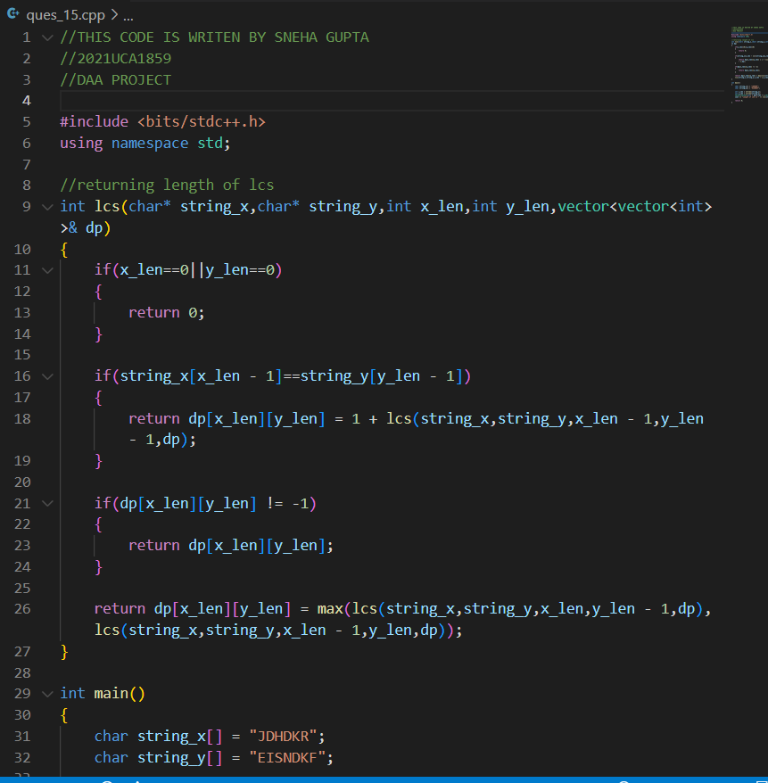

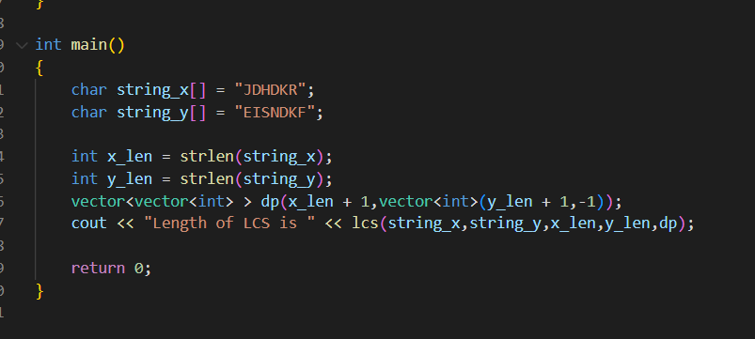

OUTPUT:

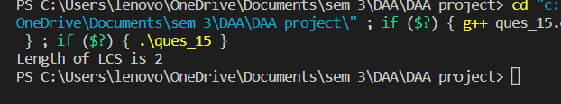

EXPERIMENT NUMBER: 16

Implement Travelling Salesman Problem

OVERVIEW:

The traveling salesman problem (TSP) is **an algorithmic problem tasked with finding the shortest route between a set of points and locations that must be visited**. In the problem statement, the points are the cities a salesperson might visit.

ALGORITHM

**Algorithm: Traveling-Salesman-Problem**

C ({1}, 1) = 0

for s = 2 to n do

for all subsets S Є {1, 2, 3, … , n} of size s and containing 1

C (S, 1) = ∞

for all j Є S and j ≠ 1

C (S, j) = min {C (S – {j}, i) + d(i, j) for i Є S and i ≠ j}

Return minj C ({1, 2, 3, …, n}, j) + d(j, i)

COMPLEXITY

Time Complexity: (**O(n^4), O(n^3*2^n))**

Auxiliary Space: O(N^2)

CODE:

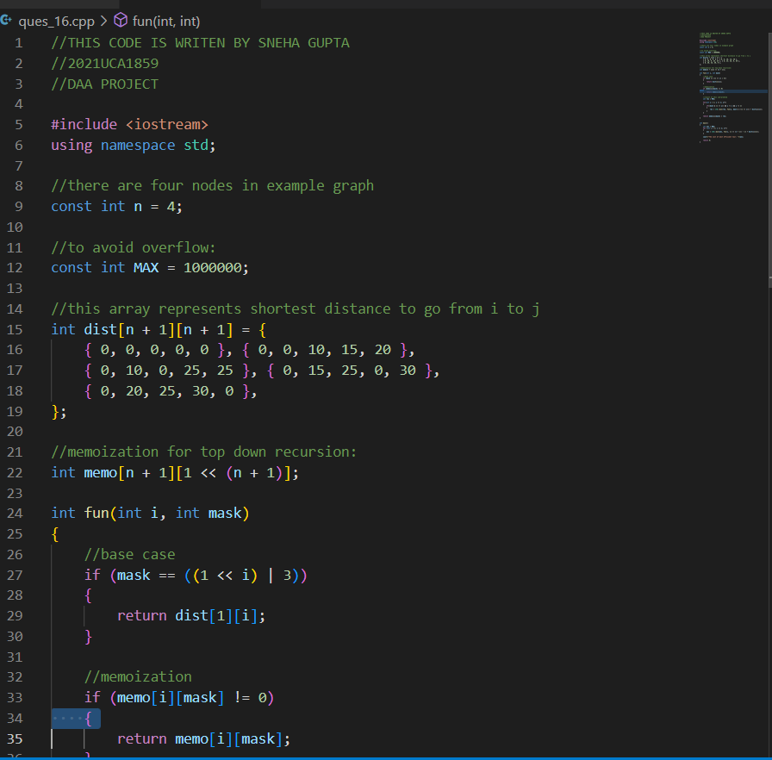

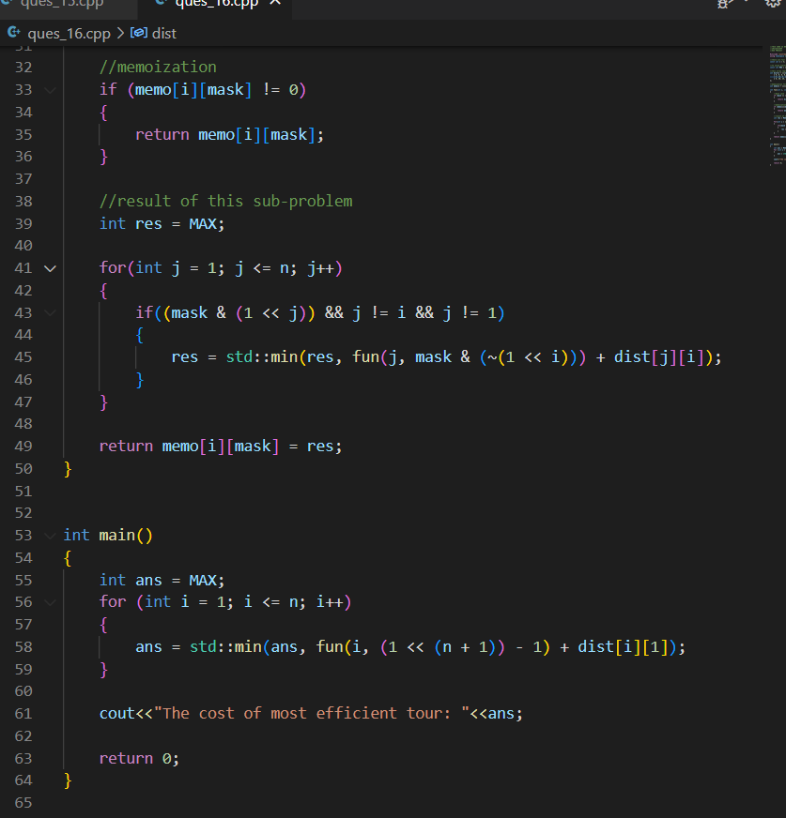

OUTPUT:

